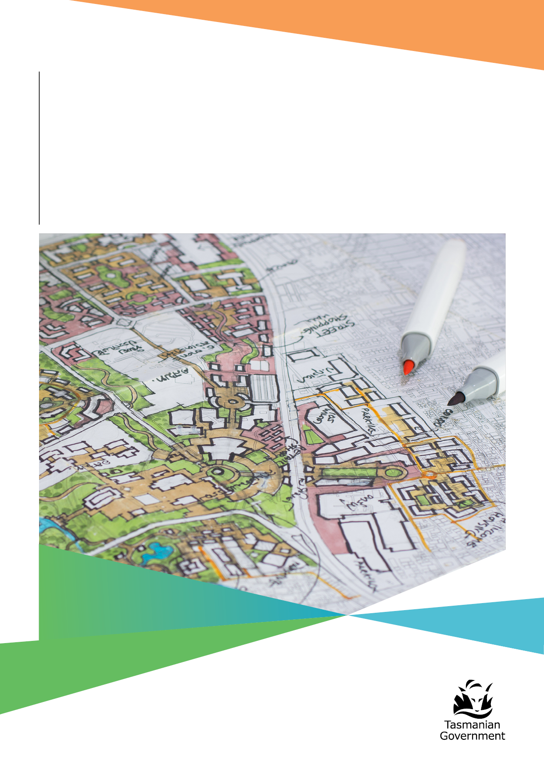
May 2025

Government Response
to the Independent Review
into Homes Tasmania

Department of State Growth


Contents
Ministerial statement 4
Why we did this review 6
What has the review told us? 7
1. System governance and performance needs to be improved 8
2. System stewardship needs to be a key focus 8
3. Housing accessibility and supply is best served by long term policy consistency 9
4. Service delivery and support needs to be streamlined 9
The Government’s response 10
Government response to Independent Review recommendations 12

Ministerial statement
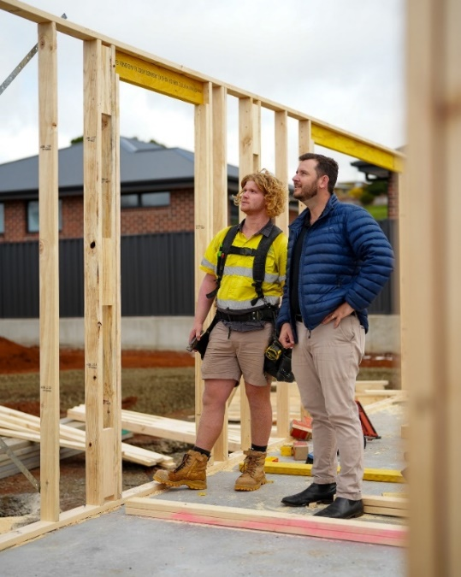
In 2022, our Government established Homes Tasmania, a dedicated housing authority responsible for delivering improved housing services and increasing the supply of social and affordable homes across the state.
In delivering on this commitment, we recognised the need to do things differently. Our goal, to deliver a well-functioning housing system that provides safe, appropriate, and affordable homes for all Tasmanians, required a significant shift away from the delivery models that had been used for decades.
By establishing Homes Tasmania, we acknowledged the need for greater innovation, improved efficiency, and faster development,
to get homes built and Tasmanians housed as quickly as possible. Led by a skills-based board, Homes Tasmania is designed to bring together the expertise needed to deliver these homes through partnerships with the private sector and Tasmania’s building and construction industry.
Ensuring Tasmanians have access to appropriate, affordable, safe, stable and well-located housing at
all stages of life was the driving reason behind our Government’s decision to reform the way public and social housing is planned, built, and managed in Tasmania. It was a bold, wide-ranging vision, one that involved modernising 90-year-old legislation that no longer reflected the challenges or realities faced by the housing sector today.
Our target to deliver an additional 10,000 social and affordable homes by 2032 is backed by the largest investment in such housing in Tasmania’s history. Through Homes Tasmania, we have already delivered over 4,300 of these homes. The National Housing Supply and Affordability Council (NHSAC) recently confirmed that Tasmania is the only state in Australia to have increased its share of social housing between 2018 and 2023.
I welcome the Review into Homes Tasmania, conducted by former New South Wales Auditor-General Ms Margaret Crawford PSM, and I acknowledge the Member for Franklin, Mr David O’Byrne MP, for initiating the call for this Review.
Our ambitious goal of 10,000 additional social and affordable homes by 2032 remains firmly in our sights. With seven years to go, the Homes Tasmania dashboard shows we are already approaching the halfway mark. But as this Review highlights, there is more we can do to ensure Homes Tasmania is positioned to meet this target as effectively as possible.
The Review, which examined both Homes Tasmania and the Homes Tasmania Act 2022, has been timely and appropriate for an organisation now settling into its role. It has identified clear areas for improvement, for both Homes Tasmania and our Government, to address.
Importantly, Ms Crawford’s Review does not find a system that is broken. Rather, it concludes that while there is a strong foundation, Homes Tasmania requires greater clarity of purpose, a stronger strategic direction, a more focused vision and role, and increased flexibility to achieve the outcomes originally envisaged under our housing model. The Review also clarifies the role of government, making clear that the responsibility for solving the housing challenge must remain with government, not be shifted solely onto a statutory authority.
I am especially pleased that Ms Crawford recognised the staff of Homes Tasmania as hardworking, committed, and highly knowledgeable. As with any new organisation, there are new skills to be developed and systems that must evolve and mature. These are matters we will work through to give Homes Tasmania the flexibility and clarity it needs to deliver on its mandate.
To support this, our Government will immediately relocate existing policy functions, regulatory responsibilities, and system stewardship from Homes Tasmania to the Department of State Growth.
This shift will allow Homes Tasmania to focus squarely on its core responsibilities: building social and affordable housing, delivering tenancy and homelessness services and providing key worker accommodation.
We will also clarify roles and accountabilities, and strengthen the systems and processes that support them, ensuring they are fit for purpose, well understood, efficient and sustainable. This will help set up both Homes Tasmania and our broader housing agenda for long-term success.
I thank Ms Crawford for her diligence and commitment in undertaking this Review, and I acknowledge the secretariat team that supported her work. I also thank the many stakeholders who took the time to meet with Ms Crawford and contribute to her findings.
The Tasmanian Government’s response to the recommendations of Ms Crawford’s Review is outlined in this document. As flagged in the Review, I look forward to working closely across government and with local councils, the building and construction industry, and with community housing and homelessness organisations, to ensure more Tasmanians have access to safe, appropriate, and affordable housing.
Finally, I once again thank Ms Crawford for her thoughtful engagement with so many Tasmanians and her valuable contribution to the future of housing in our state.

Hon Felix Ellis MP
Minister for Housing, Planning and Consumer Affairs

Why we did this review
On 22 November 2024, in response to a motion moved by the Member for Franklin, Mr David O’Byrne MP, calling for a review of Homes Tasmania, Premier Jeremy Rockliff MP appointed Ms Margaret Crawford PSM to lead an independent, targeted review of the organisation.
That review is now complete. It provides an objective assessment of how Homes Tasmania has performed in its first two years of operation and in delivering on its foundational promise.
The Review makes 20 recommendations, and this report outlines the Tasmanian Government’s response to those recommendations and findings.
The Government remains firmly committed to ensuring Homes Tasmania successfully delivers housing, homelessness, and crisis accommodation services to Tasmanians. This Review has offered a valuable opportunity to evaluate the effectiveness of the Homes Tasmania model in addressing the challenges of housing supply and homelessness.
The Review focused on several key areas: the effectiveness of Homes Tasmania’s roles and responsibilities, its reporting and accountability frameworks, and its engagement and collaboration with stakeholders, including the Tasmanian building and construction sector, particularly in relation to procurement arrangements.
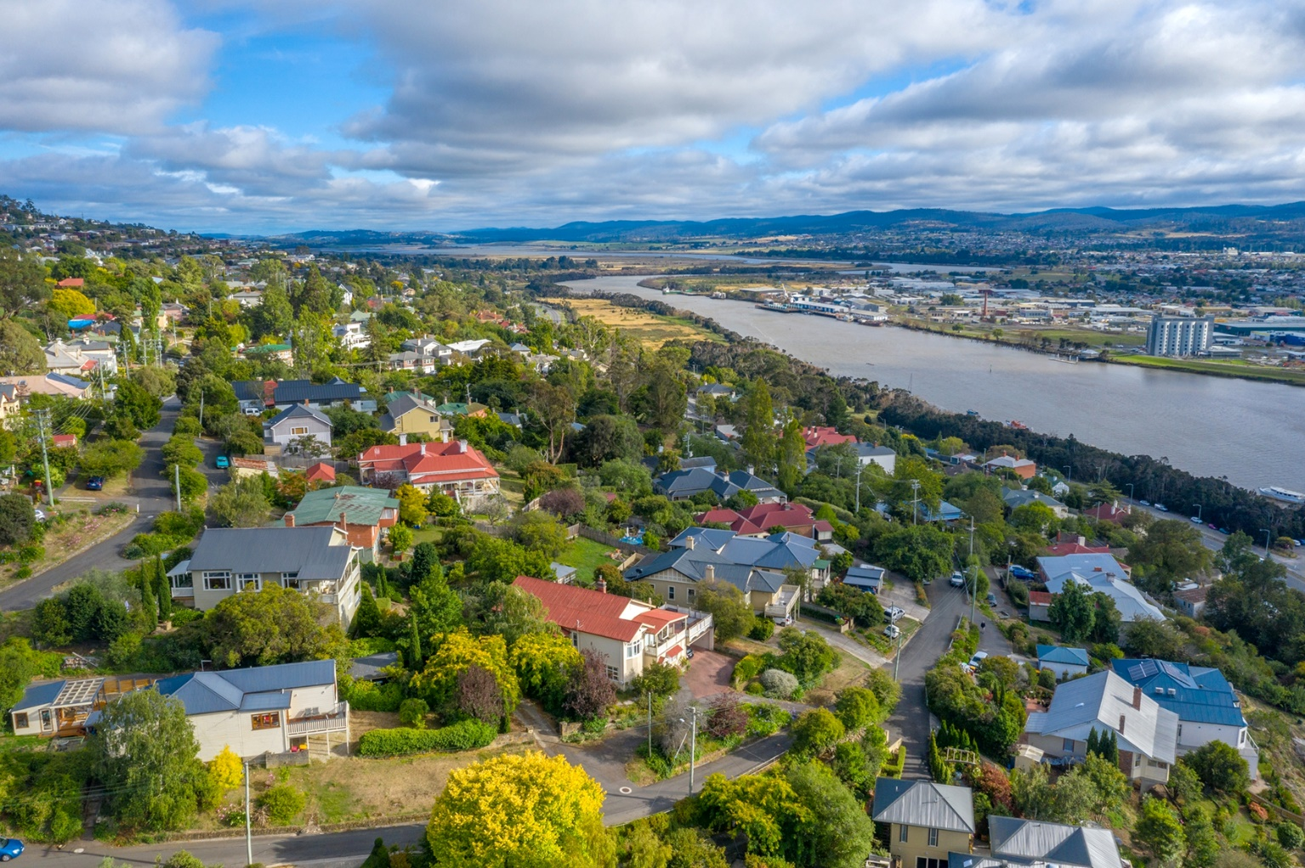

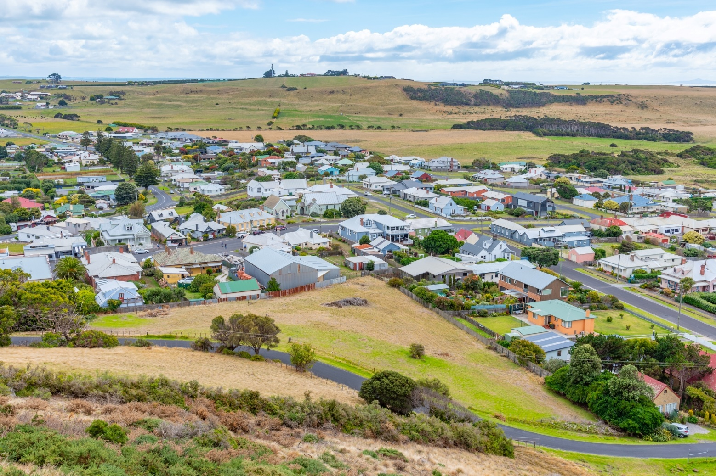
What has the review told us?
Homes Tasmania was established as a more agile, commercial, and innovative mechanism for the Tasmanian Government to work with industry, the private sector, and the social housing and homelessness sectors to improve housing outcomes and expand opportunities for people in need. The model was designed to harness flexible, collaborative partnerships by aligning government programs across the entire housing supply continuum.
In parallel, the Tasmanian Housing Strategy includes a clear commitment to delivering a well-functioning housing system, one that provides safe, appropriate, and affordable housing for all Tasmanians. Homes Tasmania continues to play a central role in implementing actions under this strategy.
However, the Review found that the current arrangements intended to support Homes Tasmania in forming innovative and flexible partnerships, particularly to accelerate housing supply, are not operating as originally envisioned and stakeholder support is decreasing.
The Review examined the role of Homes Tasmania’s skills-based board, and whether the expectations placed on the organisation by Government, along with the operational controls imposed, have enabled or hindered its success. Ultimately, the Review identified four key areas for improvement to better support Homes Tasmania in delivering on its mandate.

System governance and performance needs to be improved
The Review found that decision-making and accountability between the responsibilities of the Homes Tasmania Board and the Minister’s accountability to the Parliament for the performance of Homes Tasmania are currently unclear.
The Homes Tasmania Act 2022 intends for Homes Tasmania to be governed by a skills-based board. The Review found that current governance practices have evolved into the board taking on more of an advisory role, as opposed to a governance role, as Homes Tasmania has needed to seek Government policy direction.
The Review noted it is crucial that the Government clarify the role of the Board of Homes Tasmania — either as an advisory board or as a governance board empowered to manage the authority, consistent with Government policy, but at arm’s length from the Minister.
There is recognition across government and the housing sector that relying on output-based performance metrics as a measure of success, ahead of service impacts and outcomes for individuals, undermines the ability to understand both the focus and effectiveness of service delivery and support. The absence of comprehensive data and the inconsistent use of platforms impede effective tracking and support of homeless populations.
The Review found that public reporting mechanisms which provide transparent reporting on the activities and performance of Homes Tasmania are effective; however, there is a gap in the clear communication of plans for future programs and the development pipeline. The Review proposes increasing the metrics included in public reporting to support better reporting on asset projections and project management.

System stewardship needs to be a key focus
System stewardship is a holistic approach to governance that acknowledges the complex and adaptive nature of developing policy and delivering services to members of the community. Federal, state and local governments all play a role in responding to issues relating to housing supply and homelessness.
Many of the factors that improve housing outcomes are outside of the control of Homes Tasmania, such as taxes and charges, labour and migration policy, land release and planning reform, infrastructure development, industry facilitation, direct funding and partnerships.
The Review again found that there was duplication between the Department of State Growth and Homes Tasmania in providing strategic and policy advice, and who was providing this system stewardship role needed to be clarified.

Housing accessibility and supply is best served by long term policy consistency
The Review states that a lack of certainty of funding and public policy constraints imposed on the organisation were impacting Homes Tasmania’s ability to innovate and achieve leverage through creative partnerships with other housing providers.
The Review notes that it is important for the Government to recognise that long term policy consistency is key to effectively tackling housing and homelessness. Increasing the stock of housing, especially social housing, is a long-term challenge that is compounded by the annual nature of current funding models.

Service delivery and support needs to be streamlined
The Review noted that current demand for assistance with shelter and homelessness support is outpacing available service responses. The Review found this issue is not attributed to the structure and operations of Homes Tasmania, however the impact of these delays in service delivery to the Tasmanian community are significant.
The Review heard of specific challenges relating to Housing Connect and the housing register, service compliance with the Residential Tenancy Act 1997 and risks associated with funded staff to client ratios. It also heard that there is a lack of understanding on where the responsibility lies for meeting accommodation standards for individuals requiring modifications.
The Review called for improvements to risk-assessment practices, increased awareness of risks and the streamlining of business practices to improve service provision to the Tasmanian community.


The Government’s response
Under the Tasmanian Housing Strategy, the Tasmanian Government works alongside Homes Tasmania, local government and partners in the not-for-profit and private sectors to deliver on our priorities to:
- Deliver more quality homes, faster.
- Support people in need.
- Improve private market affordability and stability.
- Enable local prosperity.
The Review highlighted that strategic housing policy is a responsibility of Government, and that having Homes Tasmania as both the strategic policy adviser to Government, and the delivery agency of that policy has confused reporting lines and as a result has not delivered the outcomes that were envisaged.
To address this, the Government has determined that strategic housing policy will be returned to central government and will be provided by the Department of State Growth. Figure 1 outlines the new key focus areas for the Department of State Growth and Homes Tasmania in relation to the housing system.
Figure 1 Focus areas for Homes Tasmania and the Department of State Growth
As shown, the Department of State Growth will act as a System Steward for the Tasmanian housing system and will work closely with Homes Tasmania and the sector to build a healthy housing system.
As System Steward, the Minister can turn to the Department of State Growth to provide guidance and leadership for the stakeholders within the housing system, removing the current reporting issues identified by the Review as needing urgent clarification. Transferring the role of System Steward to the Department of State Growth also allows Homes Tasmania’s Board to resume the leadership focus on operational policy and delivery of housing.

A key decision already made to support this transition of responsibilities is that the Community Housing Registrar who is responsible for regulating the Community Housing Framework in Tasmania has already been moved from Homes Tasmania to the Department of State Growth. The Registrar will manage the Community Housing Provider system, while Homes Tasmania will continue to have direct and active engagement with Community Housing Providers to manage housing stock.
To further support this shift in focus, the Department of State Growth will work with Homes Tasmania to remove regulatory and reporting requirements identified in the Review and seek variations to the Treasurer’s Instructions where appropriate to enable Homes Tasmania to partner more effectively with key housing stakeholders to deliver new housing.
To support all the above, a new Ministerial Statement of Expectations for Homes Tasmania will be developed by no later than September this year. This Ministerial Statement will consider the recommendations of the Review and will reflect that the key priorities for Homes Tasmania will be operational policy and housing delivery, with strategic policy and regulation to be under the remit of the Department of State Growth. This will support Homes Tasmania to focus on their core function of building social and affordable housing, providing tenancy services and providing homeless services and key worker accommodation.
The work of this Review, combined with the new Ministerial Statement of Expectations, will lead to changes in how the housing policy system operates.
Although not a direct recommendation of this Review, to ensure that the Tasmania Housing Strategy and associated Action Plan are up to date, relevant and operating effectively in the new policy environment, the Department of State Growth will examine these documents to determine if any action or review change is required.
A more detailed response to each recommendation is provided in the next section.


Government response to Independent Review recommendations
The Review has provided a series of recommendations designed to make impactful change, improve
the functioning of Homes Tasmania and in turn, improve outcomes for the Tasmanian community.
The Tasmanian Government’s response to the recommendations of the Review is detailed below.

1 | Complete the planned Review of Finance of Homes Tasmania.  This work will be undertaken by the Department of State Growth, as part of this change process. Work is envisaged to be completed by the end of 2025.
2 | Regardless of the quantum, provide certainty to Homes Tasmania regarding the funding envelope they can work within.  This issue will be incorporated into the Financial Review being conducted by the Department of State Growth.
3 | Consider a suite of authority specific modifications to the Treasurer Instructions, and other restrictive policies, that limit Homes Tasmania from engaging in innovative partnerships to deliver new housing.  The Department of State Growth will work with the Department of Treasury and Finance and Homes Tasmania to determine the relevant exemptions to the Treasurer’s Instructions which may be required to achieve improved purchasing and partnership outcomes for Homes Tasmania.
4 | Require Homes Tasmania to report on any departures from Treasurer’s Instructions or public policy requirements.  This will be considered as part of the response to recommendation three.
5 | Urgently clarify whether the Board of Homes Tasmania is a governance board, empowered to manage the authority, consistent with government policy, but at arm’s length from the Minister, or whether the government needs more direct control of the operations of the authority.  The Board has been charged with managing the Authority, consistent with Government policy. An updated Ministerial Statement of Expectations will be issued no later than 30 September 2025 to reflect proposed arrangements.
6 | Be clear that strategic housing and homelessness policy is the responsibility of the Department of State Growth.  Strategic housing and homelessness policy will return to central agencies, specifically to be led by the Department of State Growth. The Department of State Growth will act as steward for strategic housing and homelessness policy, informed and in partnership with key partner agencies, including the Department of Education Children and Young People, the Department of Justice, the Department of Premier and Cabinet, and the Department of Health. The Department of State Growth and Homes Tasmania will work through this transition, and if any direction is needed, it will be incorporated into the revised Ministerial Statement of Expectations for Homes Tasmania.

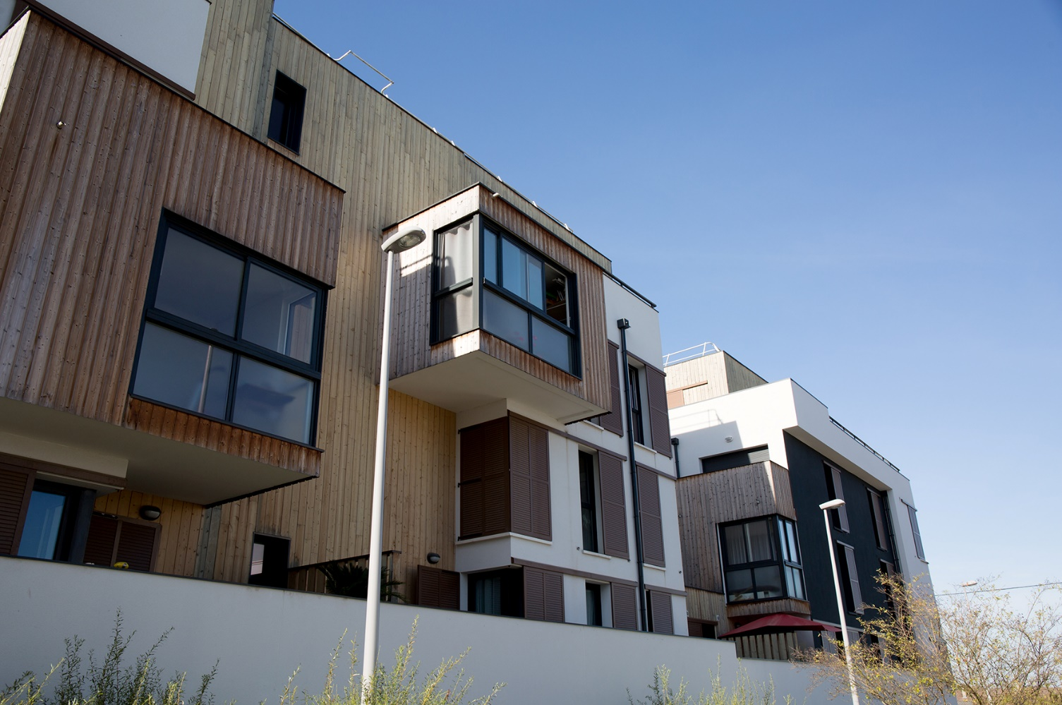
7 | In developing strategic housing policy, the Department should advise the Minister on the best mix of housing types that should comprise the 10,000 target, including the mix of infield or greenfield development, and the Minister, the Department and Homes Tasmania should clearly indicate the government’s housing preferences to the sectors engaged in housing development.  This will be examined as part of the Financial Review which will also address recommendations one and two.
8 | Be explicit when reporting additions to housing supply compared with the purchase or rental of existing properties (noting the current Dashboard does show new build compared with existing homes under the “My Home” shared equity program).  A new, user-friendly Housing Dashboard was released in September 2024 to further transparency in the delivery of social and affordable housing across the state.  This new Dashboard features a new format with additional information, including detailed reporting on completed homes, land packages, funding models and the status of pipeline projects.  The Department of State Growth will work with Homes Tasmania to progress any required changes to the Homes Tasmania Dashboard, including reviewing whether the management of the dashboard reporting should move to the Department of State Growth.

9 | Consider adding more metrics in Homes Tasmania Dashboard showing the population cohorts seeking and receiving assistance.  Additional metrics were added relating to applicant profile in the changes made to the Housing Dashboard in 2024.  The Department of State Growth will work with Homes Tasmania to review the reporting metrics in the Homes Tasmania Dashboard, as part of the Outcomes Reporting Framework which is being developed as a priority under the Housing Action Plan.
10 | Deliver the asset management plan to redevelop and reprofile aging assets in the Homes Tasmania portfolio, flagged in the Action Plan to be completed by 30 June 2025.  Homes Tasmania is progressing work on this as a priority of the Action Plan.
11 | Prioritise investment in tools and technology to support better reporting on asset projections and project management.  This will be a matter for Homes Tasmania’s Board to progress with their executive, noting that  a new Chief Financial Officer has commenced employment at Homes Tasmania.
12 | Assess the risks associated with funded staff to client ratios.  This will be reviewed as a medium-term priority (in 2026).
13 | Ensure the Homes Tasmania board is comprehensively briefed on the risks associated with the findings of the Commission of Inquiry into Children in Institutional Care.  The Department of Premier and Cabinet has briefed the Homes Tasmania Board on the risks associated with the Commission of Inquiry.
14 | Be clear about who is responsible for meeting accommodation standards for properties housing clients with a disability and older adults requiring property modifications to age in place.  A review of current approaches will be progressed by Homes Tasmania and the Department of State Growth to provide further advice on this matter.
15 | Pursue the slated review of the Residential Tenancy Act 1997.  The Government has committed to a review of the Residential Tenancy Act 1997 by  30 June 2027 under the Action Plan.
16 | Finalise the builder panels as soon as possible.  Homes Tasmania has progressed work to establish the builder panels. The Department of State Growth will work with Homes Tasmania to finalise the panels by the end of June 2025.

17 | Continue to regularly meet with sector participants and provide greater clarity about escalation and decision-making processes.  This will be made clear to the Board of Homes Tasmania through the updated Ministerial Statement of Expectations. It will be facilitated by the shifting of strategic housing policy to the Department of State Growth, which will support Homes Tasmania to focus on operational matters.
18 | Consider the development of a Direct Dealing (unsolicited Proposal) Framework to govern unsolicited proposals and co-design with industry participants.  This matter will be considered by the Department of Treasury and Finance and the Department of State Growth as a medium-term priority (in 2026).
19 | Continue to pursue the initiatives outlined in the Action Plan that are the responsibility of other parts of government.  The Government is continuing to pursue the initiatives outlined in the Action Plan. The Department of State Growth, in conjunction with its key partner agencies, will review the Action Plan, to determine if the responsibility of any actions need to be moved.
20 | Lead a conversation with the Tasmanian community regarding the need for and benefits of new types of housing in Tasmania.  This work is part of the ongoing business of Government being led by the Department of State Growth. The Department of State Growth already has a Housing, Population and Planning team, which was established earlier this year who will be completing this work.


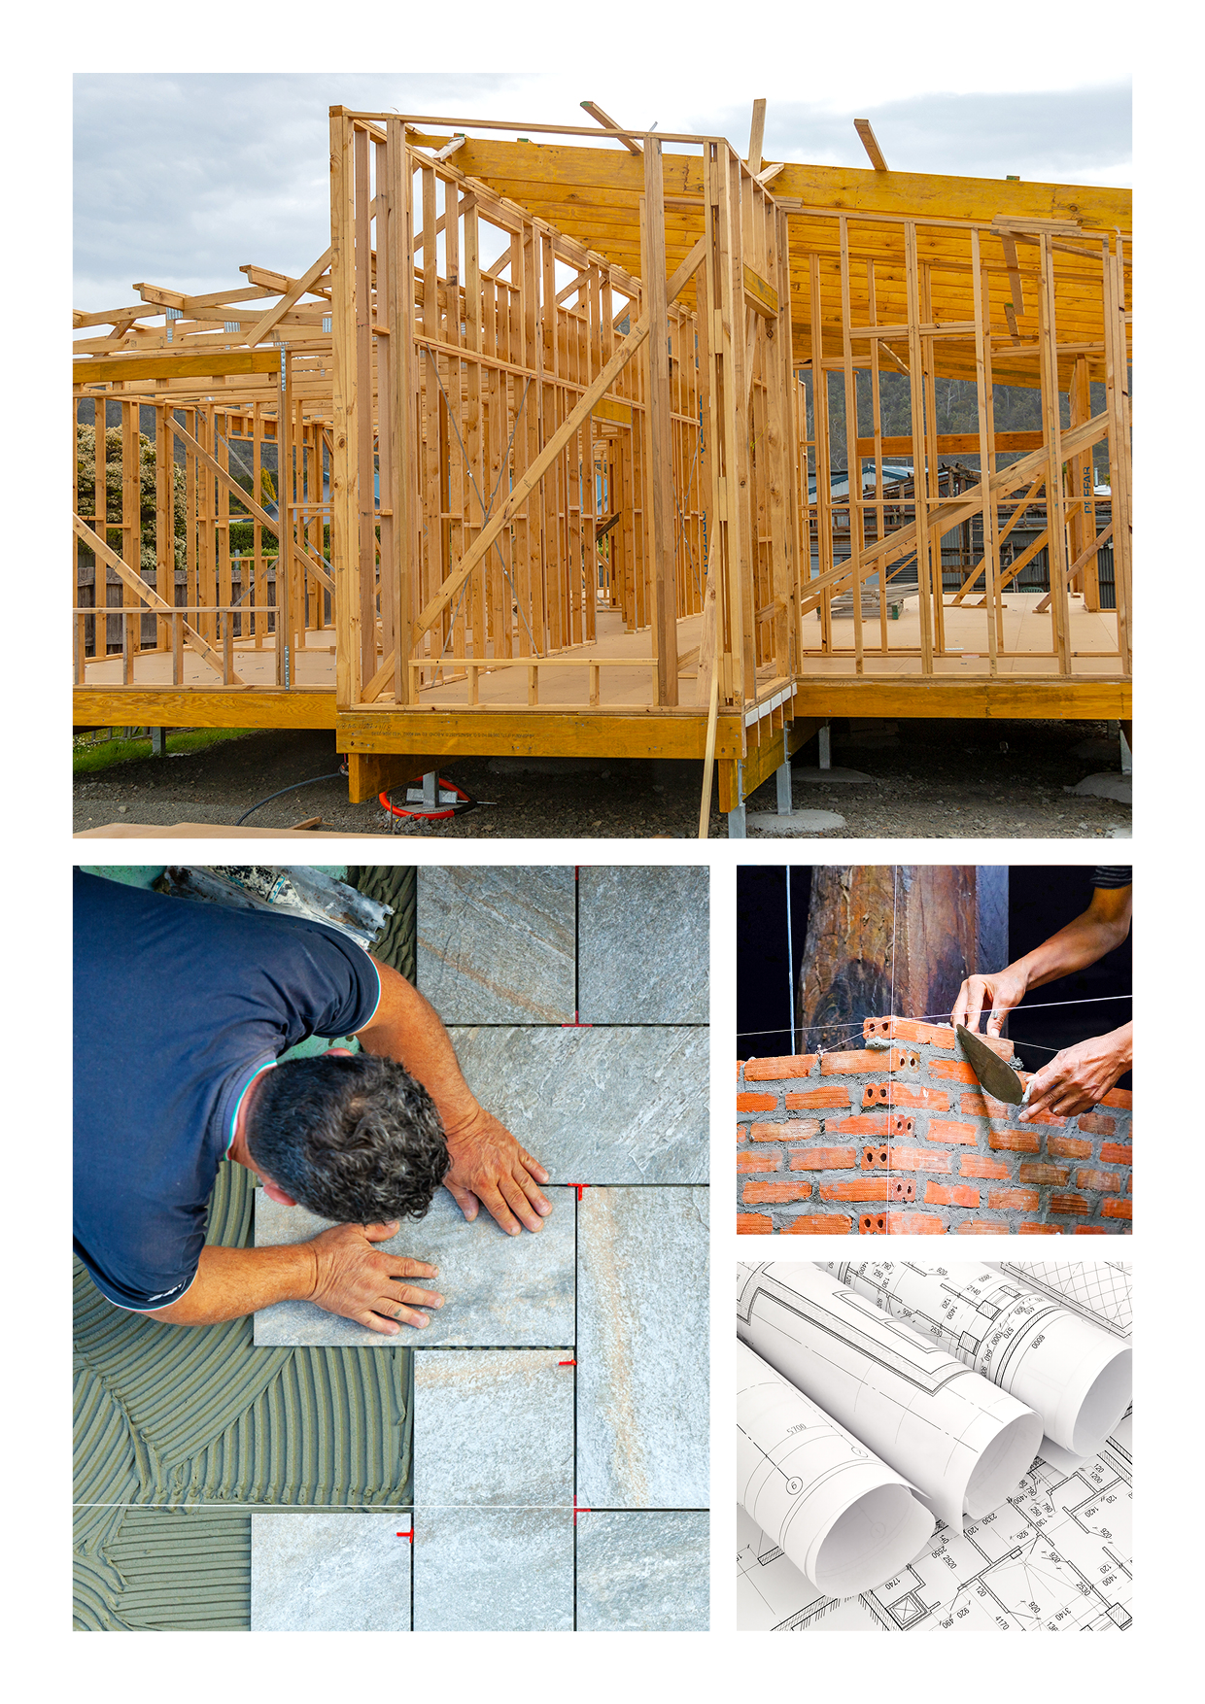


Department of State Growth
4 Salamanca Place
Hobart TAS 7001 Australia
Phone: | 1800 030 688
Email: | housingpolicy@stategrowth.tas.gov.au
Web: | www.stategrowth.tas.gov.au

