Glenorchy to Hobart CBD Transit Corridor

Transit Corridor Assessment Report – Stage one

Land use planning

Summary report



**July 2012**

Department of Infrastructure, Energy and Resources

**CONTENTS**

1 Key points 3

2 Transport and land use planning 4

3 Development patterns 4

3.1 Separation of land uses 5

4 Land use along the Transit Corridor 5

4.1 Residential density 5

4.2 Trip attractors 8

4.2.1 Activity centres 8

4.2.2 Educational institutions 10

4.2.3 Other trip attractors 11

5 The case for more compact and mixed use development patterns 14

5.1 Cost of infill development 15

6 Strategic planning to support infill development 16

6.1 Planning Scheme provisions 17

6.2 Identification of high residential density opportunities 17

# Key points

This report highlights key issues in regard to land use planning:

* **Transport and land use planning:** Land use planning directly affects both the demand for travel and mode of travel. Past land use policy has resulted in low density development patterns (particularly in outer urban areas) and separation of land uses, which has created high dependency on the car and makes effective provision of public transport problematic.
* **Land use along the Transit Corridor:** The Corridor has a high number of trip attractors located along its length, including activity centres:
  + - The Corridor is the most densely populated commercial strip in Greater Hobart containing five activity centres including Hobart CBD and Glenorchy. The total number of people employed along the Corridor is 42 285 people, based on journey to work data (ABS, 2006). Employment is a major driver of public transport demand.
    - The Corridor already contains pockets of medium to high residential density. The challenge will be to investigate whether there are opportunities for further intensification of residential and mixed use along the Corridor to increase the potential market for public transport.
* **Infill verus Greenfield development:** 85 percent of new dwellings in Greater Hobart are built on Greenfield sites, at a relatively low density of seven to ten dwellings per hectare (STCA 2011). This is largely because the development market in Tasmania is geared towards Greenfield development.
* Research shows that compact and mixed use development patterns create more sustainable travel behaviour. The wider benefits of more compact development patterns include:
* More efficient use of existing infrastructure, including lower infrastructure costs for servicing new infill lots.
* Creating greater market demand for existing public transport services.
* Reducing distances between residential areas and trip attractors, thereby making walking and cycling more viable transport options.
* Ability to better cater for demographic change, in terms of providing for housing diversity.
* Research undertaken in other capital cities indicates that the cost of constructing infill dwellings is higher than the cost of constructing a Greenfield dwelling. These differences will need to be overcome if infill development is to become a viable option in Greater Hobart. The barriers to infill development will need to be closely explored by both State and local Government.
* Infill development opportunities provide Glenorchy and Hobart an opportunity to substantially grow their populations along high frequency public transport corridors. Strong planning and policy changes are required to shift population growth from the outer areas of Greater Hobart to inner areas.
* **Strategic planning to support infill development:**Strategic planning documents are in place to guide future settlement patterns within Greater Hobart. The *Southern Tasmania Regional Land Use Strategy* reflects the concept of Transit Corridors and increasing residential densities in inner urban areas. The challenge will be in ensuring this strategy is implemented.

# Transport and land use planning

Land use planning directly affects both the demand for travel and mode of travel. To increase the use of public transport, Transit Corridors should be located as close as possible to higher density residential areas and they should link activity centres. This maximises the number of people able to easily access public transport services and increases the attractiveness of the service through its capacity to access popular trip attractors.

# Development patterns

Historically, public transport infrastructure has been a strong force in shaping Australian cities, largely because development followed train and tram lines. However, as the car became more prevalent and affordable in the 1950s, development patterns changed, resulting in housing estates being created in outer areas as people were no longer reliant on public transport to travel to work.

Greater Hobart’s settlement pattern is strongly influenced by its environmental setting, with the Derwent River, Mount Wellington and Meehan Range restricting the location of urban development and transport networks. This has resulted in a highly dispersed settlement pattern and limited opportunities for Greenfield expansion in the inner urban areas of Hobart and Glenorchy. On average, Greater Hobart has an average population density of just 12 people per hectare, which is low for Australian cities (which, in turn, are low by international standards).

There has been a strong trend toward housing and population growth in outer urban areas such as Kingston/Blackmans Bay, Margate, outer urban areas of Clarence, Sorell and Brighton, based on choice and housing affordability. The majority of affordable housing stock is located on the urban fringe in broad-hectare public housing estates.

The pattern of residential development in Greater Hobart has a significant impact on how the transport system is used:

* Limited local employment opportunities and essential services in outer urban areas, meaning people travel more and further to go to work, school or shops.
* A high reliance on cars for private travel, resulting in a high number of car trips.
* Difficulty in providing effective public transport services, as fewer houses are distributed across greater distances than in inner urban areas.

Low density urban areas often have high levels of car ownership and use, due to the spatial diversity of travel patterns. In comparison, more dense urban areas often have high levels of alternative transport use such as public transport, walking and cycling because origin-destination points are close together.

Providing adequate area coverage, travel speed and service frequency for public transport is a challenge in a low density city such as Hobart. The low density pattern of development has resulted in bus routes being planned, generally, on a low-frequency, high-penetration basis. This means that bus routes are often very long, as they must service widely spread-out suburbs and therefore have longer travel times to reach the final destination than cars. Although there are several express bus services which generally enjoy relatively high levels of patronage, these services are not particularly frequent. The result is often poorer service in outer suburbs, which can be problematic as outer areas tend to contain lower socio-economic groups who are more likely to be dependent on public transport.

## Separation of land uses

Development patterns are also closely linked to the shift in planning policy towards the separation of land uses, which occurred during the mid twentieth century. Older inner urban areas developed in the late 1800s and early 1900s generally have higher densities, a mixture of housing types and contain more mixed use developments. In such areas different forms of land use were located together as the main form of transport was walking.

With the rise of the car, land use policy changed to create single use zoning, which resulted in outer urban areas having separated land uses. Outer urban areas are dominated by single detached dwellings, lower densities and lack activity centres. Subsequently, most people living in outer urban areas are more car-dependant, as they live distant from places of employment, shopping and entertainment areas.

In Australia over the last two decades there has been a policy shift back towards encouraging mixed use development because of the benefits it offers in terms of transport and liveability.

# Land use along the Transit Corridor

## Residential density

Land use planning policy will need to support the Transit Corridor by allowing increased residential density adjacent to the Corridor, which should improve public transport demand.

At present approximately 85 percent of new dwellings in Greater Hobart occur through Greenfield development, at a relatively low density of seven to ten dwellings per hectare (STCA 2011). This is well below the agreed national standard for effective delivery of public transport services, which is a minimum of 15 dwellings per hectare.

Residential areas along the Transit Corridor already contain established medium to higher density residential areas in the Greater Hobart context. These areas are West Moonah, New Town and North Hobart, which contain a population density of 20-30 people per hectare. Areas north of Montrose have a lower density at around 10-20 people per hectare. The average population density in Greater Hobart is 12 people per hectare.

Often there is community concern regarding increased residential densities, as there is a perception that density affects the amenity and local character of an area. The *Southern Regional Land Use Strategy* has recommended 25 dwellings (gross net density) per hectare as an appropriate scale and intensity of development adjacent to Transit Corridors and principal and primary activity centres. The typical built form of this scale is terrace housing, mixed with residential multi-apartment buildings of generally three storeys.

Examples of similar densities in Hobart include unit developments along Sandy Bay Road between Hampden Road and St Georges Terrace and along Brooker Avenue at Glebe. There are already areas within Hobart that have densities greater than 30 dwellings per hectare; examples include St Georges Terrace in Battery Point, Wapping and North Hobart between Burnett Street and Mount Stuart Road.

Figure Population density in Greater Hobart

Source: ABS, 2006

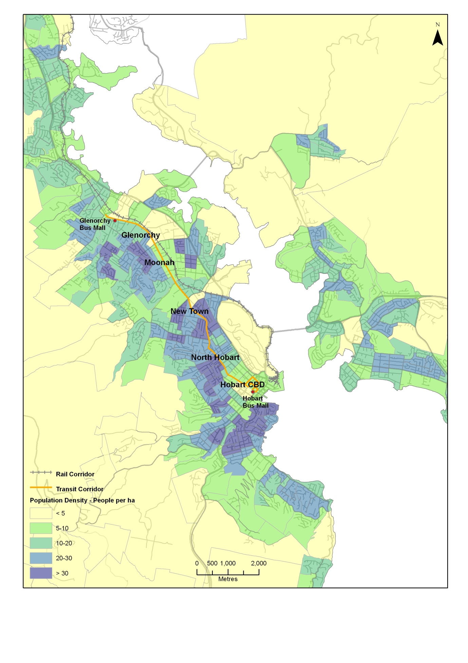

Figure Dwelling density along the Transit Corridor

Source: ABS, 2006

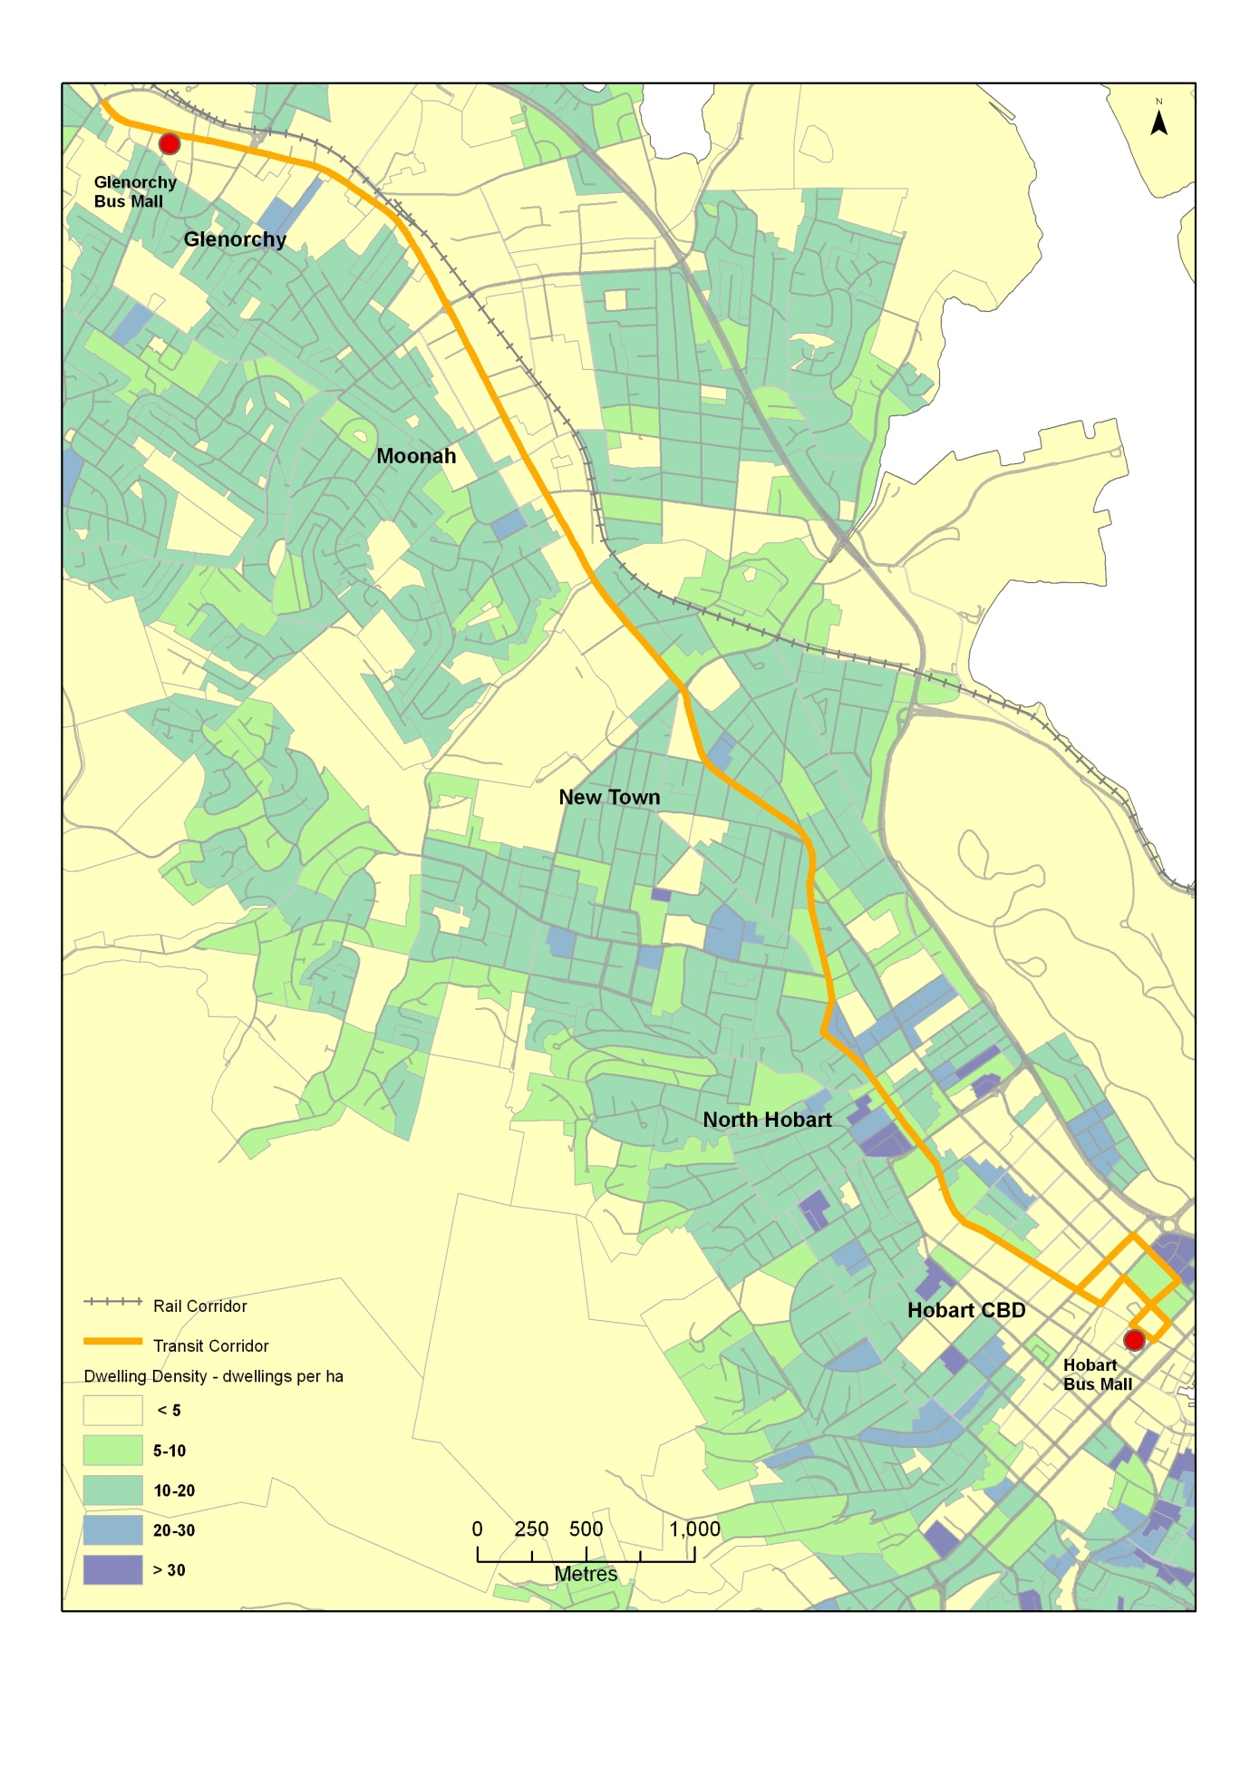

## Trip attractors

The Transit Corridorhas a high number of trip attractors located along its length, including activity centres and secondary and tertiary educational institutions which affect the demand for travel. The majority of attractors (such as retail and service industries) are located within activity centres.

### Activity centres

The *Southern Regional Land Use Strategy* promotes the development of activity centres based on an activity centre network. The network recognises the role of the Hobart CBD as the centre for public administration, financial services and commerce for Tasmania and the region whilst also recognising the ‘poly-centric’ nature of Greater Hobart.

Activity centres provide the focus for services, employment, and social interaction. They have a multi-functional role, which is broader than just a retail and commercial focus. Activity Centres are also centres of community and government services, entertainment activities and locations for major employment and education institutions.

The following activity centres are located directly on the Transit Corridor; their hierarchy is based on the *Southern Regional Land Use Strategy* activity centre network:

* Hobart CBD: Primary Activity Centre.
* Central Glenorchy: Principal Activity Centre.
* Moonah shopping precinct: Major Activity Centre.
* New Town shopping precinct and North Hobart shopping precinct: Minor or Neighbourhood Centre.

Activity centres are also major sources of employment, which is also a key driver of public transport demand. The total number of people employed along the Corridor is 42 285 people (ABS, 2006). This is based on journey to work data, so the total amount is likely to be much higher. The Hobart CBD is the major employment destination along the Corridor, attracting 26 127 people in the journey to work, followed by Glenorchy, Derwent Park and Moonah activity centres which attracted 10 652 people. More discussion on employment density is contained within the Demographic Influences and Travel Patterns Report.

The Corridor has a high number of activity centres compared to other potential Transit Corridors in Greater Hobart. This is largely because of historical development patterns which have evolved around the Corridor as a core public transport route. The Corridor provides an important link between the Hobart CBD and lower order activity centres.

The map below shows the location of activity centres along the Corridor based predominately on the density of commercial, community and social activity. These activity centres are linked by commercial strip development, particularly between Glenorchy and Moonah and from North Hobart to the Hobart CBD.

Figure Locations of Activity Centres along the Transit Corridor

Source: Discussions with Hobart and Glenorchy City Councils

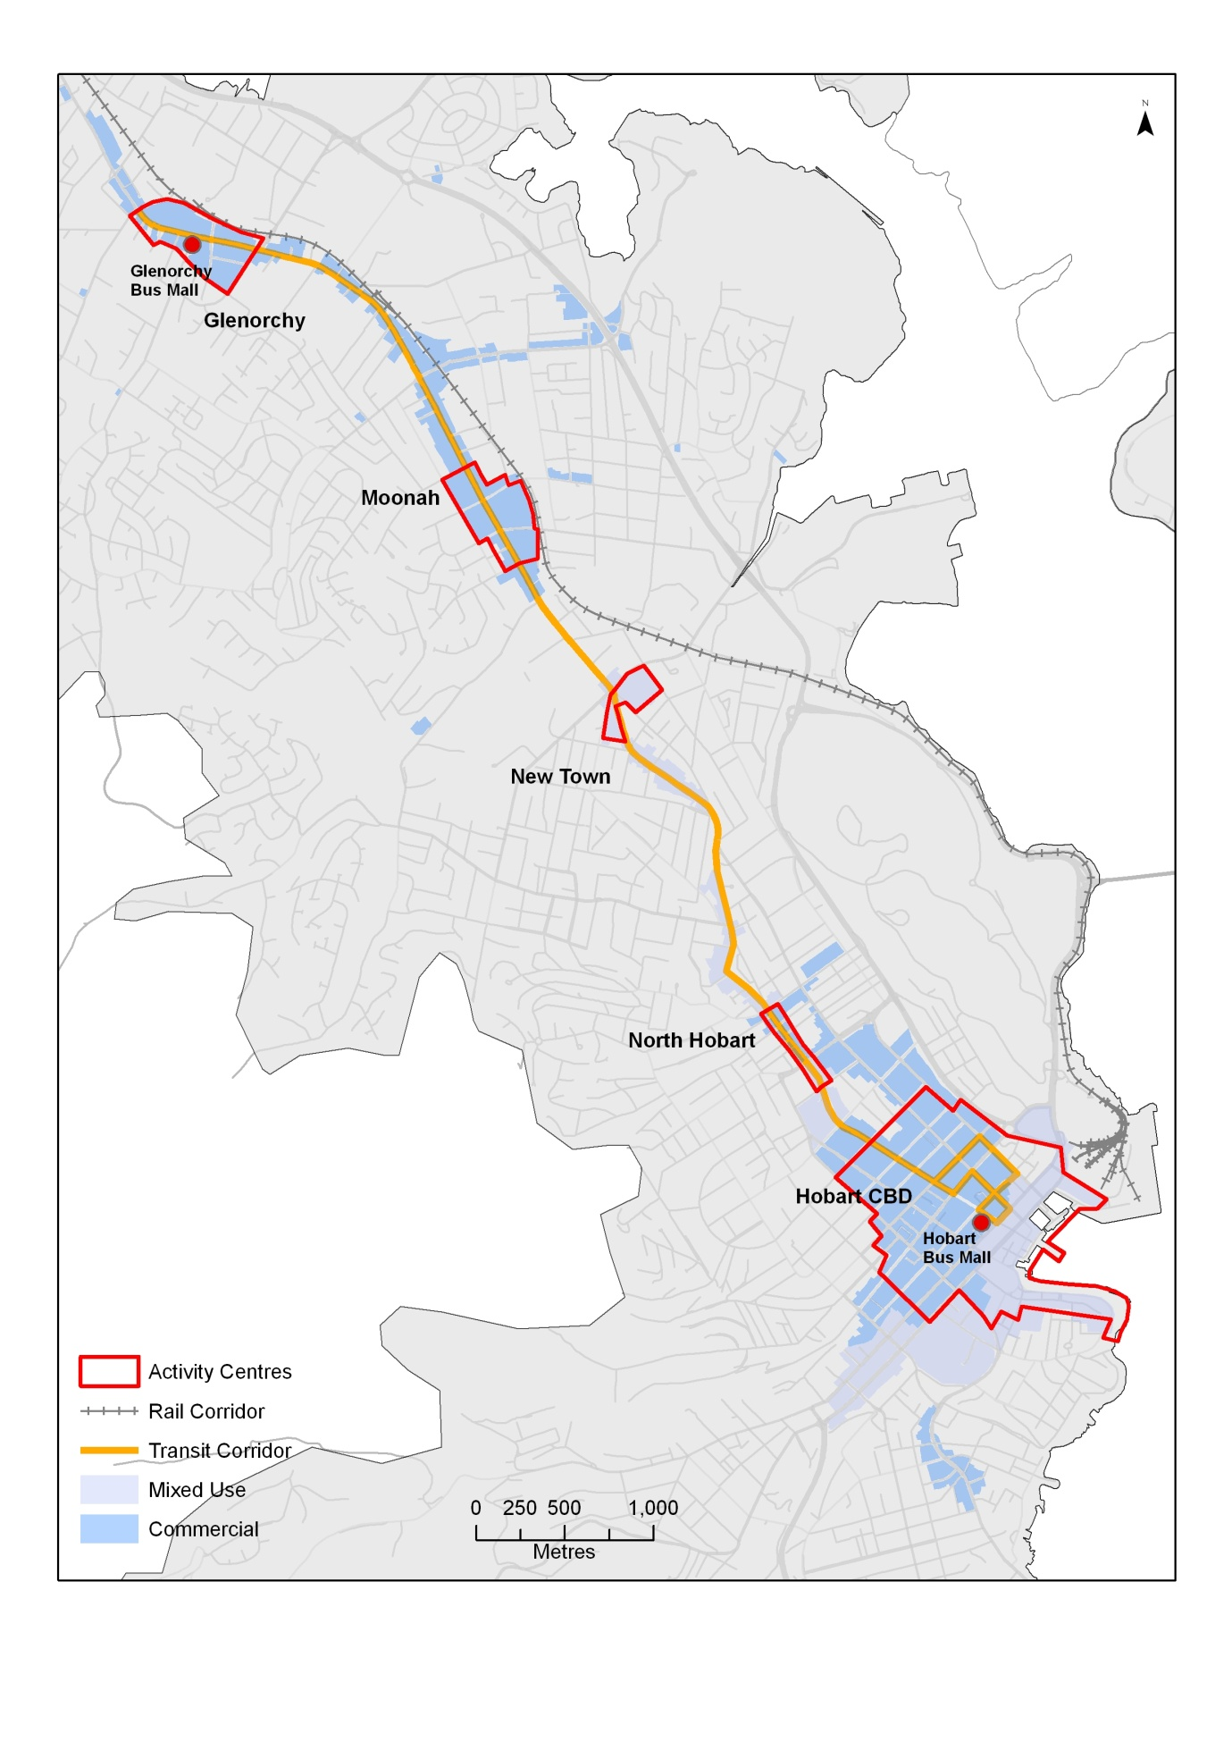

### Educational institutions

The Transit Corridor has several major education institutions, either along the Corridor or within walking distance (0-800 metres). These institutions include major secondary schools and tertiary institutions such as the Tasmanian Polytechnic and School of Medicine.

The total number of students attending secondary or tertiary institutions within 800m of the Corridor is 10 259, this figure includes:

* 5395 secondary students.
* 4864 full time equivalent tertiary students.

Students attending secondary and tertiary education are more likely to catch public transport to and from school if they live outside of the institution’s walking catchment. Therefore, the Transit Corridor caters for a large student demand.

Figure Student enrolments by Secondary and Tertiary Educational institutions within 800m of the Transit Corridor

|  |  |  |
| --- | --- | --- |
| **Educational Institution** | **Institutional Type** | **Enrolment numbers** |
| St Michaels Collegiate, Macquarie Street, Hobart | Secondary | 468 |
| St Mary's College, Harrington St, Hobart | Secondary | 493 |
| Lambert School, Church Street, Hobart | Secondary | 37 |
| The Friends School, Commercial Road, North Hobart | Secondary | 875 |
| Sacred Heart College, Cross Street, New Town | Secondary | 460 |
| Ogilvie High School, New Town Road, New Town | Secondary | 929 |
| New Town High School, New Town Road, New Town | Secondary | 787 |
| Cosgrove High School, Main Road, Glenorchy | Secondary | 258 |
| Elizabeth College, Elizabeth Street, North Hobart | Secondary | 1088 |
| Tasmanian Polytechnic and Tasmania Skills Institute (Campbell Street Campus, Hobart) | Tertiary | 2248* |
| Tasmanian Polytechnic and Tasmania Skills Institute (Bathurst Street Campus, Hobart) | Tertiary | 559* |
| Drysdale, Collins Street, Hobart | Tertiary | 807* |
| UTAS, School of Medicine, Collins Street, Hobart | Tertiary | 585* |
| UTAS, Conservatorium of Music, Sandy Bay Road, Hobart | Tertiary | 278 |
| UTAS, School of Art, Hunter Street, Hobart | Tertiary | 387 |

* denotes Full Time Equivalents, note student enrolments are Secondary and Tertiary enrolments only.

Source: Tasmanian Department of Education, Catholic and Independent Schools, UTAS, and Tasmanian Polytechnic and Tasmanian Skills Institute, based on 2009 enrolments.

### Other trip attractors

Other major attractors along the Transit Corridor include health care facilities. Hospitals located directly on the Corridor include:

* The Royal Hobart Hospital, Hobart CBD. The Royal is Tasmania’s largest hospital and clinical teaching school, it is also a major research centre: employs over 2000 full time equivalents and provides 490 beds.
* The Hobart Private Hospital which is co-located with the Royal Hobart Hospital: 146 beds.

Hospitals within 800 metres of the corridor include:

* The Calvary Health Centre Hospital, Augusta Road, Lenah Valley: 173 beds.
* St Helens Private Hospital, Macquarie Street: 37 beds.

Other attractors along the Corridor include:

* Royal Hobart Showgrounds, Glenorchy.
* King George V cultural and sport precinct, Glenorchy, which is undergoing an extensive upgrade.
* St Johns Park precinct, New Town includes uses such as aged care and State Government offices.

Figure Location of major trip attractors (Northern section of Corridor)

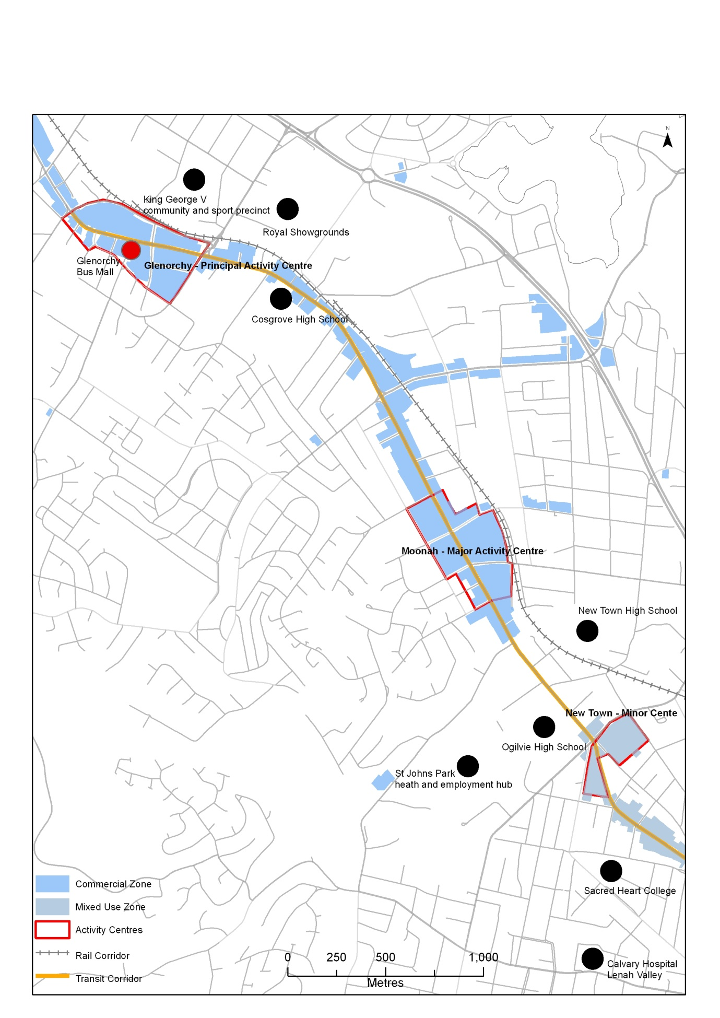

Figure Location of major trip attractors (Southern section of Corridor)

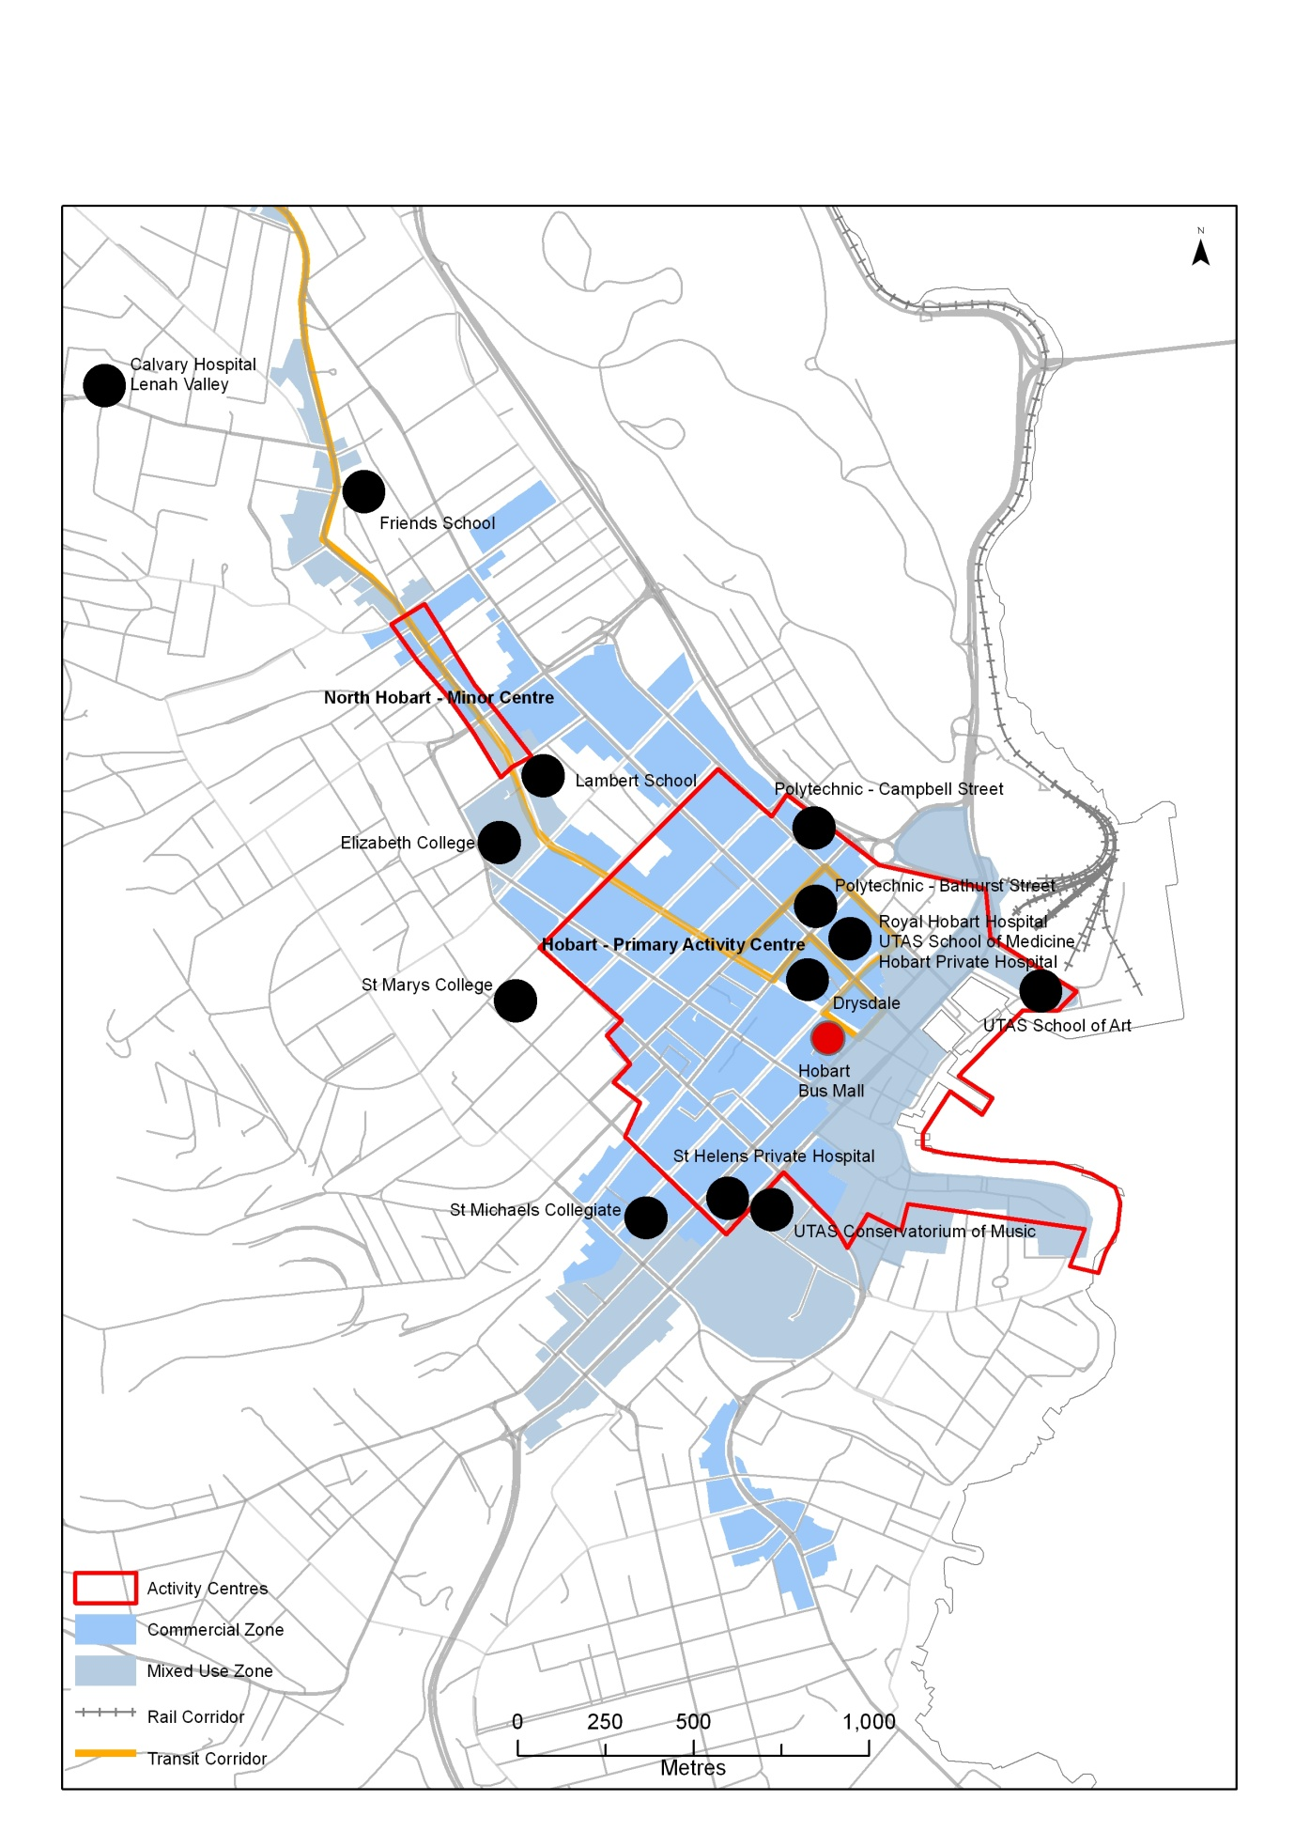

# The case for more compact and mixed use development patterns

While existing Planning Schemes in Greater Hobart make provisions for mixed use and infill residential development (especially around activity centres), the uptake of this has been slow outside the Hobart CBD. This is largely because the development market in Tasmania is geared towards Greenfield development. Greater Hobart also does not have the large scale infill and Greenfield development that occurs in other major cities; therefore there have been no formal requirements to create mixed use development precincts.

Mixed use and more compact development is one way that the planning system can respond to take advantage of existing transport infrastructure. For example, targeting development near existing high frequency public transport routes is a means to increase residential, employment, retail and entertainment activity within one place. These developments are known as ‘transit-oriented developments’, and typically occur around mass transit systems such as light rail or bus rapid transit.

Studies have found residents in transit-oriented developments have 50 percent less car use per household and save around 20 percent of their household income because they need one less car (Newman 2004). While Greater Hobart does not have a true mass transit system, there are opportunities to intensify development around high frequency Transit Corridors to create greater demand for the current public transport system.

Research undertaken by the New Zealand Transport Agency in 2012 also showed that residents of Auckland and Wellington living in inner urban areas are more likely to walk and use public transport for everyday trips, as opposed to using the car. Households living in these areas are also likely to own fewer cars. The research showed that while density on its own was insufficient to explain people’s travel behaviour and level of car ownership, when combined with mixed use development there was greater opportunity for residents to walk or catch public transport and drive less than residents who lived in lower density areas with fewer trip attractors.

Increasing densities in urban areas has advantages from an economic perspective, in terms of maximising the use of existing infrastructure such as public transport and physical infrastructure such as water, sewerage, electricity, schools and community facilities. Density also provides economies of scale to support new commercial developments, thus leading to economic renewal in inner urban areas.

Demographic change, such as smaller household size and population ageing, will drive demand for a greater diversity in housing stock. Infill development is more suitable in terms of providing for a diversity of housing needs and meeting the challenges of demographic change, as it provides opportunities for smaller housing close to services rather than building new dwellings in Greenfield sites remote from services.

Figure The economic, social and environmental benefits of infill and mixed use development

|  |  |  |
| --- | --- | --- |
| **Economic** | **Social** | **Environmental** |
| Redeveloping underutilised inner urban land for higher order land uses resulting in urban renewal of inner urban areas. | Meeting the demand for affordable housing and providing opportunities for greater diversity of housing choice in locations with good access to services and public transport. | Minimising the impacts of urban development on biodiversity, habitat loss, reduced water quality and loss of productive agricultural land. |
| More efficient use of existing infrastructure by concentrating users and transport services in more compact areas, rather than providing new infrastructure to low density areas. | A more accessible and connected community with better access to services which will reduce social exclusion. | Reduction in greenhouse gas emissions by reducing reliance on the car for travel, as alternative modes of transport are more accessible. |
| As density increases, the cost of infrastructure per dwelling decreases. Infrastructure costs also tend to be higher in servicing outer urban areas as a result of distance and lower densities. | A more liveable and vibrant community with a greater proportion of people living close to services and activities. |  |
| Provision of new infrastructure has ongoing costs associated with operating and maintenance. While developers may contribute towards the cost of new infrastructure, they are not responsible for ongoing maintenance and operating costs. | A more healthy community by providing people with opportunities to walk or cycle as part of daily trip making. |  |
| A higher population density will generate a greater market demand to support existing and new businesses and make public transport services more economically viable. |  |  |
| Reducing exposure to oil price vulnerability by providing people with more accessible transport choices. |  |  |
| Reduction in travel costs and car ownership levels means people have more disposable income to spend on other activities. |  |  |

## Cost of infill development

Recent research by Curtin University of Technology and Parsons Brinckerhoff highlighted the cost of fringe residential development versus infill. The cost of infrastructure provision was drawn from a study called ‘Future Perth’, which gathered data from case studies in United States, Canada, and Australia. The report found that the cost to service new lots in terms of provision of utilities, community services and transport by Government in Australia was:

* Urban fringe: $80,000 per lot.
* Infill development: $26,000 per lot.

While developers do pay contributions towards the cost of servicing new lots, the contributions do not reflect the true cost of infrastructure provision, particularly the cumulative impacts on transport networks and provision of public transport. In Tasmania there is not a consistent ‘headworks’ policy across local Government, or even within State Government agencies.

The Curtin University report highlighted, that as density increases, the infrastructure costs per dwelling decrease through either utilising excess capacity or requiring less of the service (because of shorter distances and greater compactness).

Based on research by SGS in 2003, road construction is the most significant infrastructure cost between fringe and infill development, with costs being 50 percent higher for urban fringe development.

While the cost of infill development may be less expensive to Government, the cost of constructing an infill dwelling is often more expensive for the developer than constructing an average Greenfield dwelling. Research by the National Australian Housing Supply Council in 2010 highlighted that an average infill dwelling costs around $136 400 more to construct than an equivalent Greenfield dwelling.

The main reasons for this cost difference are:

* Higher construction costs for medium and high density dwellings compared with single detached dwellings, including cost of land, demolition and higher building standards.
* Difficulties in aggregating and preparing land for development eg infill sites tend to have multiple titles in different ownership.
* Delays in securing development finance, as infill developments typically contain more dwellings and the capital outlay is greater.
* Lengthy and sometimes uncertain planning and development assessment processes.
* Community opposition to infill and to medium and high density dwellings, causing delays in the planning process.

The cost differences in constructing infill and Greenfield dwellings will need to be overcome if infill development is to become a viable option in Greater Hobart. The barriers to infill development will need to be closely explored by both State and local Government.

# Strategic planning to support infill development

The*Southern Tasmania Regional Land Use Strategy* is the overarching document to guide future settlement patterns in Greater Hobart. The Strategy reflects the concept of Transit Corridors and increasing residential densities in inner urban areas.

The Strategy outlines a Greater Hobart Residential Strategy to manage residential growth by establishing a 20 year urban growth boundary and proceeding on the basis of a 50/50 ratio of Greenfield to infill development. The Strategy identifies the following infill targets:

* Glenorchy City Council: 40 percent infill (5300 dwellings).
* Hobart City Council: 25 percent infill (3312 dwellings).

The Strategy recommends an Infill Development Program to identify key redevelopment opportunities, without relying upon small scale subdivision and unit development to promote these changes. The challenge will be in ensuring implementation of the Strategy occurs in respect of meeting the infill targets.

The table below highlights what is required for this Strategy to be successful.

Figure Infill Development Program requirements

|  |  |
| --- | --- |
| **Urban growth boundary -** control of low density, rural and environmental living opportunities outside of the Urban Growth Boundary, particularly within ‘commutable’ distance. | **Provision of high quality open spaces -** to support theamenity of higher density living. |
| **Reduction in regulatory barriers -** to multiple dwellings and higher density development within Planning Schemes. | **Crown land** **coordination** - the coordination of use and development of Crown Land within Greater Hobart. |
| **Identification of high density residential opportunities** - particularlyon greyfield and brownfield sites. | **Community education -** to dispel common negative myths about multiple dwelling development and promoting the importance of higher urban densities. |
| **Cooperation between the public and private sector** - to develop majorgreyfield and brownfield sites. | **Consistent developer charges** - for physical infrastructure that reflects long term cost benefits of higher densities and developing existing serviced areas. |
| **Affordable housing** - specific Government initiatives to assist in increasing the stock of affordable housing. | **Minimising construction costs -** of infill development by reviewing State and local Government taxes, fees and charges that contribute to development costs. |
| **Non-government regulated influences** -measures to encourage financial institutions tolend money for infill development. | **Monitoring and review** - achievement of the Greenfield and infill targets will require regular monitoring and review. |

Source: Based on STCA, 2011

The Draft *Capital City Plan* incorporates the policies and strategic directions of the *Southern Regional Land Use Strategy.* Therefore the Plan supports the concept of infill and mixed use adjacent to Transit Corridors and activity centres.

## Planning Scheme provisions

The Planning Scheme provides the primary statutory tools for influencing density in particular locations through zoning and development control. Both Glenorchy and Hobart City Councils are in the process of creating new Planning Schemes. These Schemes will need to be based on the Regional Model Planning Scheme which is currently under development by the STCA and due for completion in early 2013.

At this stage it is anticipated that the Planning Schemes will contain the following provisions to encourage infill development:

* Application of the Inner Residential Zone within 400m of the Transit Corridor and within 800 metres of Moonah and Glenorchy activity centres on land currently zoned Residential in Glenorchy City Council.
* Application of the Inner Residential Zone on land currently zoned Residential 1, 3, 4 which includes the suburbs of West Hobart, North Hobart and New Town in Hobart City Council.
* The development standards for the Inner Residential Zone encourage a minimum density of 25 dwellings per hectare (net density).
* Provisions to encourage mixed use development and higher density in activity centres.
* Development of a Multiple Dwelling Code.

## Identification of high residential density opportunities

The *Southern Regional Land Use Strategy* identifies land around the Transit Corridor as an infill area. The first step is to identify sites along the Corridor that could potentially be developed for higher density residential uses. This enables a clearer understanding of what the future dwelling density and population capacity of the Corridor will be.

A GIS model has been developed to identify sites which are potentially developable for infill development. Stage Two of the Transit Corridor project will outline the results of the model and consider different development scenarios, including conversion of light industrial land between Glenorchy and Moonah for infill residential development.



**Department of Infrastructure, Energy and Resources**

10 Murray Street,

Hobart TAS 7001

Ph: 1300 135 513

Visit: www.dier.tas.gov.au