
Glenorchy to Hobart CBD Transit Corridor
Transit Corridor Assessment Report – Stage one

Walking and Cycling

Summary report

Department of Infrastructure, Energy and Resources
July 2012

CONTENTS

1 Key points 3
2 The role of walking and cycling on the Transit Corridor 4
3 Walking and cycling travel distances 4
3.1 Walking and cycling to public transport 4
3.2 Travel distances to access work and education 7
4 Walking 8
4.1 Pedestrian connections to bus stops in Activity Centres 8
4.1.1 Findings of pedestrian access assessment 9
5 Cycling 9
5.1 Cycling needs 10
5.2 Cycling gap analysis workshop 13
5.3 Bicycle parking 13

Key points
This report highlights key issues regarding walking and cycling with access to and along the Transit Corridor.
- Walking and cycling travel distances:
- Research shows that the time required to travel to public transport stops is a key factor of influencing the community’s perceptions of whether public transport is a viable mode choice. Land adjacent to the Corridor has a reasonable level of population density:
    - 18 090 people live within walking distance (0-800 metres).
    - 60 940 people live within cycling distance (3.2 kilometres).
- The majority of suburbs adjacent to the Transit Corridor are within cycling distance to the Hobart CBD (30 minutes travel time for work), meaning that there is no impediment from a distance perspective in people riding to work. However there may be other impediments in terms of safety and connectivity.
- Quality of supporting infrastructure for pedestrians:
  - All public transport trips have a walking component, even if another mode is used to access public transport.
  - The Transit Corridor project focuses on improving pedestrian linkages to bus stops to facilitate modal change. Bus stop infrastructure is an important component of the operation of the bus system and the community’s perception of it.
  - Ten bus stops along the Corridor were selected for assessment based on the volume of boardings. The key issues identified at bus stops for pedestrians included:
  - Lack of route map information and locality maps.
  - Pedestrian congestion at bus stops due to narrow footpaths, location of waiting areas and volumes of through pedestrian traffic.
  - Poor pedestrian connections and way-finding.
  - Inconsistency in the type of shelter and seating.
  - Inadequate bus stop lengths – creating difficulties for buses to stop close and parallel to the kerb.
  - Low kerb heights, making boardings difficult for some passengers.
- Cycling networks:
  - Research indicates that cycling mode share can be increased if cycle routes are safe and connected.
  - The Greater Hobart Principal Urban Cycling Network and the Arterial Bike Network identify existing and proposed cycling routes which facilitate access to the Transit Corridor. However, there are several key points where connectivity between the Corridor and the existing cycle infrastructure is poor.
  - A gap analysis identified a number of new routes to connect adjacent suburbs to the Corridor and the existing cycle infrastructure. In some instances improved connectivity will require traffic engineering interventions that make cycling safer and more convenient, whereas in other places connectivity might be addressed by appropriate signage of cycle friendly streets and paths that already exist.
- Bicycle parking:
  - Existing bicycle parking facilities along the Transit Corridor are limited in number and location, mainly comprising hoops in activity centres, which are more appropriate for short-term parking.
  - There is currently no evidence of people combining cycling with a public transport trip along the Corridor. This may be because there is no secure bicycle parking along the Corridor, except for secure parking at Argyle Street car park and bicycles cannot be transported on buses.

The role of walking and cycling on the Transit Corridor
The Transit Corridor is an attractor because of the number of activity centres and trip attractors along its length. It is also used as a through route for trips to other destinations.
People walk or cycle to the Transit Corridor for the following reasons:
- Access the attractions on the Corridor.
- Travel along the length of the Corridor.
- Connect to public transport routes along the Corridor.
Parallel routes to the Transit Corridor also exist for cycling (Inter-City Cycle Way and Argyle Street) to access key attractions along the Corridor. These routes are often used for longer trips or for safety and amenity reasons. Cycling along the Transit Corridor is necessary for short distances to access services, activity centres and public transport.

Walking and cycling travel distances

Walking and cycling to public transport
Research shows that the time required to travel to public transport stops is a key factor in perceptions of public transport being a viable mode choice. It is generally accepted that walking five minutes (400 metres) is an acceptable amount of time for people to access public transport, particularly for buses. People can be prepared to walk ten minutes (800 metres) if public transport has characteristics which minimise perceived waiting times; these characteristics include reliable and predictable services, high service frequency and quality supporting infrastructure, such as shelter and travel time information. The equivalent amount of time (10 minutes) for cyclists to access public transport is a distance of 3.2 kilometres (Ensor 2011).
The Transit Corridor has 18 090 people living within walking distance (0-800 metres) of the Main Road itself, which is 19 percent of Hobart and Glenorchy City Council’s population. The average population density within 0-800 metres of the Corridor is 16 people per hectare. This is above the Greater Hobart average of 12 people per hectare, but not as high as some other inner city areas of Hobart.
The population density within the Transit Corridor walking catchment is reasonable given that the majority of development directly adjacent to the Corridor is non-residential.
The number of people within cycling distance (3.2 km) of the Corridor is 60 940. Due to the linear pattern of development of Greater Hobart, the cycling catchment covers the majority of suburbs that are adjacent to the Corridor
The map below outlines the cycling and walking distances to the Corridor using the road network. The map shows that:
- Most of the Hobart CBD is within 400 metres of the Transit Corridor.
- New Town has the highest number of people living within 0-800 metres of the Corridor at 4570 people, followed by Moonah at 3250 people.
- A large proportion of the industrial land at Derwent Park and Moonah is within 800 metres of the Corridor.

Figure 1 Walking and cycling distances to the Transit Corridor
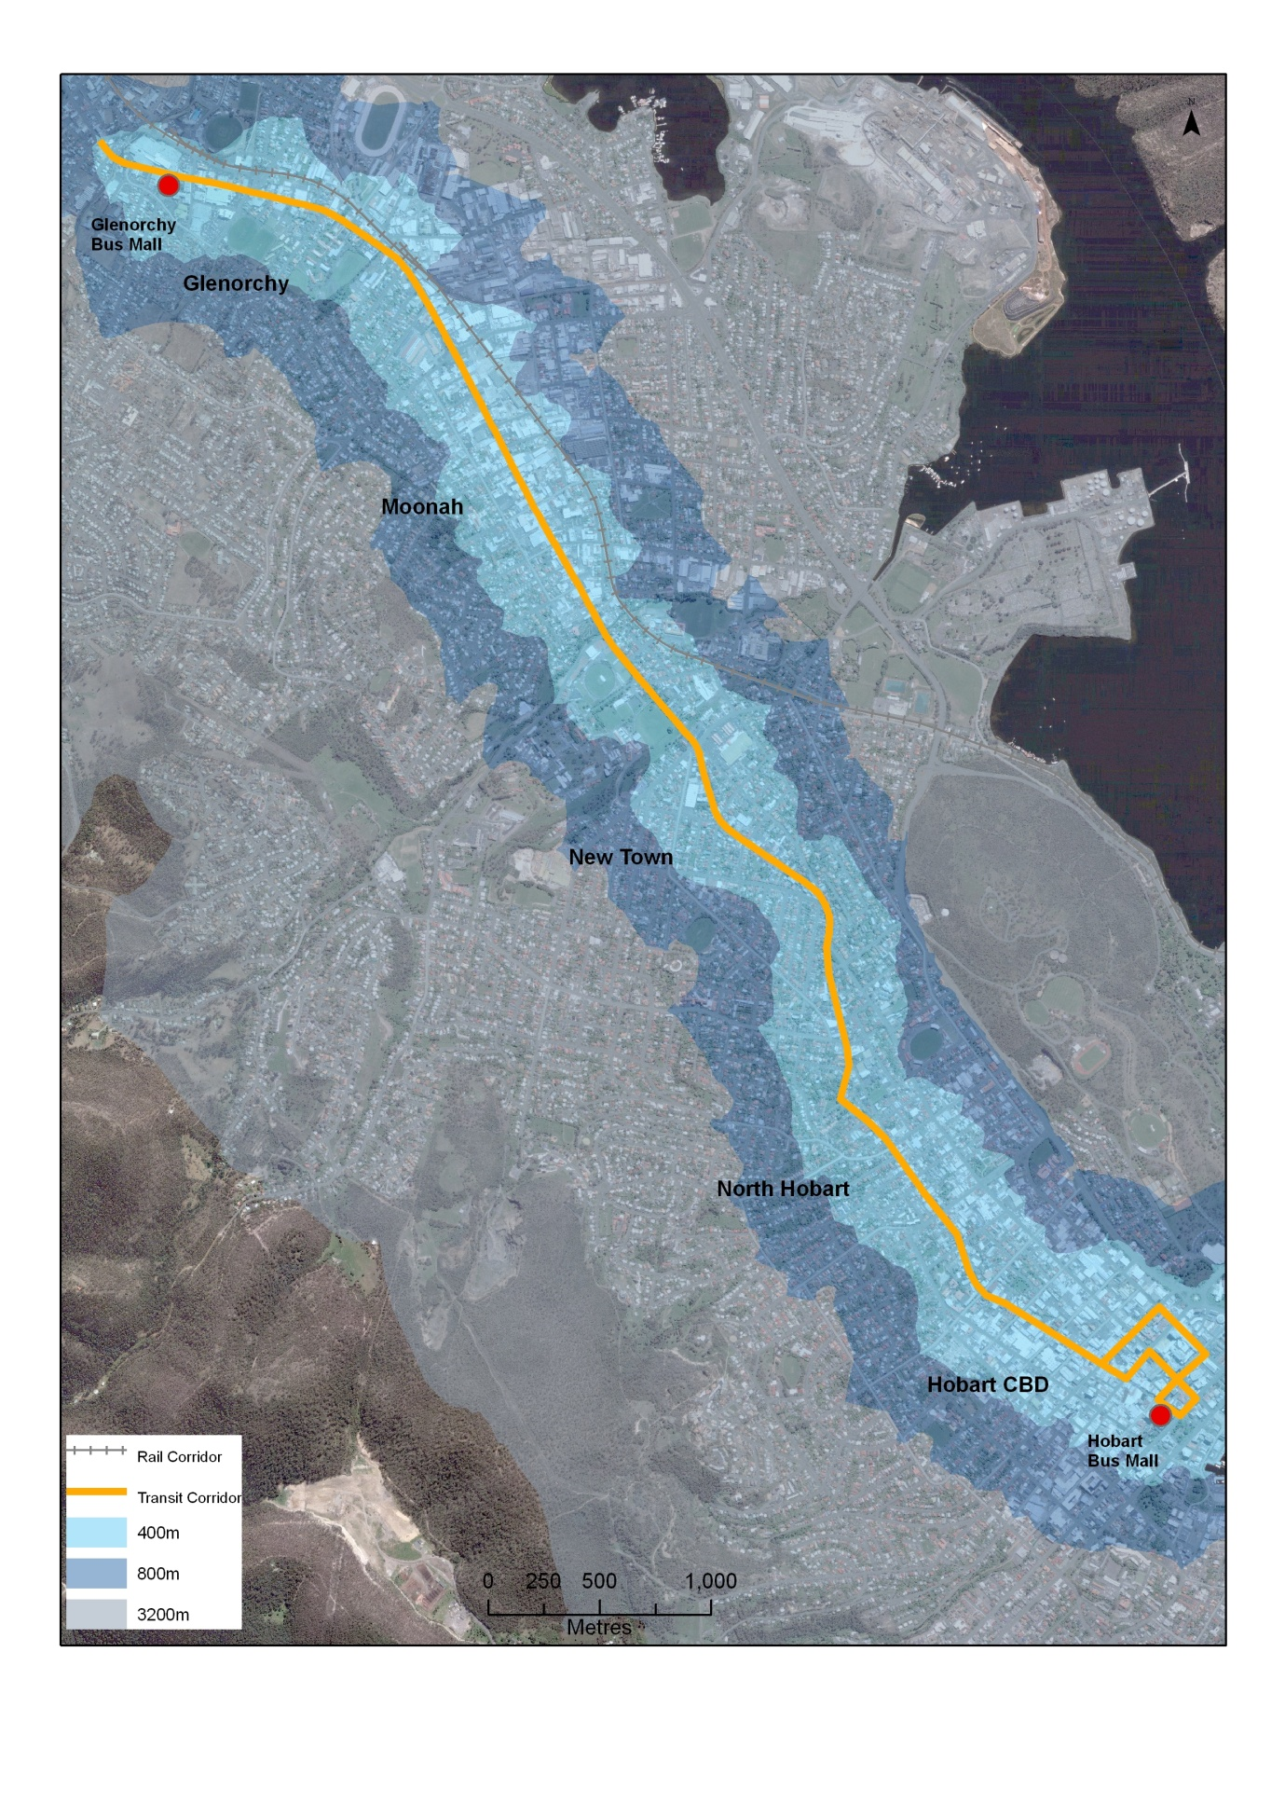

Travel distances to access work and education
Most people are prepared to travel longer distances to access places of work or education, regardless of mode choice. 30 minutes is generally accepted to be the maximum amount of time that people will travel to access these activities.
For walking, this translates to a distance of around three kilometres. The suburbs of West Hobart, North Hobart, southern parts of Mount Stuart and New Town are within 30 minutes walking distance of the Hobart CBD.
Journey to work data shows that these inner suburbs have a greater proportion of people walking to work than outer areas:
- Hobart CBD: 52.8 percent.
- North Hobart: 37.1 percent.
- West Hobart: 31.6 percent.
Suburbs within Glenorchy which are within walking distance of Glenorchy activity centre have a much lower proportion of people walking to work:
- Goodwood: 10.3 percent.
- Moonah: 9.2 percent.
- Derwent Park: 7.6 percent.
This could be as a result of Glenorchy having a lower employment density than Hobart CBD and because car parking is readily available and free.
Research also shows that most people are prepared to cycle up to 30 minutes (or around 10 kilometres) to access work or education. The majority of suburbs adjacent to the Corridor are within cycling distance to the Hobart CBD. However, the steeper topography in parts of Lenah Valley, West Moonah and Glenorchy may discourage some people cycling to work, as well as safety reasons.
The table below shows average cycle times, based on a standard level of fitness, between the Hobart CBD (Hobart GPO) and identified destinations on the Corridor using existing cycle infrastructure (the inter-city cycleway and the Argyle Street bicycle lanes).
These cycle routes facilitate cycling journeys which are of a length that is within the 30 minute timeframe that people will spend travelling to work, between key points on the Corridor and the Hobart GPO.
Figure 2 Average commuter cycling travel times
Destination | Route | Travel Time AM (8.15 -8.45) Minutes- inward | Travel Time PM (5.00 -5.30) Minutes - outward
Hobart CBD to North Hobart (Corner Elizabeth/Newdegate Street) | Argyle Street | 9 | 9
Hobart CBD to New Town (Corner New Town Road and Argyle Street) | Argyle Street | 12 | 11
Hobart CBD to New Town (Corner Bay Street and inter-city cycleway) | Inter-City Cycle Way | 15 | 17
Hobart CBD to Moonah (Corner Hopkins Street and inter-city cycleway) | Inter-City Cycle Way | 20 | 22
Hobart CBD to Moonah (Corner Derwent Park Road and inter-city cycleway) | Inter-City Cycle Way | 23 | 25
Hobart CBD to Glenorchy (Corner Elwick Road and Inter-City Cycle Way) | Inter-City Cycle Way | 29 | 30

Walking
Walking is the second most popular form of travel in Greater Hobart, representing 20 percent of household trips during the week (Greater Hobart Household Travel Survey 2008/09). Walking is an essential mode of transport for those households that do not have a car, or are single car households. Walking has many benefits including:
- Improving health outcomes.
- Affordability.
- Improving social outcomes, by encouraging more interaction and enabling people to spend time in public places, which tends to make these places safer and more vibrant.
All public transport trips have a walking component, even if another mode is used to access public transport. Therefore it is critical that walking connections to the Corridor is improved. Creating a walkable environment also has the potential to increase the catchment area of public transport services.
The walkability of an area is dependent on a number of factors, including:
- Street layout: can affect pedestrian permeability and connectivity, for example a street layout based on cul-de-sacs means pedestrians have to travel further to reach destinations. Pedestrians generally prefer the shortest and most direct route to bus stops.
- Topography: steep gradients can deter people from using certain routes and reduce the walking catchment of an area.
- Safety: routes which are perceived to be unsafe through poor passive surveillance and lighting can reduce walkable catchments. Conflict with other road users is also a concern for pedestrians.
- Infrastructure: poor quality surfaces can restrict users with limited mobility. Pedestrians need to be able to safely cross high traffic volume roads, without undue delay in their journey by means of supporting infrastructure, including traffic lights or pedestrian refuges.
- Amenity: the quality of public spaces as a result of traffic noise and poor urban design can create an unattractive walking environment, discouraging pedestrians.
- Way finding: measures such as signage or well delineated routes can link trip attractors in a logical way, improving a person’s ability to walk easily and safely between locations.
In Melbourne, under the ‘SmartRoads’ network management approach, pedestrians are given higher priority in activity centres than other modes of transport, generally because there are higher volumes of pedestrians in these areas and there is a need to encourage these public spaces as places for people.

Pedestrian connections to bus stops in Activity Centres
The Transit Corridor project focuses on improving pedestrian linkages to bus stops to facilitate modal change.
As there are 66 bus stops on the Transit Corridor, it was not feasible to assess pedestrian connections to all stops. Rather, the focus is on assessing bus stops which have a high number of boardings; typically these occur in activity centres or near high trip attractors. Ten bus stops were selected for assessment based on the above factors, including an assessment of the potential movement of the Springfield Depot inward bus stop to a location on Main Road.

Findings of pedestrian access assessment
The pedestrian access assessment identified a number of issues common throughout the Transit Corridor, including:
- Lack of route map information and locality maps.
- Pedestrian congestion at bus stops due to narrow footpaths, location of waiting areas and volumes of through pedestrian traffic.
- Poor pedestrian connections and wayfinding.
- Inconsistency in the type of shelter and seating.
- Inadequate bus stop lengths – creating difficulties for buses to stop close to and parallel to the kerb.
- Low kerb heights, making boardings difficult for some passengers.
The results of the pedestrian assessment are attached at Appendix B: Pedestrian Access Assessment Report.

Cycling
Cycling has a low mode share in the journey to work, with only 0.9 percent of Greater Hobart residents cycling to work (ABS 2006). Despite the low mode share, the number of people cycling to work has been steadily increasing over the last decade. The graph below shows that inner suburbs have a greater proportion of people cycling to work. North Hobart has the highest mode share for cycling at 3 percent.
The journey to work data shows that a much higher proportion of males cycle, compared to females. There is little evidence within the data of people using two modes (eg cycling and bus) to travel to work. This could be because there is no secure bicycle parking along the Corridor except for the Hobart CBD and there are no mechanisms to effectively transport bicycles on buses.
Cycling can be used to expand the effective public transport catchment of an area. All suburbs adjacent to the Transit Corridor are within cycling distance (3.2 kilometres) to not only the nearest bus stop on the Corridor, but also the nearest activity centre. This means that if people want to combine cycling and public transport as part of a multi-modal trip, there is no impedient from a distance perspective.
People are more likely to combine cycling as part of a public transport trip if secure bicycle parking facilities are provided at major bus stops along the Corridor. Given that there is little evidence of people currently combining cycling and public transport, a better approach would be to provide secure parking at major bus stops within activity centres to also benefit people visiting activity centres for shopping, entertainment or social purposes.

Figure 3 Journey to work mode share by suburb for cycling
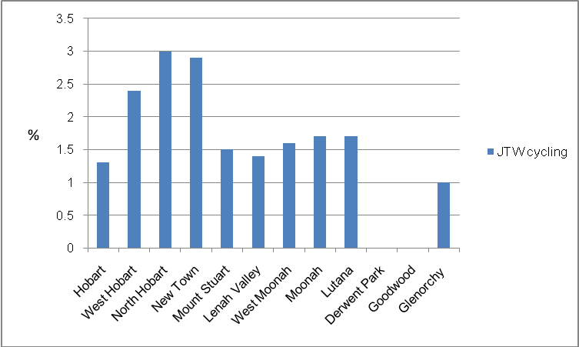
Source: ABS 2006

Cycling needs
Research indicates that the mode share of cycling can be increased if cycle routes are safe and connected.
The needs of cyclists are diverse, and vary according to age, levels of mobility, experience and confidence. For example, experienced cyclists commuting to work are likely to prefer fast and direct on-road facilities, whereas children riding to school, or less experienced adult cyclists may prefer off-road facilities or riding on the footpath.
It is not possible to cater for all users in all situations; however, infrastructure and the built environment must be designed so that it is attractive to a wide range of users. Providing safe, well-connected cycling infrastructure, whether on or off-road, encourages more people to cycle.
Safety considerations also apply to cycling along the Transit Corridor; safety perceptions will affect travel decisions for cyclists and potential cyclists. For cyclists, travelling along the Transit Corridor provides a direct route to trip attractors, but they may prefer alternative routes because of the volume of traffic movements, interactions with on-street parking and the number of intersections.
Alternative routes which run parallel to the Transit Corridor include:
- Inter-City Cycle Way: off-road dedicated cycle path and part of the Principal Urban Cycling Network. The route runs parallel to the Transit Corridor from Glenorchy bus mall to New Town. The route then deviates from the Transit Corridor as it follows the rail corridor along the Derwent River to the Hobart CBD.
- Argyle Street: on-road bicycle lanes and part of the Principal Urban Cycling Network. The route runs parallel to the Transit Corridor from the top end of North Hobart to the Hobart CBD.
The map below the outlines the Principal Urban Cycling Network and the Arterial Network:
- Arterial Network: based on the routes identified in The Hobart Regional Arterial Cycling Network Plan.
- Principal Urban Cycling Network: identified through a joint process between DIER, local Government and cycling stakeholders.
It should be noted that these documents are plans, and therefore some routes are only proposed and cycling infrastructure is not yet in place.

Figure 4 Cycling networks adjacent to the Transit Corridor
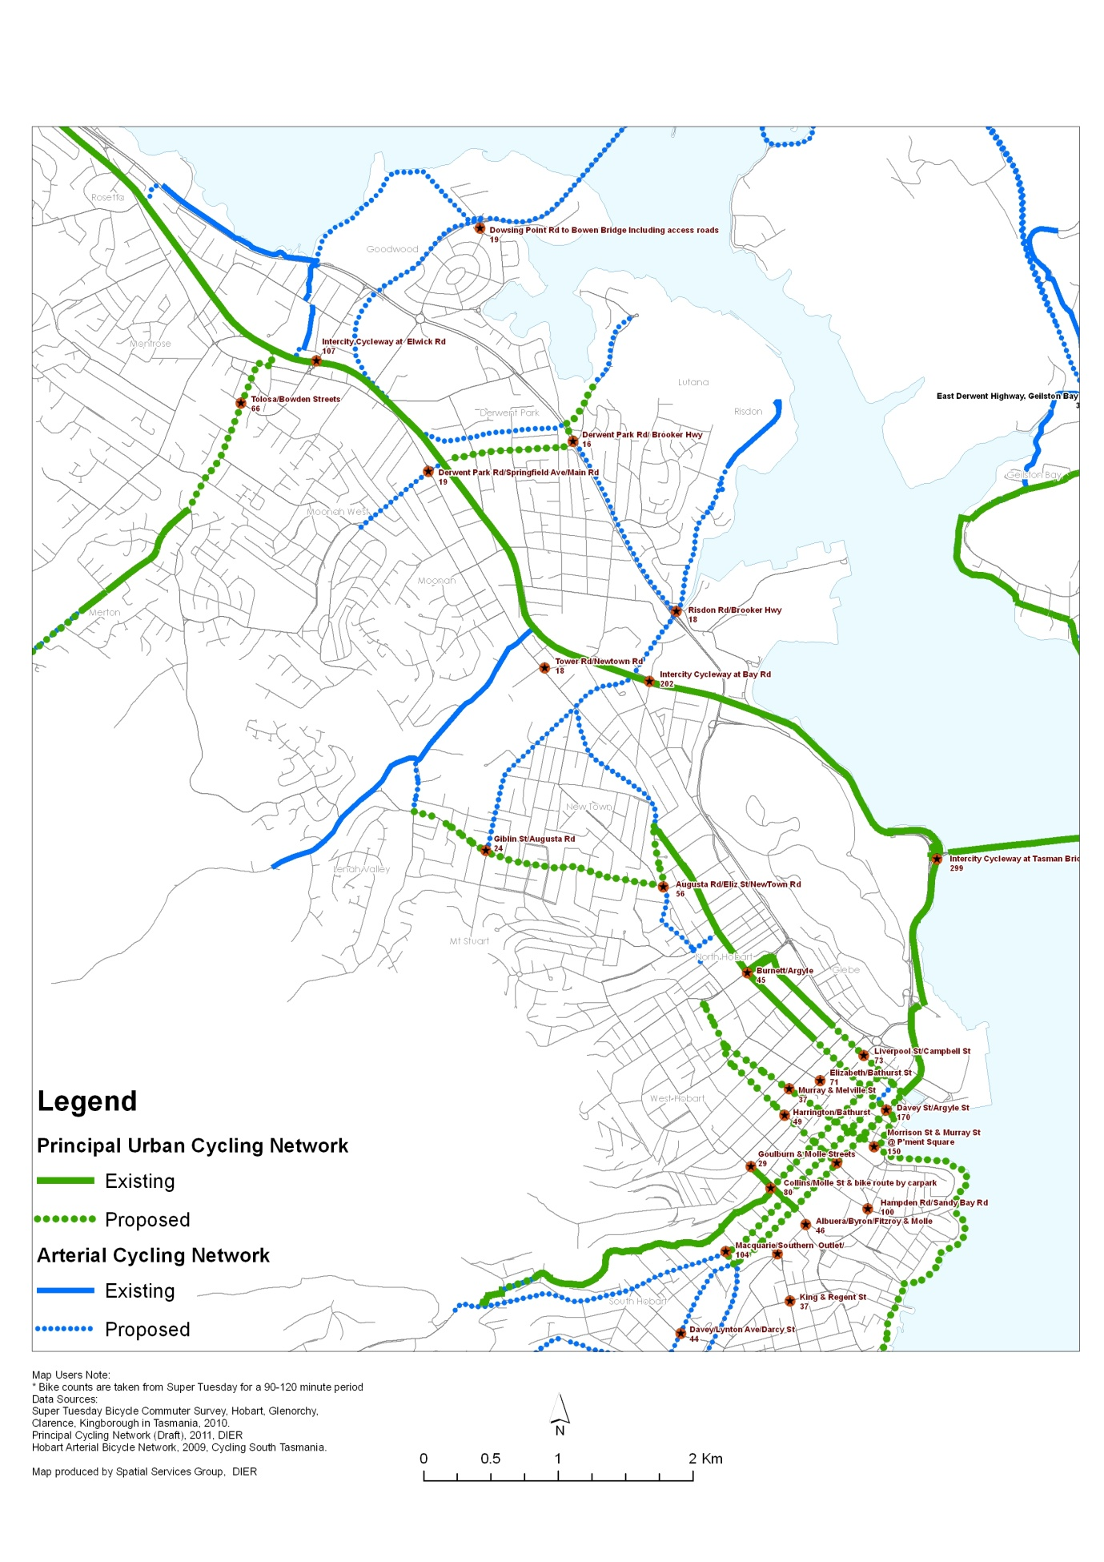

Cycling gap analysis workshop
Although the existing on-road and off-road cycle infrastructure provides access to the Transit Corridor at some locations, there are several key points where connectivity between the Corridor and the cycle network is poor, examples include connecting New Town to the Inter-City Cycle Way. In some instances, improved connectivity will require traffic engineering interventions that make cycle movements safer and more convenient, whereas in other places connectivity might be addressed by signage on cycle-friendly streets and paths that already exist.
A workshop with cycling stakeholders was held on 2 February 2012 to identify these gaps in connectivity. The workshop identified a number of potential new routes, including parallel routes to the Arterial Network, which may be better suited for cyclists. Routes which directly connected to the Transit Corridor and the Principal Urban Cycling Network were investigated further through site visits.
Appendix C: Cycling Infrastructure Assessment details the gaps identified at the workshop and the results of the site assessment.
Stage Two of the project will be the prioritisation of identified routes, taking into account factors such as the role of each route in achieving and supporting the objectives of the Transit Corridor, the ease and cost of implementation, and the likely demand for each route.

Bicycle parking
Existing bicycle parking facilities along the Transit Corridor are limited in number and location, mainly comprising hoops in activity centres, which are more appropriate for short-term parking. Figure 5 shows the location of bicycle facilities along the Corridor.
Short-term bicycle parking is most appropriately located within or very close to activity centres, and the existing distribution of hoops along the Transit Corridor generally follows this pattern. However there are currently limited short-term bicycle parking facilities at convenient locations in the Moonah activity centre (five hoops are located north of the core retail area, with three of these found in McDonalds alone).
Hobart City Council has recently approved additional bicycle parking within the Hobart activity centre (June 2012). There will be an additional three bicycle parking hoops located on the Transit Corridor (Elizabeth Street). The bicycle parking will comprise a ‘pole ring’, and the final location will be subject to discussion with adjacent property owners.
Further details on bicycle parking within the Corridor at located at Appendix B Cycling Infrastructure Assessment.

Figure 5 Bicycle parking along the Transit Corridor
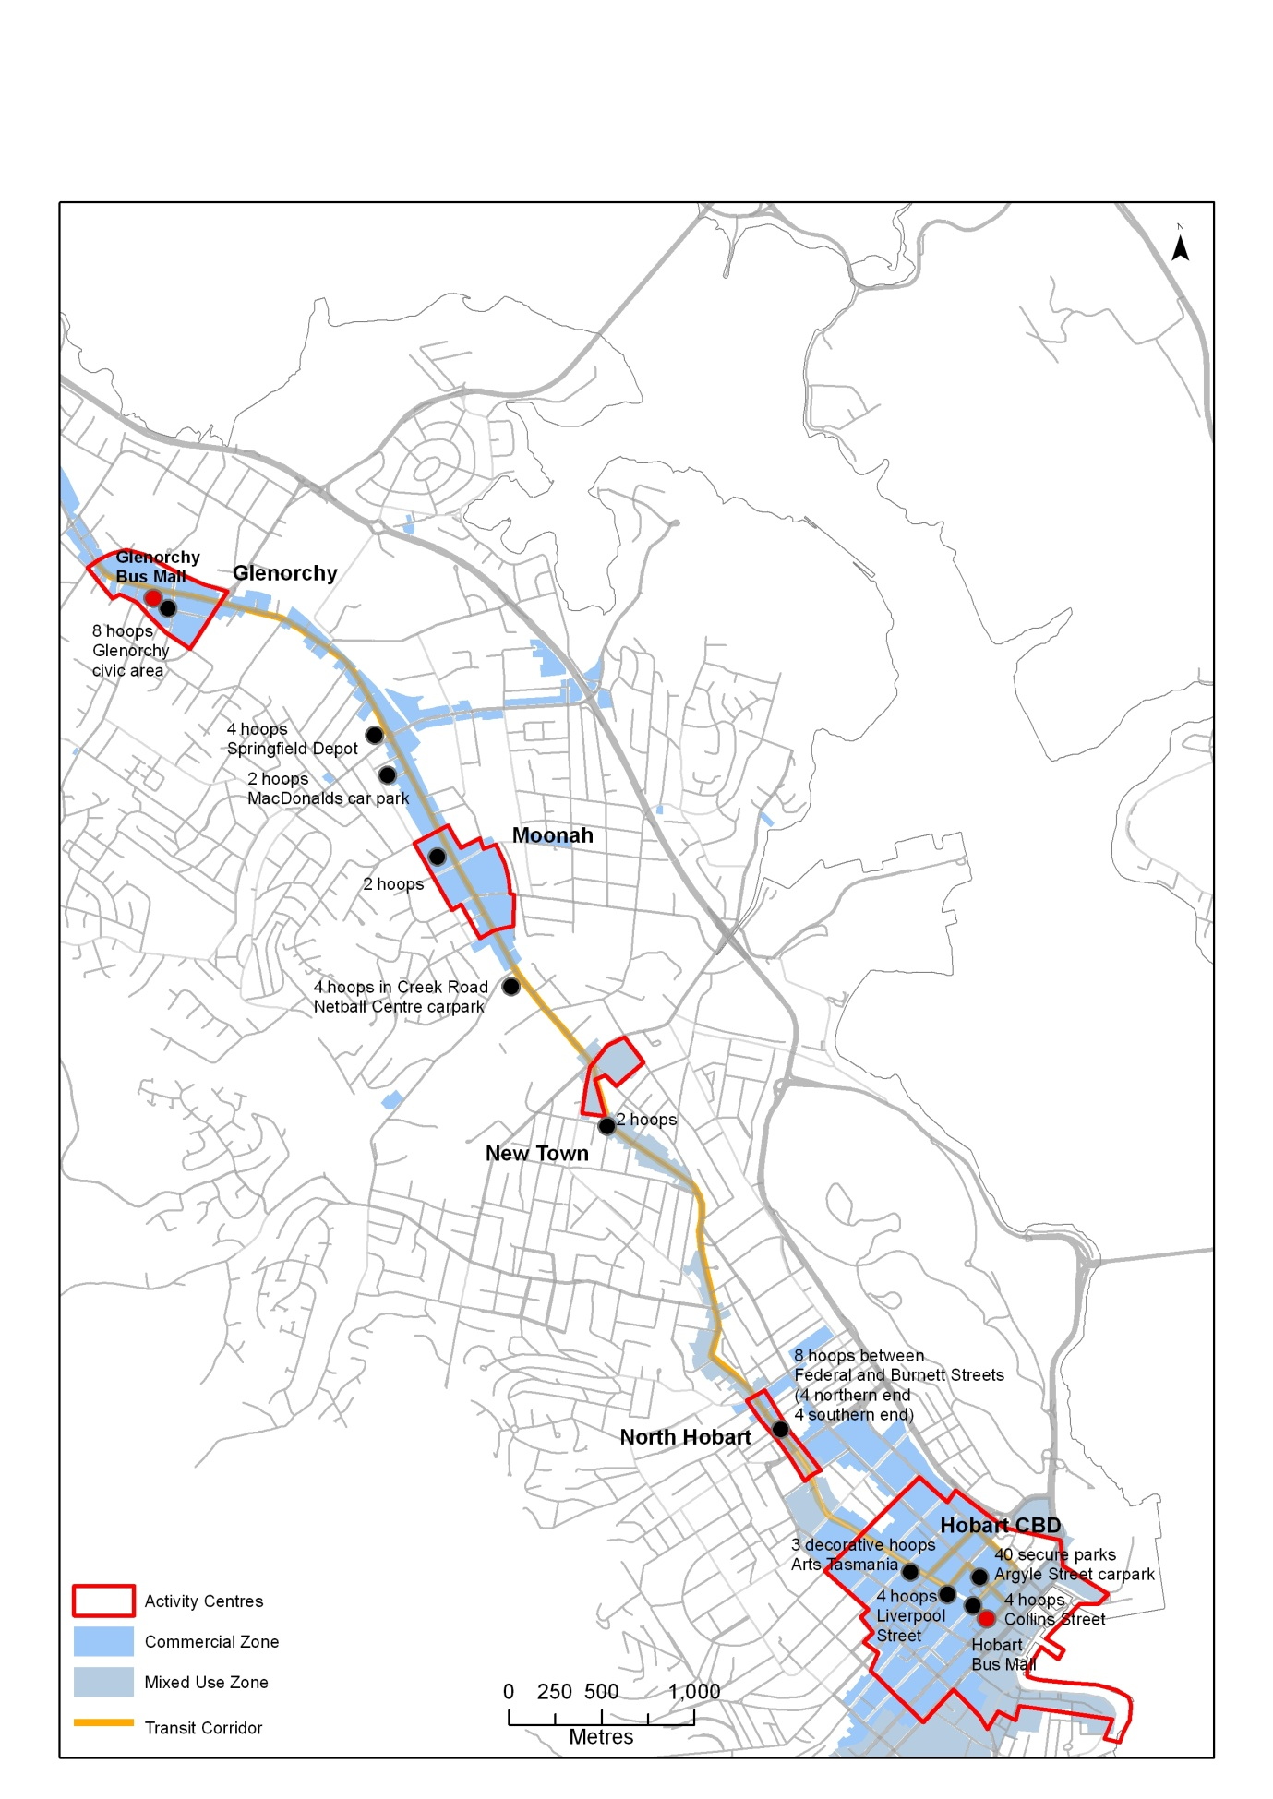



Department of Infrastructure, Energy and Resources

10 Murray Street,
Hobart TAS 7001
Ph: 1300 135 513
Visit: www.dier.tas.gov.au

