

Glenorchy to Hobart CBD Transit Corridor

Transit Corridor Assessment Report – Stage one

Project Background and Concept

**July 2012**

Department of Infrastructure, Energy and Resources

**CONTENTS**

1 Project context 3

1.1 Project Background 3

1.2 Focus on improving existing public transport system 3

1.3 What are Transit Corridors? 4

1.4 Glenorchy to Hobart CBD Transit Corridor Plan 5

1.4.1 High level review of corridor options in the Northern Suburbs 5

2 Project Objectives 6

2.1 Strategic transport policy and planning objectives 6

2.2 Project objectives and outcomes 6

2.3 Project outputs 7

3 Planning Framework 8

3.1 Project Outline 8

3.2 Project planning framework 8

4 Project Alignment with infrastructure and land use plans. 10

4.1 Australian Government policy and planning frameworks 12

4.1.1 Infrastructure Australia 12

4.1.2 National Urban Policy 12

4.2 State Government policy and planning frameworks 12

4.2.1 Tasmanian Infrastructure Strategy 12

4.2.2 Southern Integrated Transport Plan 13

4.2.3 Southern Regional Land Use Strategy 13

4.2.4 Capital City Plan 13

# Project context

## Project Background

The *Tasmanian Urban Passenger Transport Framework* describes the strategic direction for delivering better modal choice to people in urban areas. The Framework identified transit corridors as one of the key measures to improve public transport use.

The presumption underpinning the Framework is that consolidation of population density and activity is desirable around designated high frequency transit corridors which connect to the Hobart CBD. These corridors will need to be supported by high quality infrastructure to enhance the attractiveness and reliability of public transport. Land use change is also required to increase population density and activity around the corridors.

The *Hobart Passenger Transport Case Study*identified two major transit corridors in Greater Hobart based on function, population catchment andexisting service frequency:

* **Sandy Bay to Claremont**, passing through Sandy Bay, Hobart CBD and Glenorchy using Sandy Bay Road, New Town Road and Main Road.
* **South Hobart to Howrah**, passing through the Hobart CBD, Rosny and Bellerive using Macquarie Street, Tasman Highway, Rosny Hill Road, Cambridge Street and Clarence Street.

It is proposed that these corridors will be the focus for investment in public transport, walking and cycling infrastructure and for policies and strategies aimed at land use change.

Transitcorridorsare intended to target the wider passenger transport task, focusing on making public transport an attractive option throughout the day rather than specifically focusing on managing commuter demand in peak travel periods.

The weekday peak is only a proportion of the overall passenger transport task in Tasmania. If a meaningful change to travel behaviour is to be achieved, public transport must be able to offer a viable alternative for a broad range of trips throughout the day. Results from the *Greater Hobart Household Travel Survey* 2008/09 show that during the week; one third of trips are for work (32%), while shopping (22%) and recreation and entertainment (19%) are also important trips. Therefore it is important to consider and plan for this diversity of trip needs.

Transit corridors are intended to be the focal point for communities to develop around from a land use perspective both in terms of population and employment activity, rather than simply being a means of providing the fastest trip between two points.

## Focus on improving existing public transport system

The Framework emphasises the importance of increasing the demand for public transport as a proportion of total trip making. The Framework deliberately emphasises improving the existing public transport system, together with improving walking and cycling networks over the short to medium term.

The first priority is to reconsider the public transport product currently on offer, and ensure that the basic expectations on service frequency, accessible infrastructure, price, convenience and reliability are met.

The *Tasmanian Urban Passenger Framework* provides the policy and planning context for how passenger services should be developed over the long term to better meet metropolitan passenger needs. Over the long term, the Framework identifies light rail and bus rapid transit as desirable options, but only if demand for public transport exceeds, or is expected to exceed, the capacity of existing infrastructure and land use changes are likely to lead to greater densification of population around major corridors.

As a first step, the Framework recommends improving the frequency and reliability of public transport to increase demand on existing corridors. This is seen as the logical starting point to achieve a meaningful improvement in the mode share of public transport.

## What are Transit Corridors?

Transit corridors are existing high frequency public transport corridors that link key activity centres and are close to existing high density residential areas. Corridors need to have strong attractors within the corridor to encourage a mix of trips for work, shopping and to meet social needs.

Transit corridors need to pass through residential areas where there are high concentrations of people as opposed to supporting low density development. A higher concentration of people means that there will be a greater public transport catchment within walking distance of the corridor. Typically transit corridors will run along main streets as opposed to highways, as main streets are the locations where a greater number of people live, work or conduct their day to day activities.

The transit corridor project focuses on existing public transport corridors in order to maximise the use of investment in road based infrastructure and public transport services. Although bus systems are relatively flexible, it is difficult to change a route given people’s expectations and travel patterns.

The transit corridors will serve as public transport spines and infill development areas for Greater Hobart supporting higher densities and a greater mix of land uses consistent with the *Southern Regional Land Use Strategy*. The corridors will be focal point for investment in improving the public transport system.

Transit corridors need to maximise the potential for people to use public transport as part of their trip making purposes:

* Providing high frequency and quality public transport services between key activity centres and residential areas along the defined corridor.
* Providing supporting infrastructure to ensure public transport services are reliable and high quality.
* Improving information to public transport users to ensure services are easy to use and understand.
* Increasing population and activity through increased residential densities and mixed uses around defined corridors.
* Encouraging walking and cycling as part of trip making by creating better connections to walking and cycling routes.

## Glenorchy to Hobart CBD Transit Corridor Plan

The *Hobart Passenger Transport Case Study*identified Main Road, including New Town Road and Elizabeth Street as one of the major transit corridors in Greater Hobart based on its function, population catchment andexisting service frequency.

During the project scoping phase, criteria were identified for determining priority transit corridors. The criteria were as follows:

* + **Frequency of public transport services**: corridors must already have a high level of public transport frequency such as services running every 10 minutes or less during peak weekdays.
  + **Major trip attractors along corridor**: corridors must have two or more activity centres including the Hobart CBD and/or a major attractor such as a major educational institution. Preference was given to developing corridors which link to principal activity centres (Glenorchy, Rosny, Kingston) or major activity centres.
  + **Land use density:** transit corridors need to pass through areas with higher residential densities to create a greater demand for public transport.
  + **Transport disadvantage:** people who are transport disadvantaged are more likely to use public transport; therefore it would be beneficial if transit corridors included one or more areas of transport disadvantage.
  + **Travel patterns**: people’s travel patterns and mode share provides an indication of whether there will be demand for transit corridors along defined locations.

Based on the above scoring framework it was recommended that a Transit Corridor Plan be developed as a priority for the Glenorchy to Hobart CBD corridor, with the preferred route focusing on Main Road/New Town Road/Elizabeth Street.

### High level review of corridor options in the Northern Suburbs

The focus on Main Road as a Transit Corridor was confirmed through a high level review of the three corridor options in the Northern Suburbs which are the:

* Brooker Highway.
* Rail corridor.
* Main Road.

Based on this review it is recommended that Main Road should be the focus of the transit corridor investigation for the following reasons:

* The Brooker Highway is not a suitable transit corridor, as it is Hobart’s key urban highway with a high freight and car based passenger function as opposed to a core public transport route. Previous bus priority modelling on the highway indicated modest travel time benefits for buses, whilst cars would experience significant delays. The function of the Brooker Highway does not support increased land use density and activity around the corridor from a land use planning perspective.
* The rail corridor has been the subject of four separate studies that have assessed the potential role of the corridor for public transport. The transport issues, including public transport priority, potential stops and likely demand are well understood from these studies. The work completed to date suggests that the capital costs of refurbishing the rail corridor may outweigh the potential benefits of using the corridor.
* Main Road is an existing public transport route with a higher proportion of the population within walking distance of the corridor than other corridor options. It also contains major trip attractors and is integrated with surrounding land use patterns, such as high residential densities (in terms of Greater Hobart) and mixed use. The development of a transit corridor on Main Road is also likely to have significantly lower infrastructure and service delivery costs than implementing other options on the rail corridor.
* In spite of the high public transport patronage and service frequency, no serious analysis has been undertaken of what the Main Road can potentially deliver. Regardless of the ultimate decision on the rail corridor, public transport services will be likely to continue to be required from Glenorchy to Hobart via Main Road.

# Project Objectives

## Strategic transport policy and planning objectives

The *Tasmanian Urban Passenger Transport Framework* provides the overarching framework for delivering better modal choice to people in urban areas. The vision that underpins the Framework is*:*

***A safe and responsive passenger transport system that supports improved accessibility, liveability and health outcomes for our communities, in the context of the challenges of climate change.***

The framework is focused on improving outcomes in the following priority areas:

* Reduced greenhouse emissions.
* Liveable and accessible communities.
* Travel reliability.
* Healthy, active communities.
* Integrated transport and land use planning.

The Transit Corridor project is one of the recommendations from the Framework. Therefore objectives and outcomes for the Transit Corridors project have been developed to be consistent with the objectives and outcomes in the Framework.

## Project objectives and outcomes

***Overarching project objective***

To provide high quality public transport corridors and services in urban areas to encourage and support modal change, through guiding future Government investment along Transit Corridors and creating more supportive land use patterns.

***Specific project objectives***

* Improving the travel time reliability of public transport services.
* Improving public transport frequency, by ensuring that the corridor has services operating every 10 minutes or less during peak periods on weekdays.
* Making better use of existing urban road and public transport networks through sensibly sharing road space, targeted infrastructure upgrades and use of non-infrastructure solutions to support modal change.
* Improving people’s access to activity centres and key trip generators along the corridor.
* Creating additional public transport demand within the corridor through encouraging mixed use and higher residential development along the corridor.
* Ensuring public transport routes are easy to understand and consistent throughout the day.

The is:

Specific project objectives have been developed to provide clear direction on what

***Project outcomes***

* Reduced greenhouse gas emissions by encouraging the use of low carbon emission transport such as public transport, walking and cycling.
* Creating liveable and accessible communities through encouraging land use patterns that integrate with the public transport system to improve the attractiveness and effectiveness of public transport, walking and cycling options.
* Improved travel reliability by providing consistent travel times, in particular, the overall time of undertaking a journey, including waiting times for all users of the transport system.
* Creating healthy, active communities by encouraging use of walking and cycling trips either as part of a trip or for the total trip.
* Better integration of transport and land use planning to ensure transport and land use planning system are integrated and work together to support an attractive and effective passenger transport system.

***Project outputs***

* A Transit Corridor Plan, addressing public transport services and infrastructure needs including service frequency and reliability, adjacent land use opportunities and walking and cycling connections.
* The development of an agreed, systematic approach to transit corridor planning that can be applied to other transit corridors.

## Project outputs

# Planning Framework

## Project Outline

***Stage 1 Corridor assessment:***

* High level review of the three potential transit corridor options from Glenorchy to Hobart CBD, to confirm whether Main Road should be the focus of the transit corridor investigation. These corridors are the Brooker Highway, Main Road and the Rail Corridor.
* Provides the context for identifying existing problems on the corridor from a public transport perspective through undertaking a corridor audit. This approach enables us to have a better understanding of the issues in order to inform identification of options for improvement and develop effective and targeted solutions*.*

Output: High level review of corridor options report, Stage 1 corridor assessment report.

***Stage 2 Identification of corridor improvements and testing:***

* This stage will identify options for improving the corridor from a public transport perspective; it will include strategic analysis of potential options to identify the most suitable measures for the corridor.Some options will be investigated in greater detail to determine their effectiveness such as bus priority*.*

Output: Stage 2 corridor improvements report.

***Stage 3 Draft plan and implementation strategy:***

* The last stage will be the development of a draft Corridor Plan based on Stages 1 and 2. The Plan will outline identification of priority actions in terms of short, medium and long-term timeframes and outline specific tasks and responsibilities. It is envisaged that this phase will involve formal public consultation*.*

Output: Stage 3 Transit Corridor Plan.

Output: Stage 2 corridor improvements report.

## Project planning framework

The framework below is based on Infrastructure Australia’s reform and investment framework which sets out a process for identification of problems, option development and actions. Part of the option generation and assessment at a metropolitan level has been undertaken previously through the Light Rail Business Case and modelling of bus priority on the Brooker Highway. The high level review of corridor options in the Northern Suburbs confirmed that the focus of the Transit Corridor investigation should focus on Main Road.

During Stage Two of the project, the metropolitan options will need to be assessed against the Transit Corridor option.

Figure Project Planning Framework

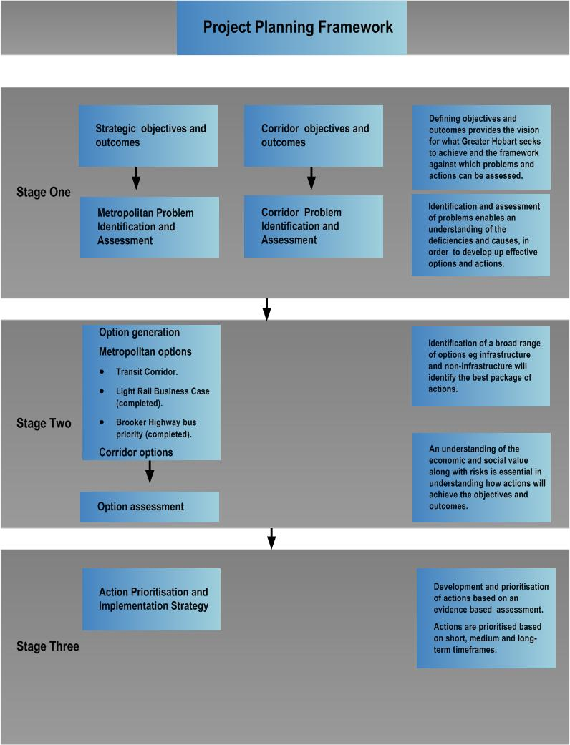

Adapted from Infrastructure Australia Reform and Investment Framework

# Project Alignment with infrastructure and land use plans.

The Transit Corridor Plan will need to link to existing strategic plans and policies and also to other strategic planning frameworks under development. To be successful transport and land use policy and plans need to support the development and operation of Transit Corridors, this includes regional and local settlement strategies, car parking provision and pricing and walking and cycling network plans.

Figure 2 provides an overview of the policy and planning hierarchy in Tasmania.

Figure Transit Corridor Plan relationship to other strategic planning projects

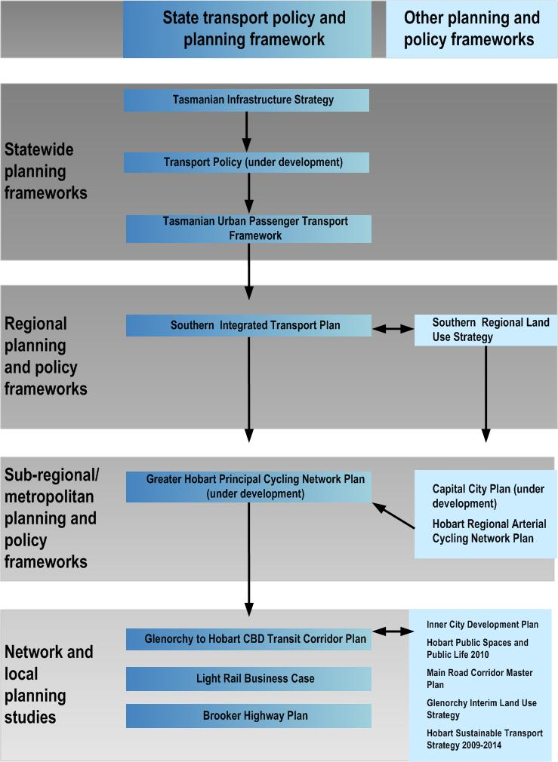

## Australian Government policy and planning frameworks

### Infrastructure Australia

Infrastructure Australia’s role is to advise the Australian Government on national infrastructure including transport infrastructure.The Transit Corridor project aligns with the principles set out in Infrastructure Australia’s theme for action ‘Transforming our Cities’. Infrastructure Australia in its 2011 report to the Council of Australian Governments (COAG) has developed principles for funding of urban road projects. These principles are:

* Making better use of existing networks.
* The efficient movement of freight.
* The efficient movement of road based public transport.

Infrastructure Australia states that it is highly unlikely to support funding for projects which do not meet these principles or provide mechanisms to recover the cost of the project through pricing or sending signals that influence demand.

The Transit Corridors project meets these principles in terms of making better use of existing networks, the efficient movement of public transport and sending signals to influence demand.

The Australian Government is also proposing to develop a *National Urban Public Transport Strategy*. This will include advice on new infrastructure and better use of the existing public transport system.

### National Urban Policy

The Australian Government has recently developed a *National Urban Policy* which sets out a number of important objectives and priorities to guide planning and development of our cities which focus on enhancing productivity, sustainability and liveability. The Transit Corridor project aligns with the following objectives and priorities in the *National Urban Policy*:

* Integrating planning of land use, social and economic infrastructure.
* Investing in urban passenger transport, particularly public transport.
* Improving accessibility and reducing dependence on private vehicles by improving public transport options and reducing travel demand by co-location of jobs, people and facilities.
* Locating housing close to facilities and services, including jobs and public transport, in more compact mixed use development.
* Improving the efficiency of urban infrastructure by utilising smart infrastructure and demand management to enhance the performance of existing infrastructure networks and reduce the need for costly new investment.

## State Government policy and planning frameworks

### Tasmanian Infrastructure Strategy

The *Tasmanian Infrastructure Strategy* provides the guiding framework for all infrastructure investment decisions across government. The Transit Corridor project is also consistent with the strategy as itfocuses on maximising the use of our existing transport network. Transit corridors will focus on making the best use of our existing investment in road based infrastructure and public transport services through the use of technology and innovation, demand management, land use planning and targeted infrastructure solutions.

### Southern Integrated Transport Plan

The *Southern Integrated Transport Plan* developed in partnership with the Southern Councils was released in 2010. The Plan provides the strategic framework for planning and investing in Southern Tasmania’s regional transport system over the next 20 years. The plan contains actions to implement the *Tasmanian Urban Passenger Transport Framework* including the transit corridor project. The plan contains objectives and strategies to encourage and support the greater use of passenger transport.

### Southern Regional Land Use Strategy

The Southern Tasmanian Councils Authority (STCA) in partnership with the State Government has developed the *Southern Tasmania Regional Land Use Strategy* which will guide future settlement patterns in Southern Tasmania. DIER has been working with the STCA to ensure the strategy reflects the actions in the *Tasmanian Urban Passenger Transport Framework* including increasing residential densities around designated high frequency public transport corridors.

The strategy targets the areas around the Transit Corridor and principal and primary activity centres for increased density of at least 25 dwellings per hectare. Infill development targets have been identified for:

* Glenorchy LGA: along the Transit Corridor; (5300 dwellings).
* Hobart LGA: North Hobart/New Town along Elizabeth Street/New Town Road corridor and Sandy Bay from CBD to UTAS; (3312 dwellings).

### Capital City Plan

In 2009, COAG announced reforms aimed at ensuring that all Australian capital cities would have comprehensive and integrated strategic plans in place by 2012. The State Government has prepared a draft Capital City Plan for Hobart which collates State, regional and local Government policies into a strategic document.

The plan develops an integrated strategic framework of actions and priorities to guide Government and utility providers in their investment and planning decisions. Objectives and directions in the Plan support the Transit Corridor concept.



**Department of Infrastructure, Energy and Resources**

10 Murray Street,

Hobart TAS 7001

Ph: 1300 135 513

Visit: www.dier.tas.gov.au