Tasmanian Development and Resources Board
Quarterly Summary Activity Report – 31 December 2024
Report to Minister for Business, Industry and Resources

The Board continues to provide strategic advice to government regarding key industry and economic growth matters.
The Tasmania Development and Resources Corporate Plan 2021-2024 is available on the State Growth website. The TDR Corporate Plan 2024-2027 is currently being finalised.
The Board’s focus areas include:
- administration of programs and assessment of applications for financial assistance to support strategic focus areas for growth agreed by the Tasmanian Government
- supporting industry sectors that have the capacity to accelerate growth in jobs and the Tasmanian economy, through the provision of strategic government support
- supporting the role of the Office of the Coordinator-General to identify opportunities, attract investment and encourage businesses to establish, relocate, diversify and expand in Tasmania
- provision of an advice and advisory role to the Tasmanian Government on matters relating to the policy objectives of the TDR and government.
During the quarter, the Coordinator-General presented on progress with current opportunities, the development of inputs into his Office’s work program, briefed the Board on potential future projects and brought forward proposals for the Board’s consideration.
Presentations included updates regarding Brand Tasmania’s latest research and the Launceston Private Hospital, a Government election commitment.
The Tasmanian Development Act 1983 is now being administered by the Minister for Business, Industry and Resources
The TDR General Purpose Financial Statements and the Independent Audit Report were noted.

A Case Study
ReadyTech Centre of Excellence
- In October, leading Australian software company, ReadyTech, proudly announced the opening of its new Launceston office and Centre of Excellence that will create new high quality job opportunities in Tasmania’s growing ICT sector.
- The Centre, located within St. Luke’s Health Wellness Hub on Cimitiere Street, is housed in a cross-laminated timber building that incorporates innovation and sustainability.
- ReadyTech’s new office was aided by support from the Tasmanian Development Board in 2021, that would see it expand in Launceston and develop a Centre of Excellence.
- The opening of the new office is an exciting milestone in ReadyTech’s journey in Tasmania as the company continues to further its investment in the state and create more opportunities for up-and-coming tech talent as part of its Centre of Excellence Strategy.
- The new workspace will see ReadyTech more than double its local workforce, growing to 90 staff, with many new roles focused on software engineering, AI and data science, product management and cybersecurity. The Company plans to partner with local education providers and collaborate with industry to develop tailored education and training programs.
- 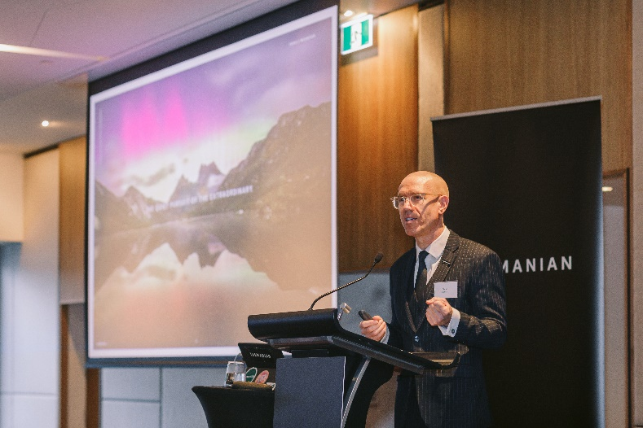
- Image Credit: Brand Tasmania

Reporting and Feedback on Board activities
The information provided here relates to any right to information requests and requests for ministerial response that relate to Board activities as well as a summary of any client complaints or stakeholder feedback received within the reported quarter.

Programs and Forthcoming Decisions
The Board activities in the next quarter will include the administration and assessment of key programs.
Regional Tourism Development Loan Scheme
December 2024 Quarter: 3 approvals totalling $4.65M
Current Approvals at 31 December 2024: 5 active approved loans totalling $5.05M
This $50 million scheme opened in June 2024 and is available to promote investment in tourism products and experiences that stimulate regional tourism and dispersal in Tasmania. Projects are assessed against priorities of the 2030 Visitor Economy Strategy including stimulation of year-round visitation, authenticity, sustainability, and accessibility. The minimum loan amount under this scheme is $100,000 and maximum loan amount is $3 million, with highly concessional interest rates for the first three years and with commercial rates to apply for the remaining term of up to two years.
AgriGrowth Loan Scheme
December 2024 Quarter: no new approvals
Current Approvals at 31 December 2024: 36 active approved loans totalling $33.95M
This $70 million scheme opened in August 2015 and is a longstanding scheme available to support agricultural projects that advance the Tasmanian Government’s AgriVision 2050 strategy – a strategy aimed at increasing the farm gate value of agriculture in Tasmania - as well as to support young farmers to pursue farming opportunities in their own right. The minimum loan amount under this scheme is $100,000 and the maximum loan amount is $3 million, with loans provided on a concessional basis. Loan applications will continue to be assessed in the coming quarter, with particular interest from young farmers in the dairy, beef and cropping sectors.
Business Growth Loan Scheme
December 2024 Quarter: no new approvals
Current approvals at 31 December 2024: 22 active approved loans totalling $6.44M
This $60 million scheme opened in September 2020 and is scheduled to close in December 2024 unless extended. The scheme is available to assist businesses in Tasmania to develop or expand, or undertake new projects, that promotes growth in the Tasmanian economy and align with the Tasmanian Government’s strategic objectives. The minimum loan amount under the scheme is $100,000 and maximum loan amount is $3 million, with loans provided at a concessional interest rate.

Tourism Development Loan Scheme
The Scheme closed in 2023 (no new approvals)
Current approvals at 30 December 2024: 20 approved loans totalling $20.4M
The $50 million scheme opened in August 2021 and closed in February 2023. Loan funds were available to assist the improvement and development of tourism products and experiences that supported Tasmania’s position as a sought-after and leading Australian destination, as well as to support the construction of worker accommodation by tourism operators. The minimum loan amount under the Scheme was $50,000 and the maximum loan amount was $2 million, with loans provided interest free for the first three years.

Building Construction Loan Scheme
The Scheme closed in 2021 (no new approvals)
The Program provides financial assistance to eligible Tasmanian projects that will engage commercial construction companies to create new, or improve existing, buildings and associated infrastructure and can commence quickly.
The Scheme opened for applications on 29 March 2021 and closed to new applicants on 30 September 2021. A total of $44.9 million of loans were approved.
The Office of the Coordinator-General undertook the assessment of applications in accordance with guidelines, presenting eligible applications for consideration by the Tasmania Development Board.
While the projects have progressed, due to the later impacts of Covid on the construction industry and the inflationary pressures, some projects have been delayed and/or required to undergo review to work through new tenders and construction delivery schedules.

