

Glenorchy to Hobart CBD Transit Corridor

Transit Corridor Assessment Report – Stage one

Executive Summary

Summary report

**July 2012**

Department of Infrastructure, Energy and Resources

## Project objective

To provide high quality public transport corridors and services in urban areas to encourage and support modal change, through guiding future Government investment along Transit Corridors and creating more supportive land use patterns.

## Three project stages

This series of reports forms part of Stage One of the project which is an evaluation of existing problems and issues on the Transit Corridor (Main Road, New Town Road and Elizabeth Street) to inform identification of options to develop it as a genuine Transit Corridor*.*

**Stage One:**

* High level review of Transit Corridor options from Glenorchy to Hobart CBD, completed November 2011: confirmed the focus of investigation on Main Road as a Transit Corridor.
* Transit Corridor Assessment Reports: identifies problems at the metropolitan and Transit Corridor level to inform identification of options for improvement.

**Stage Two:**

* Focuses onidentifying Corridor improvement options, including assessment of the most appropriate options.

**Stage Three:**

* Development of a draft Corridor Plan; outlining priority actions over the short, medium and long term. This stage involves formal public consultation*.*

## Metropolitan problem identification

There is a need to identify the problems with the sustainability of Greater Hobart’s current transport and land use planning systems to ensure that actions developed in the Glenorchy to Hobart CBD Transit Corridor Plan properly target these issues.

The problems identified below are experienced at the metropolitan planning level.

* **Population growth in outer urban areas:**
  + Places pressure on urban arterial road networks, as people living in these areas have high levels of car dependence and public transport services in these areas are limited compared to inner urban areas.
* **Low levels of population density:**
  + Greater Hobart has a dispersed settlement pattern with an average density of 12 people per hectare; this is well below the agreed national standard for effective delivery of public transport services (15 people per hectare).
  + This results in bus services needing to be planned on a low-frequency, high-penetration basis, creating long routes and travel times which are not competitive with the car.
* **An ageing population:** 
  + Tasmania has the oldest population profile in Australia and the population is projected to experience ageing more rapidly.
  + The transport needs of the aged are not well understood; public transport cannot always accommodate the needs of older people, especially those with restricted mobility.
* **Social exclusion:**
  + Lack of access to transport can affect people’s sense of wellbeing and quality of life leading to social exclusion. Transport plays an important role in making people feel connected with others and the community at large.
* **Low levels of physical activity:**
  + Currently, 69 percent of Tasmanians are not sufficiently active, which can lead to ill-health and disease. High levels of car dependency contribute to lower levels of physical activity.
* **High reliance on cars:**
  + Greater Hobart has a high reliance on cars, with 78.8 percent of journey to work trips undertaken by the car.
  + Relative under-investment in urban public transport has created a situation where the current services are spread too thinly and lack supporting infrastructure. As a result the public transport system does not provide an advantage over the car for the majority of the community.
* **Vulnerability to increases in oil prices:**
  + Tasmania’s transport system is heavily oil dependent and exposed to increases in oil prices and disruptions to supply. People living in outer urban areas without access to reliable public transport are particularly vulnerable.
* **Contribution to greenhouse gas emissions:**
  + Transport is the second largest producer of greenhouse gas emissions in Tasmania; 92 per cent of transport emissions come from road transport, with cars being the largest contributor.
* **Increasing cost of transport infrastructure:**
  + Tasmania has an extensive and ageing transport system, with high capital and recurrent maintenance costs.
  + Providing new roads induces new demand for private travel, which is ultimately counter-productive because the original level of congestion or higher will return in the longer term.

## Transit Corridor level problems

The Stage One reports highlights transport and land use planning problems at the Corridor level. Figure 1 provides an overview of the problems at the Corridor level.

Figure Transit Corridor level problems

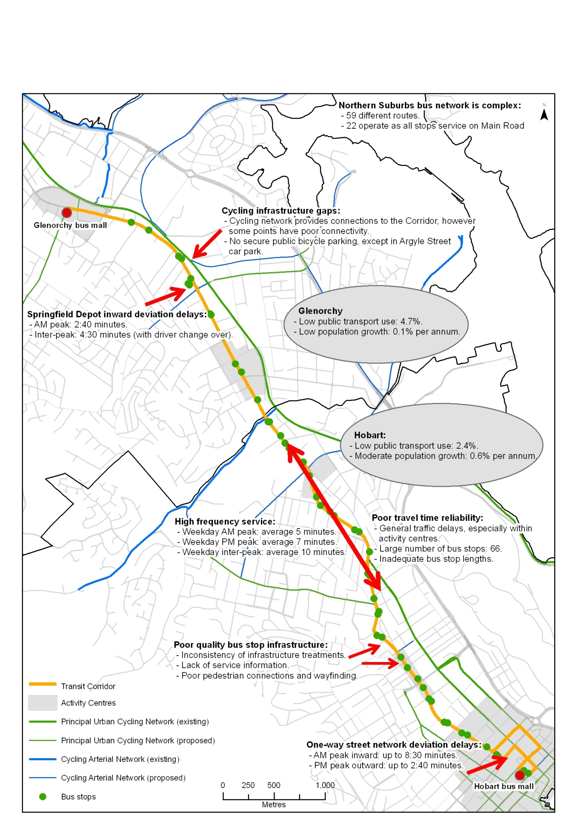

The problems at the Corridor level are:

* **Low levels of population growth in Glenorchy City Council in comparison to surrounding areas:**
  + Glenorchy is experiencing low population growth and is forecast to have static growth into the future. This low level of growth will affect the future demand for public transport along the Transit Corridor, a Corridor in which State Government is already investing substantially in public transport provision and where existing investment in activity by local Government and business is in place.
  + In order to maximise the State Government’s investment in existing infrastructure, growth needs to be targeted in these areas eg Hobart and Glenorchy.
  + Strategic land use plans are in place to encourage infill development in these areas. The challenge will be to ensure these plans are implemented.
* **Low levels of public transport use:**
* Residents living in the inner urban areas of Glenorchy and Hobart have more sustainable travel habits than the rest of Greater Hobart in terms of car ownership levels and use of public transport, walking and cycling. This can be attributed to these areas having more compact and mixed use development patterns, with a high number of trip attractors and lower travel distances.
* Despite moresustainable travel patterns in these suburbs,public transport use is still very low for all trips and car dependency is high.
* **The Northern Suburbs bus network is complex:**
  + The Northern Suburbs is serviced by multiple bus routes, with a number of different route variations. This makes the system complex and difficult for passengers and potential customers to quickly comprehend.
* **Demand for improved service frequency and temporal span:**
  + Service frequency and the associated reliability of that frequency have been found to be the most important factor affecting bus patronage in other Australian cities.
  + The Transit Corridor has one of the highest levels of bus frequency in Greater Hobart. However, there is justification in improving evening and weekend service frequency as well as providing services more consistently (harmonised timetables) over a seven day a week period. Weekday inter-peak frequency could also be improved in response to demand and capacity.
  + The temporal spread in service starting and finishing times also needs to be consistent across the week.
* **Poor travel time reliability for buses:**
  + Historically, cars have been given priority over other modes on Greater Hobart’s roads. This has resulted in poor travel time reliability for buses. Reliability on the Corridor is affected by:
    - General traffic delays: localised congestion especially during peak travel times.
    - Traffic conditions within activity centres: can affect the reliability of through traffic movements including buses.
    - The number and spacing of bus stops: there are 66 bus stops on the Corridor, which is an average of a bus stop every 250 metres.
    - Inadequate bus stop lengths: creates difficulties for buses merging back into traffic.
    - Deviations from the Corridor: the bus has to deviate from the Corridor through the Springfield Depot on the inward trip and via the Hobart CBD one-way street network on both the inward and outward trips.
  + Improving the reliability for buses is a key means of improving patronage. As road space is limited on Main Road, for genuine benefits to be gained, public transport will need to be given priority on certain sections.
* **Poor quality bus stop infrastructure and pedestrian links:**
  + There is an inconsistency of bus stop infrastructure treatments along the Corridor, including a lack of service information for public transport users and poor pedestrian connections and way-finding to bus stops.
* **Cycling infrastructure gaps:**
* Although the cycling network provides access to the Transit Corridor at some points, there are places where connectivity between the Corridor and the cycle network is poor.
* Existing bicycle parking facilities along the Transit Corridor are limited in number and location, mainly comprising hoops in activity centres, which are more appropriate for short-term parking. There is no secure public bicycle parking along the Corridor, except at the Hobart CBD.



**Department of Infrastructure, Energy and Resources**

10 Murray Street,

Hobart TAS 7001

Ph: 1300 135 513

Visit: www.dier.tas.gov.au