

Glenorchy to Hobart CBD Transit Corridor

Transit Corridor Assessment Report – Stage one

Public Transport

Summary report

**July 2012**

Department of Infrastructure, Energy and Resources

**CONTENTS**

1 Key points 3

2 History of public transport in the Northern Suburbs 4

2.1 Evolution of public transport on the Transit Corridor 4

2.2 Passenger rail 5

2.3 Competition between passenger rail and public transport 6

3 Low public transport use 6

4 Role of the Transit corridor as a public transport route 7

4.1 Northern Suburb services 7

4.2 Bus services using the Transit Corridor 9

5 Drivers of public transport demand 11

5.1 How public transport users perceive their cost of travel 11

5.1.1 Importance of bus frequency 11

5.1.2 Temporal coverage 12

5.1.3 Other factors 12

5.2 Level of frequency 12

5.2.1 Frequency harmonisation 13

5.2.2 Service reliability 14

5.3 Temporal span of services 14

6 Public transport patronage 15

6.1 Public transport patronage on the Transit Corridor by weekdays 15

6.2 Proportion of Northern Suburbs patronage using the Transit Corridor 17

6.3 Passenger utilisation of the Transit Corridor 18

6.4 Public transport patronage on express bus services 19

6.5 Transit Corridor patronage weekends 22

7 Bus stops 24

7.1 Bus stop boardings along the Transit Corridor 24

7.2 Passenger boardings from suburbs adjacent to the Transit Corridor 27

7.3 Bus stop optimisation 27

7.3.1 Transit Corridor bus stop placement 27

7.4 Bus stop infrastructure 28

7.5 Springfield Depot park and ride 28

# Key points

This report highlights key issues on the Transit Corridor from a public transport perspective:

* **Evolution of the Transit Corridor:**
  + The first significant step as a public transport route was in 1893 with the commencement of tram services.
  + The Corridor has historically, and continues to be, the core public transport route in Greater Hobart, accounting for around 20 percent of Greater Hobart’s public passenger boardings.
  + The public transport system has helped stimulate growth in the Northern Suburbs, with residential and commercial land use evolving around the Transit Corridor.
* **Role of the Transit Corridor:**
  + The Transit Corridor operates as a trunk route, with services using the Corridor for its entire length and services feeding into the Corridor at different points. It is both an important route for local trip making and ‘through’ movements linking the outer Northern Suburbs to Glenorchy and Hobart CBD.
* **Northern Suburbs bus services:**
  + The Northern Suburbs is serviced by multiple bus routes, with a number of different route variations; 22 of these routes operate as an all-stops service on the Transit Corridor.
  + The multitude of routes and variations makes the system overly complex and difficult for both current and potential passengers to quickly comprehend.
* **Transit Corridor frequency:**
  + Frequency and the associated reliability of that frequency have been found to be the most important factors influencing the level of public transport patronage.
  + The Transit Corridor has one of the highest levels of bus frequency in Greater Hobart and has comparable frequency to similar corridor services operating in other Australian cities.
  + However, improvements in early evening and weekend service frequency as well as providing services more consistently (harmonised timetables) over a seven day a week period can be justified. During the weekday inter-peak, a small increase in frequency can be also warranted on the basis that the Corridor is well patronised during this period.
  + While frequency reduces both the waiting and overall travel times for passengers, services also need to be reliable to make the most of these frequency gains. Analysis shows that there is a wide variation in travel times along the Corridor for buses, which represents a reliability problem.
  + The Transit Corridor compares reasonably well to other city services in terms of temporal spread, but there is a need for consistency of service starting and finishing times from Monday to Saturday. There is a case for services commencing earlier and finish later.
* **Transit Corridor patronage:**
  + The Corridor is a major generator of passenger movements carrying an average of 5600 boardings per day.
  + The Corridor has distinct weekday peak periods; there are three distinct peaks based on commuter and student movements. The height of the morning peak is from 8:00-8:30 AM (both student and commuter), afternoon is 3:00-3.30 PM (student) and 5:00-5:30 PM (commuters).
  + The Corridor also has strong inter-peak patronage, reflecting the role of the Corridor as a major trip attractor for shopping and accessing services.
  + The Corridor is performing well from a passenger utilisation per service perspective on weekdays during all times of the day.
  + Public transport patronage on weekends is substantially less than an average weekday: Saturday patronage is 36 percent of an average weekday patronage, while Sunday patronage is only 19 percent. This is partly because services are less frequent.
* **Express services:**
  + Most express services in the Northern Suburbs utilise the Brooker Highway between Glenorchy and Hobart. There is strong demand for express services during the peak, but outside of the peak there is very low demand.
  + 21 percent of passengers (total number of passengers either using the Corridor or the Brooker Highway) use express services, mostly via the Brooker Highway.
  + If travel times could be improved on the Transit Corridor, there may be a role for express services to operate on the Transit Corridor, as opposed to the Brooker Highway.
* **Bus stops:**
  + There are a high number of bus stops on the Corridor, with a total of 66 stops. On average, the Corridor has a bus stop placed every 250 metres, which is well below the suggested 400 metre placement. The high number of bus stops contributes to longer travel times by increasing bus dwell times.

# History of public transport in the Northern Suburbs

## Evolution of public transport on the Transit Corridor

The main form of transport when Greater Hobart was first settled by Europeans was walking and for public transport; horse-drawn transport (buses and cabs). Electric trams replaced horse drawn transport, due to the limited capacity of horse buses, low frequency at night and expense of cab fares.

Three tramways commenced operation in 1893:

* Northern Suburbs tramway: Hobart Railway station to New Town at Albert Road, via Elizabeth Street and New Town Road and Main Road.
* South Hobart tramway: Hobart Railway station to Cascade Brewery, via Macquarie Street.
* Sandy Bay tramway: Hobart Post Office to Sandy Bay at Nutgrove Avenue via Sandy Bay Road.

The Northern Suburbs tramway was progressively expanded along Main Road over the next 50 years and operated over a period of 67 years. Expansions included:

* 1893: Hobart Railway station to New Town at Albert Road.
* 1916: New Town at Albert Road to Moonah at Hopkins Street.
* 1923: Moonah at Hopkins Street to Glenorchy, Windsor Street.
* 1937: Glenorchy at Windsor Street to Tolosa Street, Glenorchy.

The tramway to the Northern Suburbs was also supported by other tram routes linking to the Corridor:

* 1928: Springfield via Springfield Avenue to Second Avenue.
* 1922: Lenah Valley via Augusta Road to Pottery Road.

Trolley buses were progressively implemented in Hobart with the first service being the Huon Road service in 1935. The trolley bus operated on some specific non-tram routes and later replaced trams with the exception of Main Road and its trunk routes. Main Road continued to operate as a tramway until 1960, when those trams were replaced with petrol buses, instead of trolley buses.

A decision was made in 1967/68 to replace all trolley buses with petrol buses in Greater Hobart. This decision was as a result of:

* Higher electricity prices.
* Inflexible nature of trolley buses as they relied on fixed routes.
* Earlier replacement of the popular Northern Suburb tramway with petrol buses instead of trolley buses.

As trams operated on fixed routes in the centre of the road, there was often congestion caused between trams and cars, especially in commercial areas such as the Hobart CBD, Moonah and Glenorchy. The narrow roads meant that cars were often unable to pass trams and had to stop when passengers alighted. There were also capacity problems with overcrowding of trams in peak travel times.

Main Road has always been the backbone of Greater Hobart’s public transport system. The Northern Suburbs tramway was the most important tramway route in Greater Hobart generating the most patronage and fare revenue. The tram service provided over 30 percent of total tram/bus revenue and in the afternoon peak provided 28 departures in 60 minutes which is a frequency of a tram every two minutes (Cooper 1993).

Today this Corridor continues to be the core public transport route in Hobart, still carrying around 20 percent of Greater Hobart’s public passenger boardings, despite growth in Hobart’s outer suburbs.

The tram system helped stimulate development and population growth in the Northern Suburbs, with residential and commercial land use evolving around the Main Road Corridor. The Corridor is the most densely populated commercial strip in Greater Hobart, stretching a distance of 7.5 kilometres from the Hobart CBD to Glenorchy activity centre.

## Passenger rail

The Hobart urban passenger rail network extended from the Hobart railyards (currently the location of the ABC building) to Brighton, passing through the Northern Suburbs. The passenger railway operated for 100 years from the 1870s until 1974. The service was well patronised for a large part of its operation, with passenger numbers exceeding one million a year from 1945 and over two million a year in the period between 1948 and 1960. The service operated effectively as a mass transit service transporting workers to major employers such as Cadburys and the Zinc works at Risdon (Nyrstar).

In the early 1960s passenger numbers started to decline rapidly. In 1973/74 patronage had fallen to 500 000 passengers per annum. In comparison, the Metropolitan Transport Trust bus service in 1973/74 carried on average 260 964 passengers per week, compared to 9885 per week on suburban rail services. Reasons cited for declining rail patronage included:

* Competition from the car and bus services - Main Road was serviced by petrol buses from 1960.
* Availability and pricing of car parking in the Hobart CBD.
* Population growth and development away from the rail line.
* Irregular and infrequent timetables.

The railway line was also in poor condition and required an upgrade of $7.5 million (in 1974 dollars). As a result, the Government made a decision to cease urban passenger rail services in 1974.

## Competition between passenger rail and public transport

Competition between rail and other forms of public transport has a long history, dating back to the establishment of the tramway on Main Road in 1893. The Tasmanian Main Line Railway Company objected strongly to the proposal to construct a tramway from the Hobart GPO to New Town when it was first proposed in the 1880s. Over the next 50 years the rail company continued to object to the progressive extension of the tramway to Glenorchy.

The Main Road tramway experienced strong patronage, despite tramway fares being almost always higher than railway fares. The railway company lowered its fares on several occasions, but failed to attract passengers. The primary reasons appear to have been:

* The tramway operated at a much higher frequency than rail.
* The railway station was situated on the edge of the Hobart CBD, (600m from the CBD core), while the tramway penetrated the core of the CBD.
* The Main Road tramway had much better access to activity centres and residential areas, with most people living to the west of the railway line, closer to Main Road.

There is a strong circular relationship between the supply and demand for transport and development of an area. Despite rail operating before the commencement of the Main Road tramway, the pattern of commercial and residential development has evolved around Main Road rather than the rail corridor. Land uses along the rail corridor (especially between Glenorchy and Moonah) are largely industrial, reflecting the role of rail in moving workers to large manufacturing businesses and the movement of freight.

# Low public transport use

As is the case with Tasmania in general, Greater Hobart has low public transport use. Journey to work data shows that Greater Hobart has the second lowest public transport mode share (6.1 percent) compared to other capital cities. Sydney has the highest at 20.2 percent (ABS 2006).

Public transport use has been significantly rising in other major capital cities from the 1990s. Greater Hobart is only now experiencing a slight increase in public transport use, increasing from 5.7 percent in 2001 to 6.1 percent in 2006 in the journey to work (ABS 2006).

Metro Tasmania experienced small but progressive declines in patronage in Tasmania from the 1990s until 2000, from when patronage remained relatively stable. Since 2008 it appears that passenger volumes have been increasing. In Greater Hobart volumes have increased from 7.79 million in 2009/10 to 8.13 million in 2010/11, a 4.4 percent increase (Metro 2011). However in the last six months (July 2011/December 2011), passenger volumes in Greater Hobart have effectively static.

Data from the Greater Hobart Household Travel Survey also indicates low public transport use in Greater Hobart, with only 4.0 per cent of total trips (weekdays only) undertaken by public transport. At the local Government level, Glenorchy has a slightly higher mode share of public transport trips at 4.7 percent, while Hobart has a lower mode share at 2.4 percent. Hobart has a much higher modal share for walking at 30.2 percent, which partly explains the lower mode share for public transport.

# Role of the Transit corridor as a public transport route

The *Tasmanian Urban Passenger Transport Framework* identifies Main Road as a major Transit Corridor for further development. Its role as an important public transport route is also recognised in Metro Tasmania’s draft *Hobart Passenger Network Plan*, where it is classified as a principal bus network.

Main Road is an important public transport route which links the principal and primary activity centres of Hobart CBD and Glenorchy. It also links the smaller activity centres of North Hobart, New Town and Moonah. The Corridor operates as a trunk route with services using the Corridor for its entire length and services feeding into the Corridor at different points.

The Transit Corridor is also important for local trip making. People use public transport for short trips within the Corridor for purposes such as shopping and accessing social services.

The Corridor is also an important ‘through’ route, linking the outer Northern Suburbs (Claremont, Bridgewater, Brighton and Bothwell) to Glenorchy and Hobart CBD.

## Northern Suburb services

Metro is the dominant public transport service provider operating along the Transit Corridor and through the Northern Suburbs. Therefore the data in this report heavily reflects Metro’s role in the urban transport task.

There are two private bus operators that predominately use the Transit Corridor that provide urban fringe services, these are:

* Derwent Valley Link (O’Driscoll Coaches), which operates services to and from the Derwent Valley to Glenorchy and Hobart. Services operate during weekdays and weekends and consist of general access passenger transport and school only services. Services either travel via the Transit Corridor or Brooker Highway. Derwent Valley Link operates around 32 trips per day (weekdays).
* Creswell Bus Services, which operates to and from the Southern Midlands via Brighton and Hobart. These are school-only services and operate only during peak school hours. Creswells operates six trips per day (weekdays).

Neither of these operators is in direct competition with Metro as they do not offer Corridor only services.

The Northern Suburbs is serviced by multiple Metro bus routes, with a number of different route variations operating throughout the day. The Northern Suburbs has 59 different routes, 22 of these routes operate as an all stops service on Main Road from Glenorchy bus mall to Hobart CBD. The multitude of routes and variations makes the system overly complex and difficult to quickly comprehend for both current and potential passengers.

The Northern Suburbs has a high penetration bus service; services operating outside the Transit Corridor are generally low frequency. This means that routes have been planned to provide a wide spatial coverage, at the expense of services operating more frequently. These services cater for a small section of the population, are poorly patronised and arguably represent an inefficient use of resources.

Based on principles of bus service planning, routes should be as simple and direct as possible producing an efficient and reliable service. The principle is to create fewer routes, but improve frequency in order to promote patronage gains.

Bus services in the Northern Suburbs have not been subject to a substantial review for 20 years. Simplifying the route structure and improving frequency on core routes is a high priority in Metro’s current work program.

The following principles apply when planning bus routes:

* Routes should be as direct as possible, producing an efficient and reliable service keeping total travel times to a minimum.
* Routes need to consider land use and associated trip attractors in order to maximise patronage.
* Buses should penetrate the core of activity centres rather than bypassing them and cross higher density residential areas, as opposed to low density areas.
* In order to maximise patronage, bus routes should have as many trip attractors along the full route length as possible.
* Bus stops should be located closer than car parking facilities to major trip attractors, such as shopping centres and educational institutions, ideally stopping at the pedestrian entrance to an activity.
* Road networks and traffic management devices need to support the accessibility and reliability of public transport ensuring that it has priority.

Source: adapted from AustRoads

## Bus services using the Transit Corridor

Metro bus services from the outer Northern Suburbs including Brighton, Bridgewater/Gagebrook, Claremont, Austins Ferry, Chigwell, Berriedale, Rosetta and Montrose travel to Glenorchy and then either terminate at Glenorchy bus mall, or are ‘through’ services which continue onto the Hobart CBD. Services either use the Transit Corridor for its entire length from Glenorchy to Hobart CBD, or travel via the Brooker Highway.

Services from West Moonah and Lenah Valley use the Corridor for part of their journey. In addition low frequency high penetration ‘shopper-style’ services through West Hobart, New Town and West Moonah touch the Corridor at many points.

Services from Goodwood to Hobart CBD predominately use the Brooker Highway and pass through New Town using Argyle Street. Inward services from Lutana also use Argyle Street. There is a potential for these services to use the Transit Corridor, rather than travel along parallel routes, particularly if travel time reliability along Main Road can be improved.

Services from Mount Stuart and West Hobart do not use the Transit Corridor, but pass through Hill and Goulburn Streets to access the CBD.

Express services generally use the Brooker Highway from Glenorchy bus mall or the Springfield Depot to Hobart CBD, travelling via Campbell and Argyle Streets until Burnett Street. There are also express services using Argyle Street for the full length until Argyle Street intersects with the Transit Corridor at New Town.

Derwent Valley Link operates express buses from the Lyell Highway junction via the Brooker Highway and Burnett and Campbell Streets.

Figure Metro bus route linkages to the Transit Corridor

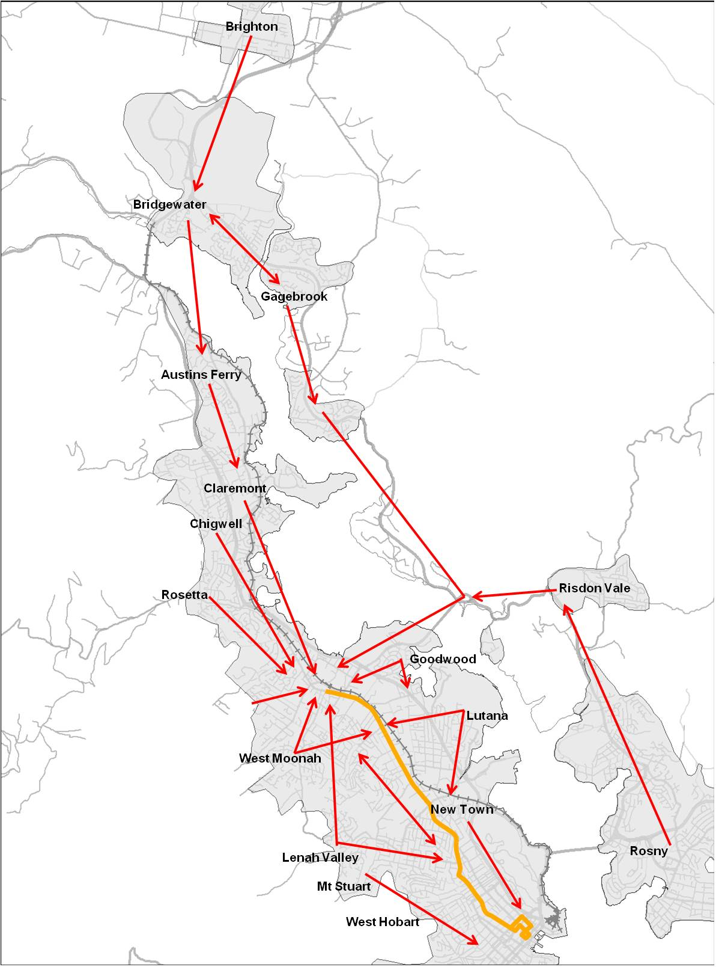

# Drivers of public transport demand

## How public transport users perceive their cost of travel

Each time a person makes a trip, there is a cost associated with that trip for the individual, known as a ‘generalised cost’. The generalised cost of travel comprises:

* Total travel time:
  + Walking time to transport.
  + Waiting time for transport.
  + In-vehicle travel time.
  + Time taken to transfer between transport services.
* Vehicle operating costs.
* Personal expenses such as parking and fares.
* Comfort and convenience of travel.

The concept of generalised cost is best explained by an example. If the travel time for public transport decreases, the generalised cost of travel also decreases. Consequently, the demand for services increases as people make judgements on how to travel at the lowest possible overall generalised cost.

Factors which influence people’s use of public transport can be grouped into ‘hard’ and ‘soft’ factors:

* **Hard factors:** include timetable frequency, speed of vehicle travel, locations of bus stops and fares.
* **Soft factors:** include reliability, provision of information, comfort and security.

Considerable market and economic research has been undertaken into the relative importance of each factor, these are discussed below.

### Importance of bus frequency

Frequency and the associated reliability of that frequency has been found to be the most important influencing factor affecting patronage. A study by Walker et al shows that in Australian cities, increased patronage occurs as a result of improving frequency and that this patronage increases over time (Walker and Donovan). This is because frequency reduces both the expected and unexpected waiting time for a service and hence each passenger’s travel time and costs.

Research indicates that waiting time is perceived by passengers as highly annoying and that waiting for a bus with uncertain arrival times is often seen as an anxious and stressful experience. Market research undertaken by Metro in 2011 indicated that the operating hours of the service and frequency of services (16 percent each) were areas where respondents were most disappointed with Metro services.

Consequently, minimising waiting time is critical to encourage use of public transport.

Service frequency is also important because it creates the necessary conditions for other factors to influence patronage, such as infrastructure improvements. For example an increase in travel time reliability for buses will shift some people to public transport only if the service is frequent enough to meet their needs.

### Temporal coverage

The temporal coverage of services determines the extent to which people can access services, across different times of the day, such as evenings (if they are working late or socialising in the evening). At times of lower demand, timetables should still operate at either high or moderate frequency with services scheduled to arrive on a highly consistent and predictable basis.

### Other factors

A number of studies have highlighted travel time reliability as a key influence in increasing bus patronage in terms of punctuality, reliability and dependability of a service. Bus reliability is discussed in greater detail in the Corridor Function and Performance Report.

Other elements associated with travel time include walking to and from public transport and in-vehicle travel time. While these aspects are valued by passengers, waiting time, (especially unexpected waiting time) is the element that passengers value the most. Particularly if a bus is late, then the waiting time is perceived as highly annoying.

When public transport is directly competing with the car for income generating journeys (travel to work), then the overall importance of travel time including in-vehicle travel time increases.

Other important factors include fare levels, access to routes, information and personal comfort and security.

## Level of frequency

The table below shows the level of frequency for the Transit Corridor in comparison to other indicative examples in Australia and overseas. The examples include Australian cities with a bus-oriented public transport system such as Brisbane and Canberra, and Melbourne which has a tram system, which is considered an alternative to a bus system. Strasbourg (population 272 000) and Freiburg (218 000) are considered to be best practise light rail systems in Europe which have a similar population to Greater Hobart.

Information is provided by temporal periods, as each period could be considered to represent different market segments each with its own challenge:

* Weekday peak services are typically used by commuters and students to undertake directed activities.
* Weekday inter-peak services are used by those undertaking non-directed activities such as shopping and personal business.
* Other temporal periods vary from weekday evening services used by those who are returning home from work to mainly recreational use during the weekends.

Figure Average level of service frequency (minutes)

|  |  |  |  |  |  |  |  |
| --- | --- | --- | --- | --- | --- | --- | --- |
| **Time of travel** | **Brisbane BUZ busway service** | **Canberra Blue Rapid Service** | **Melbourne Tram service** | **Strasbourg (France) light rail** | **Freiburg (Germany)** | **Current Transit Corridor including express bus services (Brooker)** | **Current Transit Corridor** |
| Weekday AM peak | 5$ | 3 | 7-8 | 5-6 | 4-5 | 3-4 | 5 |
| Weekday PM peak | 5$ | 4-5 | 8-10 | 5-6 | 5 | 4-5 | 7 |
| Weekday inter-peak | 15 | 5 | 12 | 6-8 | 7-8 | 7-8 | 10 |
| All evenings 6 PM to 8 PM | 10 | 6 | 10 | 6-8 | 10 | 20## | 20 ## |
| All evenings 8 PM to 10 PM | 15 | 15 | 20 | 8 | 15 | 30@ | 30@ |
| All evenings 10 PM to Midnight | 15 | 15# | 20 | 14 | 30 | 30 | 30# |
| Saturday day time | 15 | 15$ | 12 | 6-7 | 7-8 | 15 | 20 |
| Sunday day time | 15 | 15 | 12 | 14 | 15 | 30 | 30 |

$ more frequent services during busier times

# Not on Sundays

## every 30 minutes on Saturdays, Sundays

@ every 20 minutes on Fridays

The Transit Corridor has one of the highest levels of bus frequency in Greater Hobart and has comparable frequency to similar corridor services operating in other cities. When service frequency is compared, the findings are as follows:

* Weekday peak: The Transit Corridor compares favourably to other corridor services during peak periods. Peak frequency is matched to the demand for services. As there is sufficient capacity on Transit Corridor peak services there is not a strong case to improve service levels particularly as this would require additional vehicles and associated extra cost.
* Weekday inter-peak: The Transit Corridor frequency is similar to other systems. The Corridor exceeds the frequency of the bus and tram services respectively in Brisbane and Melbourne but is lower than Canberra and best practice European cities. A small increase in frequency is justified as the Corridor is well patronised during the inter-peak.
* Evening services: The Transit Corridor has a lower frequency than other comparative services, especially after 6 PM. Current Transit Corridor frequency during the evening is inconsistent between days of the week, with different evening services provided Monday to Thursday, then again on Friday, Saturday and Sunday. The frequency and consistency during this period needs to be improved, if it is to operate as a genuine Transit Corridor.
* Weekend day periods: The Corridor has a significantly lower frequency during weekends, which requires improving.

### Frequency harmonisation

Timetables should be predictable at consistent frequencies eg every 10 minutes and at easy to remember times eg 2:10, 2:20 etc. This means that people do not have to rely on accessing a timetable in order to use public transport and have greater level of certainty of when buses will arrive.

Currently services on the Transit Corridor operate on an irregular basis, this is known as deharmonsiation and creates confusion for passengers and makes concise service information hard to provide. Deharmonsiation is likely to increase passenger waiting times which lead to passenger annoyance.

### Service reliability

While frequency reduces expected and unexpected waiting and overall travel times, services also need to be reliable to make the most of these frequency gains. Analysis shows that there is a variation in travel times along the Transit Corridor for buses. This is discussed in more detail in the Corridor Function and Performance Report.

Factors affecting reliability on the Transit Corridor include:

* The Corridor operates as an on-road bus system, with very few bus priority measures which means buses are subject to localised congestion and delays.
* Some services on the Corridor operate as through services with a large number of routes, some of which are very long. The longer the route, the greater the variability in travel time.
* The Corridor has a large number of bus stops. This can cause reliability issues, because the bus has to stop more frequently.
* There is little information to minimise perceptions of unreliability, other systems have real time travel information. This lack of information about actual service reliability maximises the anxiety associated with travel and perceived and unexpected waiting times.

## Temporal span of services

The temporal span of services for a high frequency corridor is essential in attracting public transport users and making the service more attractive. A wide temporal coverage means that people can use public transport if they start work early in the morning and finish late at night; this is particularly the case for people who work in hospitality and tourism, or undertake shift work. A wide temporal span across the week also encourages the use of public transport for other trip purposes such as recreation, entertainment and shopping.

There is a need to operate services as consistently as possible over seven days, only diminishing temporal spread if demand is particularly low.

The table below compares temporal span to other city services.

Figure 3 Temporal span of services

|  |  |  |  |  |  |  |  |
| --- | --- | --- | --- | --- | --- | --- | --- |
| **Time of travel** | **Brisbane BUZ services** | **Canberra Blue rapid service average** | **Typical Melbourne Tram service** | **Strasbourg (France) light rail** | **Freiburg (Germany)** | **Current Transit Corridor including express bus services (Brooker Highway)** | **Current Transit Corridor** |
| Monday to Thursday | 5:00 AM - 12:00 AM | 5:30 AM - 12:00 AM | 5:30 AM - 12:30 AM | 5:00 AM - 1:00 AM | 5:00 AM - 1:00 AM | 6:00 AM - 11:30 PM | 6:00 AM - 11:30 PM |
| Friday | 5:00 AM - 12:00 AM | 5:30 AM - 12:00 AM | 5:30 AM - 1:30 AM | 5:00 AM - 1:00 AM | 5:00 AM - 1:00 AM | 6:00 AM - 12:30 AM | 6:00 AM - 12:30 AM |
| Saturday | 6:00 AM - 12:00 AM | 6:30 AM - 12:00 AM | 5:30 AM - 1:30 AM | 5:00 AM - 1:00 AM | 5:00 AM - 1:00 AM | 6:30 AM - 12:30 AM | 6:30 AM - 12:30 AM |
| Sunday | 6:00 AM - 12:00 AM | 7:30 AM - 7:30 PM | 7:00 AM - 12:30 AM | 6:00 AM - 1:00 AM | 5:30 AM - 1:00 AM | 7:30 AM - 9:30 PM | 7:30 AM - 9:30 PM |

The Transit Corridor is consistent with services in other cities in terms of temporal spread but there are a number of disparities:

* Overall temporal spreads are applied inconsistently with variations across the week. The need for consistency from Monday to Saturday is an important characteristic of a genuine Transit Corridor.
* Transit Corridor weekday services start later than other systems, commencing at 6:00 AM with other systems generally commencing between 5:00 or 5:30 AM.
* Weekday Monday to Thursday services and Sunday services finish earlier than other systems.
* With the exception of Sunday services in Canberra, temporal spread on Sundays is limited compared to other cities.

# Public transport patronage

## Public transport patronage on the Transit Corridor by weekdays

The Transit Corridor is a major generator of passenger movements. In 2011 the Corridor carried an average of 5600 boardings per day (Metro boardings only) which accounted for approximately 20 per cent of daily Metro boardings in Greater Hobart. The total market for travel in the Transit Corridor vicinity is larger, as an additional 1400 passengers a day use express services which travel via the Brooker Highway (Metro 2011).

The overall market for public transport demand, (including express services) is highly peaked around the work and school starting and finishing times. Typically public transport has low demand for the balance of the day, unless there are significant attractors such as those available on the Corridor including shopping and service centres and recreational attractors. These attractors generate patronage between the peak periods.

The Transit Corridor has distinct weekday peak periods, as well as strong inter-peak patronage reflecting the role of the Corridor as a strong trip attractor for shopping and accessing services. These peak periods are as follows:

* The PM school peak has the highest peak, with just over 350 passengers using the Transit Corridor between 3:00-3:30 PM with an additional 110 using express services.
* The AM peak has the second highest peak, between 8:00-8:30 AM, however if 180 express bus users are included it has a combined peak of 530, which exceeds the PM school peak.
* The PM commuter peak is the third highest peak, at 270 passengers between 5:00-5:30 PM with an additional 115 passengers using express services.
* The Corridor has strong inter-peak patronage between 9:00 AM until 3:00 PM.

With the two afternoon peaks combined, more people are travelling home in the afternoon by bus than in the morning. This is a reflection of people travelling to work or school by other modes such as a passenger in a car, or walking, and then catching the bus home in the afternoon. As the afternoon is a peak travel time for buses, there is often more choice for bus users in terms of frequency and routes, which in turn leads to greater patronage.

Figure Total passenger volumes using the Transit Corridor (weekdays)

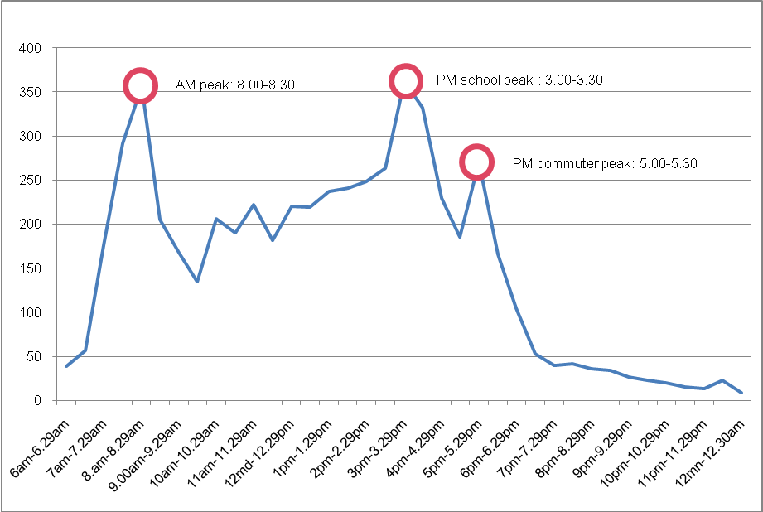

Source: Metro Tasmania, average daily boardings, July-December, 2011

When inward and outward passenger volumes on the Transit Corridor are analysed:

* Inward volumes, peak in the AM Peak (8:00-8:30 AM): this reflects the number of people travelling towards the Hobart CBD for work or school.
* Outward volumes reach their highest levels in the student PM peak (3:00-3:30 PM) and commuter PM peak (5:00-5:30 PM): these movements reflect students and commuters returning to their place of residence.

Figure Inwards and outwards passenger volumes using the Transit Corridor (weekdays)

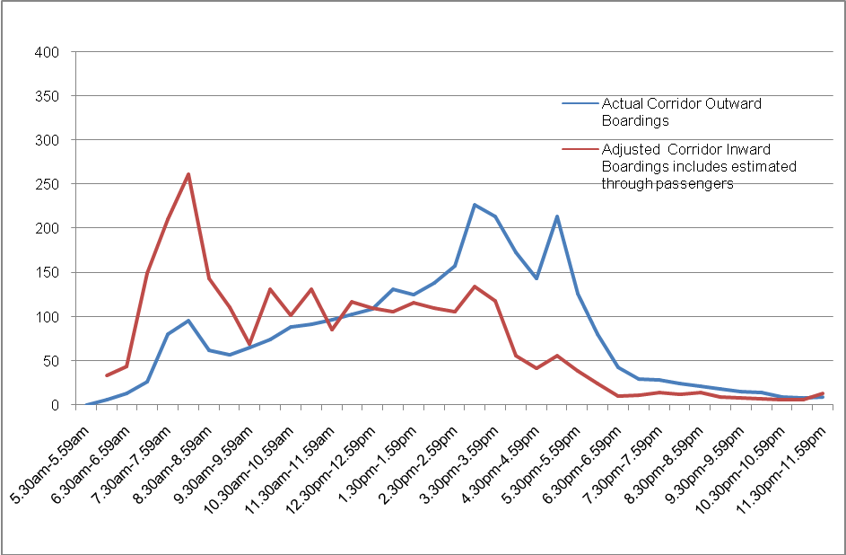

Source: Metro Tasmania, average daily boardings, July-December, 2011

## Proportion of Northern Suburbs patronage using the Transit Corridor

The graph below shows the percentage of Northern Suburbs public transport passengers using the Transit Corridor. The analysis shows that:

* On average, the Transit Corridor accounts for 44 percent of all public transport boardings in the Northern Suburbs.
* The proportion of passengers using the Corridor in the AM and PM peak decreases to around 30 to 40 percent, largely because passengers are using express bus services on the Brooker Highway.
* The proportion of people using the Corridor increases significantly outside of peak periods:
  + 60 percent of Northern Suburbs passengers in the inter-peak.
  + Between 70 to 80 percent in the evening (7:00 PM onwards).

When Northern Suburbs patronage is compared to the Transit Corridor, the results show that the Northern Suburbs has relatively larger peaks and relatively lower utilisation of services outside peak periods. The peaked nature of Northern Suburbs patronage is due to the relatively large level of student patronage. During the evening, nearly all Northern Suburbs patronage use Main Road services.

Figure Percentage of passengers in the Northern Suburbs using the Transit Corridor (weekdays)

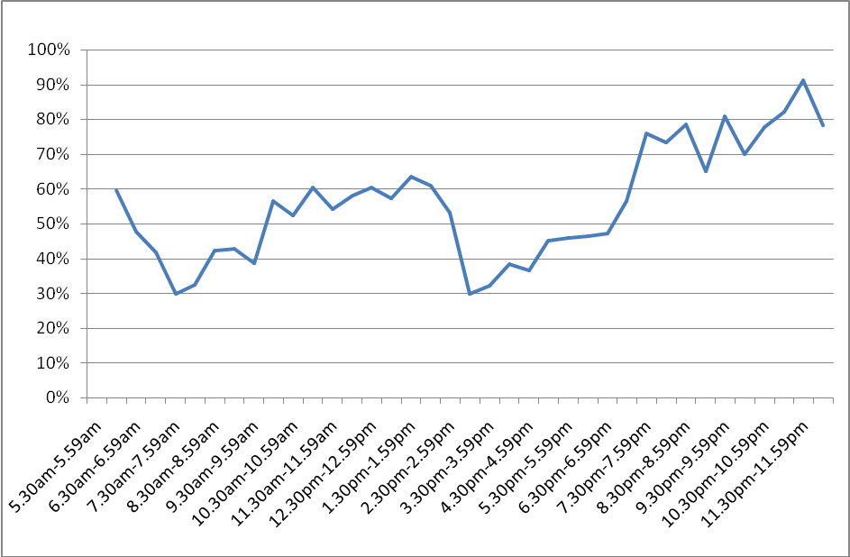

Source: Metro Tasmania, average daily boardings, July-December, 2011

It should be noted that the above patterns for the Northern Suburbs are consistent with overall trends within Greater Hobart, which typically demonstrate a highly peaked demand for public transport services.

While some suburban routes carry significant passenger numbers between peaks, notably south east towards Rokeby/Clarendon Vale, north east to Risdon Vale and immediately south towards Sandy Bay, overall there is considerable excess capacity in the inter-peak with peak services close to capacity.

With respect to other corridors in Greater Hobart, only services towards Sandy Bay and UTAS exhibit similar patterns to the Transit Corridor with good utilisation during all times of the day and on a seven days a week basis.

Services towards Rosny Park and Shoreline generate some inter-peak demand attributed to travel to larger shopping attractors. Travel southward towards the Kingston shopping centre occurs mostly during peak periods, however it is expected that inter-peak demand will increase slowly over time as the Kingston retail area expands and population grows.

## Passenger utilisation of the Transit Corridor

The graph below shows the number of passengers per service using the Transit Corridor. The analysis shows:

* AM and PM peak inward bus services have the highest utilisation at 39 people per bus.
* Both inward and outward inter-peak services have high utilisation at 34 people per bus.
* Evening services after 7 PM have the lowest number of passengers at 11 people per bus.

Figure Passengers per bus service on the Transit Corridor (weekdays)

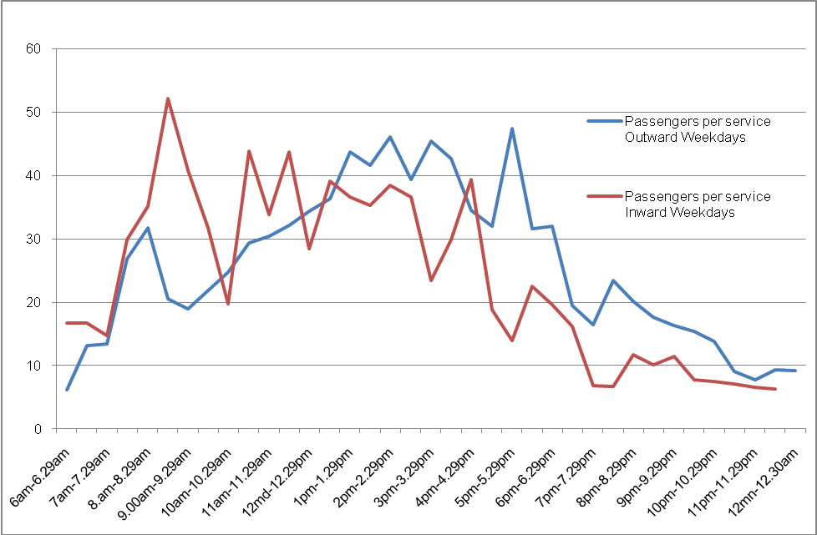

Source: Metro Tasmania, average daily boardings, July-December, 2011

There are no agreed national standards for measuring the effectiveness of passenger utilisation. However some jurisdictions have developed and published their own standards, such as Translink in Queensland. The standards below are based on the Translink Network Plan 2011:

* Minimum threshold for maintaining a service at a minimum level is seven passengers per hour.
* Minimum threshold for maintaining a service operating above a minimum, such as a higher frequency service is 14 passengers per hour.
* Maximum threshold for triggering service improvements for any service is 30 passengers per hour.

An economic evaluation undertaken by Stanley (2010) infers that a minimum of five people per hour is considered as a justification to maintain a service from a social inclusion perspective. This is because the value of a trip for those that are socially excluded is about four times greater than the value of a normal public transport user.  Socially excluded people are often the core market for evening and weekend services.

Although the standards from Translink and Stanley are measured by passengers per hour, rather than per bus, it is clear that the Transit Corridor is performing well from an utilisation perspective, as it is carrying well above 14 passengers per hour. During the weekday peak, inter-peak and at weekends (during the day) the Corridor is carrying between 68 to 82 passengers an hour.

Based on the Translink standards, utilisation on the Transit Corridor can clearly justify service frequency improvements at such times.

## Public transport patronage on express bus services

Currently there are additional trips made by passengers travelling on express services to and from the Northern Suburbs and Hobart CBD which generally travel via the Brooker Highway. Approximately 1120 additional trips (weekdays) are made during peak periods on the Brooker Highway, which accounts for 29 percent of total Transit Corridor and express bus trips during the peak. There are substantially less trips on the Brooker Highway during the inter-peak (330) representing 11 percent of total trips during that period. There are no express services during the evening.

From the analysis above, it is clear that there is a demand for express services during the peak, but outside of this period there is very low demand. Outside of the peak, most passenger trips from the outer Northern Suburbs terminate either at Glenorchy or transfer to the Transit Corridor all stops service for travel to attractors along the Corridor.

Express services on the Brooker Highway were established in 1985, to compensate for passengers forced to transfer between services at the newly built Springfield Depot. Consequently such services where supplied above the actual demand. Only services operating at the height of the AM and PM peak attracted strong patronage. Such peaks were, and continue to be, driven by high levels of peak student demand. Between peak periods, demand for express services is low.

In 1992, outer Northern Suburbs services which travelled along Main Road were converted to travel express via the Brooker Highway between Glenorchy and Hobart. This change did little to improve patronage, especially during non-peak periods.

The overall market for public transport is shown below:

* 21 percent of passengers use express services mostly via the Brooker Highway, focused in peak periods.
* 34 percent of passengers make exclusive use of the Transit Corridor between Glenorchy and Hobart.
* 45 percent of passengers, board north of Glenorchy and are through passengers on the Transit Corridor.
* In total during weekdays, there are 7080 boardings either via the Transit Corridor or Brooker Highway.

Bus travel times on the Brooker Highway are quicker than Main Road. If travel times could be improved on the Transit Corridor, there may be a role for express services to operate on the Transit Corridor, as opposed to the Brooker Highway.

Peak express services on the Brooker Highway follow a similar demand profile to the Transit Corridor during the height of the peak, occurring between 8:00-8:30 AM. However, the PM peak on the Brooker Highway is smaller, flatter and longer (3:00- 5:30 PM).

Figure Passenger boardings on express buses mainly via the Brooker Highway (weekdays)

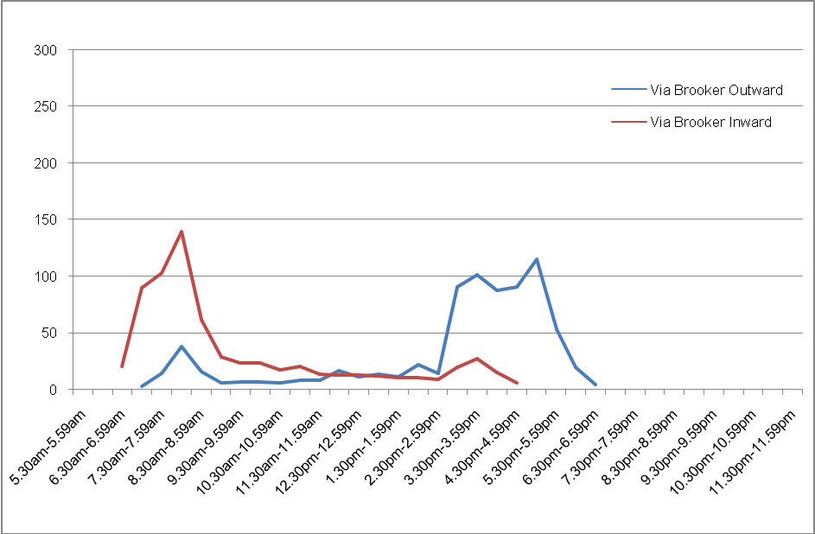

Source: Metro Tasmania, average daily boardings, July-December, 2011

Figure Passenger boardings on the Transit Corridor and Brooker Highway (weekdays)

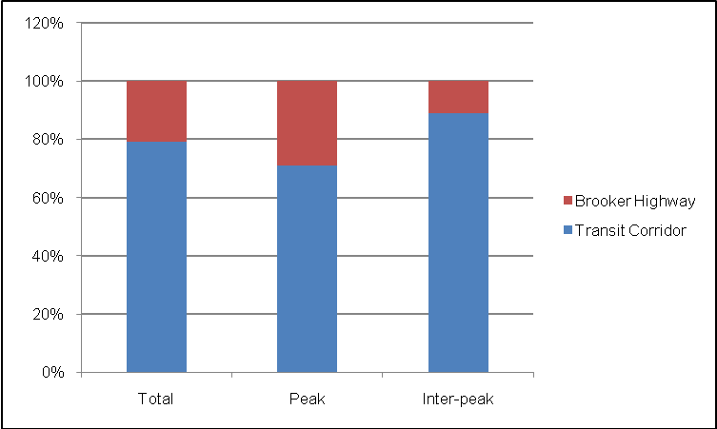

The graph below shows the number of passengers per bus using the Brooker Highway. The analysis shows:

* AM peak inward bus services have the highest utilisation at 31 people per bus. However there is a needle peak in the AM peak of 56 passengers per bus as articulated and larger 14.5 metre buses are used which can carry more passengers.
* Peak demand falls rapidly from the height of the peak. The average utilisation of shoulder peak services is seven passengers.
* Both inward and outward inter-peak services have a low utilisation of only 11 people per bus service.

Figure Passengers per bus service on the Brooker Highway (weekdays)

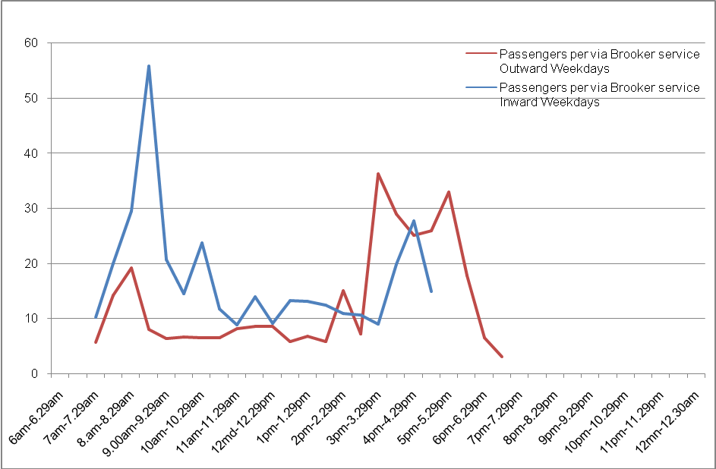

Source: Metro Tasmania, average daily boardings, July-December, 2011

## Transit Corridor patronage weekends

Public transport patronage on weekends is substantially less than an average weekday:

* Saturday patronage is 36 percent (2500 trips) of an average weekday patronage.
* Sunday patronage is 19 percent (1300 trips) of an average weekday patronage.

On Saturdays, the Transit Corridor represents approximately 63 percent of all trips in the Northern Suburbs, while Sundays are slightly lower at 59 percent. This shows the importance of bus services along the Transit Corridor during off-peak periods.

Most weekend trips are associated with persons travelling to undertake shopping, or entertainment and recreation-related trips. The number of passengers using such services to travel to work is low, and there are no students travelling for educational purposes. It should also be noted that service frequency is much lower on weekends.

Figure Public transport patronage on the Transit Corridor (weekend)

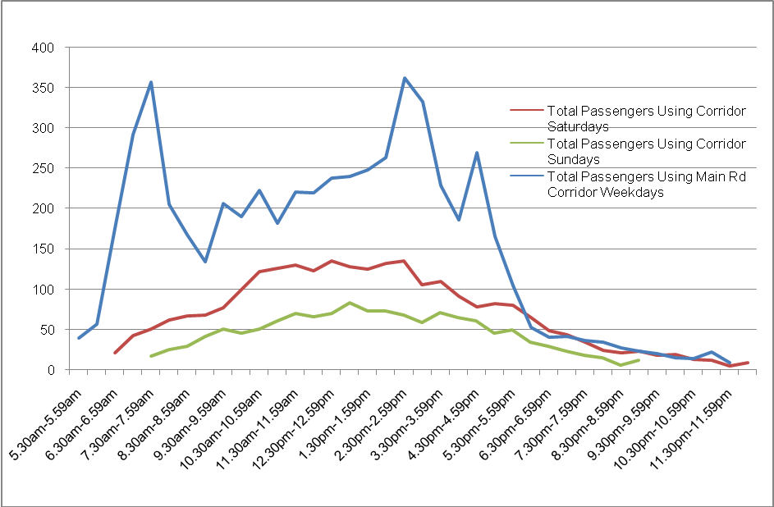

Source: Metro Tasmania, average daily boardings, July-December, 2011

As patronage is lower on weekends, the frequency of buses is also much lower. However there are some services, (especially outward services from the Hobart CBD between 12 PM to 4 PM) that are close to capacity. On these services the average number of passengers is higher than during weekdays. Based on this, frequency could be improved during the weekends between 12 PM to 4 PM.

Bus services are highly utilised during shopping periods especially when passengers are returning home from shopping in the afternoon. Evening services carry more than 10 people which is considered to be an effective level of utilisation. Sundays are slightly less.

Peak services on the Transit Corridor are utilised at similar levels to services operating during core shopping hours (9 AM to 3 PM on weekdays and 10 AM to 4 PM on weekends).

Figure Passengers per bus service on the Transit Corridor (weekend)

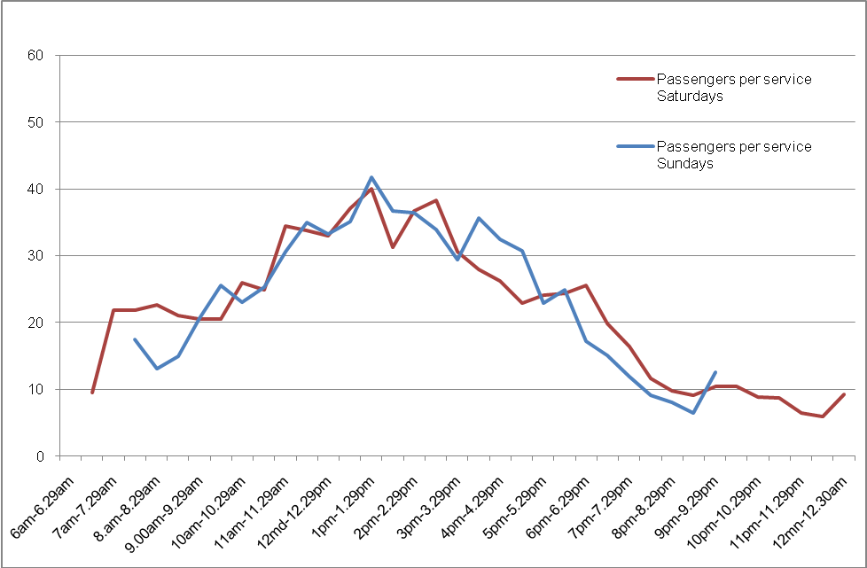

Source: Metro Tasmania, average daily boardings, July-December, 2011

# Bus stops

## Bus stop boardings along the Transit Corridor

The map below shows the inward and outward boardings on the Transit Corridor (average boardings per day). The bus stops with the highest outward boardings include:

* Hobart bus mall: 1297.
* Elizabeth Street, between Liverpool and Bathurst Street: 783.
* Moonah activity centre: 229.
* North Hobart activity centre: 185.
* New Town, Ogilvie and New Town Boys High Schools: 101.
* Springfield Depot: 100.

Inward stops with the highest boardings:

* Glenorchy bus mall: 1151.
* Moonah activity centre: 282.
* Springfield Depot: 247.
* New Town, Ogilvie and New Town High Schools: 135.
* New Town shops, Risdon Road: 130.
* New Town, Augusta Road: 124.

Bus stops with high boarding data are based predominately in activity centres and in locations where there are major attractors such as the schools in New Town. The bus stops near Ogilvie and New Town High Schools are likely to be utilised only during school peak periods.

The total number of boardings in activity centres is as follows:

* Hobart CBD: 2172.
* Glenorchy activity centre: 1151 (note includes only inward boardings).
* North Hobart: 456
* Moonah: 436.
* New Town: 228.

Some bus stops are poorly utilised, particularly those located close together or between activity centres, such as in parts of New Town and in Derwent Park. It should be noted however, that although bus stops may be poorly utilised in terms of boardings, they may have a high number of people alighting from the bus. Inward bus stops within the Hobart CBD have a very low number of boardings, but are likely to have a medium to high number of people alighting from the bus (note alighting data not recorded).

Figure Transit Corridor bus stop boardings (average daily boardings)

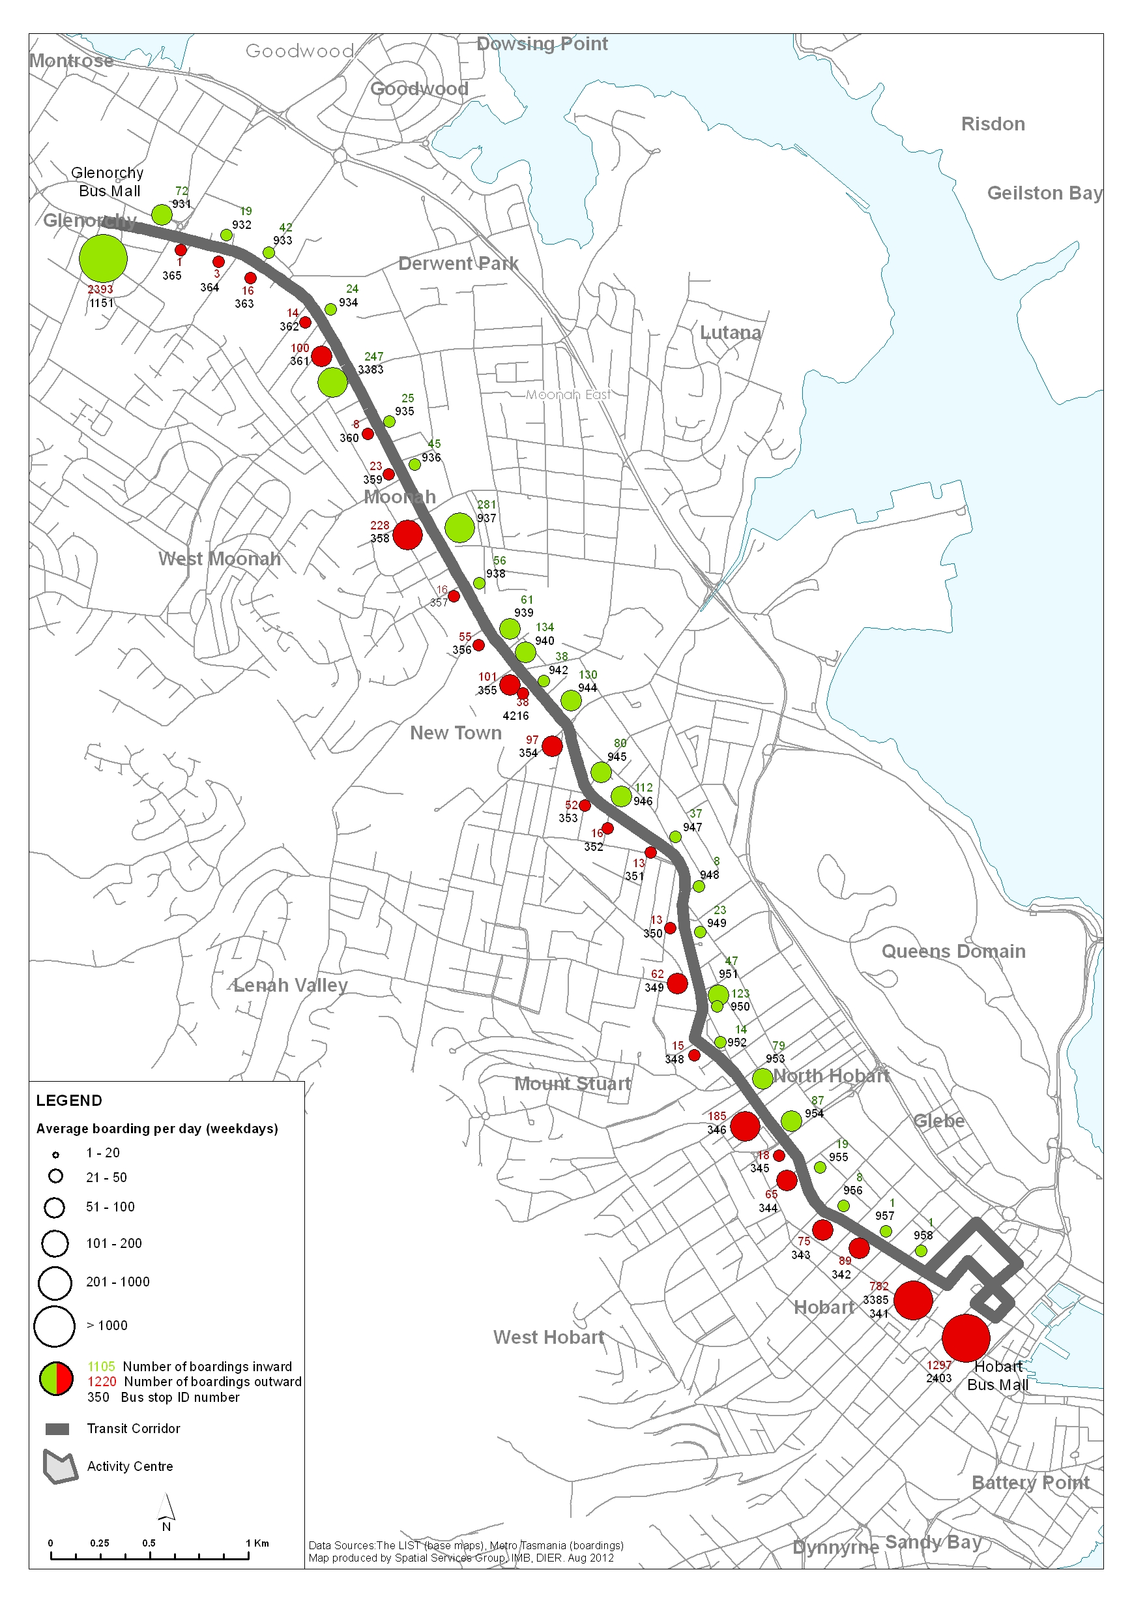

## Passenger boardings from suburbs adjacent to the Transit Corridor

When passenger boardings are analysed in more detail, boardings on the Transit Corridor are much higher than passenger boardings from suburbs adjacent to the Corridor. This shows that the Corridor receives consistently strong patronage because of the high number of attractors and service frequency on the Corridor. Passenger boardings on the Transit Corridor are 75 percent higher than bus routes in adjacent suburbs.

Suburbs with the highest number of average daily boardings include:

* Lenah Valley: 405.
* Mount Stuart/West Hobart: 391 (note service uses the local West Hobart road network and not the Transit Corridor).
* West Moonah: 180.
* East Moonah, Derwent Park and Lutana: 163.

## Bus stop optimisation

Bus stop optimisation can lead to improvements in travel time reliability through reducing the number of times a bus has to stop between its origin and destination. Bus stop optimisation involves evaluating the pattern of bus stop placement and patronage to determine which stops should be retained, removed or relocated. The focus should be on removing stops which are close together or poorly utilised. Some bus stops are poorly located which can cause bus travel time delays, as buses have difficulty merging back into traffic. Bus stop optimisation will also need to be considered in conjunction with on-road bus priority measures.

If services are more frequent, stops can be more widely spaced as research shows that people are prepared to walk further for a more frequent reliable service. However there is a need to balance bus stop optimisation against accessibility, especially for passengers that are aged or those with a disability. Infrequently spaced bus stops may also increase walk times for all passengers beyond tolerable threshold levels.

Research undertaken by other transport agencies shows that the ideal spacing for bus stops is approximately 400 metres, although a closer spacing in activity centres may be necessary to meet passenger requirements.

### Transit Corridor bus stop placement

There are currently a total of 66 bus stops on the Transit Corridor from Hobart CBD to Glenorchy including:

* 34 inwards bus stops.
* 32 outwards bus stops.

On average, the Corridor has a bus stop placed every 250 metres, which is well below the suggested 400 metre placement. For example, there are two bus stops located in close proximity to Risdon Road near Ogilvie High School on both the inwards and outwards directions which are less than 200 metres apart.

Bus stops along the Corridor are also unevenly spaced, with little consistency in distance between stops. Certain bus stops are also unevenly paired (in respect to either side of the road), which can result in passengers having difficulties locating a bus stop for their return journey.

## Bus stop infrastructure

Bus stop infrastructure is an important component of the operation of the bus system and the community’s perceptions of the system. Bus stops are the first interaction that passengers have with the system. There is a wide variation in the standard of bus stop infrastructure along the Transit Corridor. All bus stops have a pole and blade, but not all major bus stops have shelter or seating. Most of the shelters are aged and have a poor appearance and aesthetic. A pedestrian access assessment was undertaken at ten major bus stops along the Corridor, details of this assessment are in the Walking and Cycling Report.

Bus stops should ideally have the following characteristics:

* Be readily identifiable as a bus stop by having consistent branding and appearance.
* Located in a convenient and logical spot in terms of position of surrounding trip attractors.
* Located in areas which are highly visible and have some form of passive surveillance from surrounding activity eg visibility from shops, places of work or residences.

Not all bus stops require the same level of information or infrastructure. As the Metro bus network is a low-density high penetration network, there are around 2500 bus stops in Greater Hobart.

One of the main issues associated with upgrading bus stop infrastructure is that upgrades are required to be compliant with the Disability Discrimination Act (DDA), which can make upgrades expensive. There is also some uncertainty, as to where the legal responsibility for upgrading bus stops and their various elements lies.

## Springfield Depot park and ride

A park and ride is located at the Springfield Depot, which consists of approximately 70 car parking spaces. The park and ride has been operating since the Depot ceased to be an interchange in the 1990s.

Observation of the park and ride indicates that the majority of people are using the park and ride for public transport purposes:

* One third use express bus services.
* 60 percent use the all-stops service.
* The remainder use the facility for local parking or for car pooling

The park and ride is also used as a convenient stopping point for some kiss and ride trips (passenger drop-off from a car).

The park and ride is generally at capacity around 8:30 AM, the most popular arrival time is around the height of the AM peak (8:00 to 8:30 AM).



**Department of Infrastructure, Energy and Resources**

10 Murray Street,

Hobart TAS 7001

Ph: 1300 135 513

Visit: www.dier.tas.gov.au